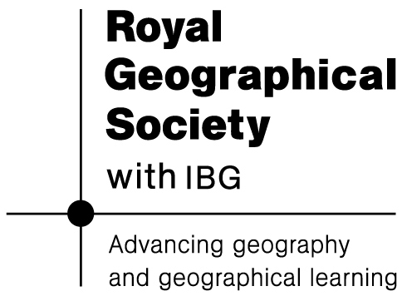
Africa – a continent of contrasts
Images source: NASA public domain images
Lesson 1: Naming continents

AFRICA

North America
Fact = ________________________________________________________________

South America
Fact = ________________________________________________________________

Europe
Fact = ________________________________________________________________

Asia
Fact = ________________________________________________________________

Antarctica
Fact = ________________________________________________________________

Africa
Fact = ________________________________________________________________
Fact = ________________________________________________________________
Fact = ________________________________________________________________
Fact = ________________________________________________________________
Fact = ________________________________________________________________

