The Alpine Convention
on Sustainable Tourism

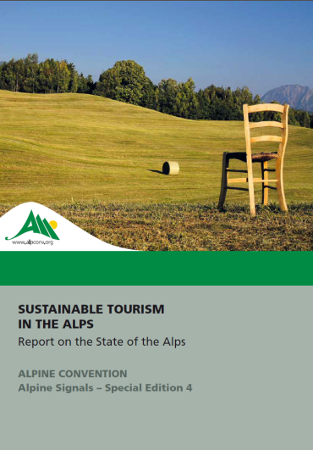
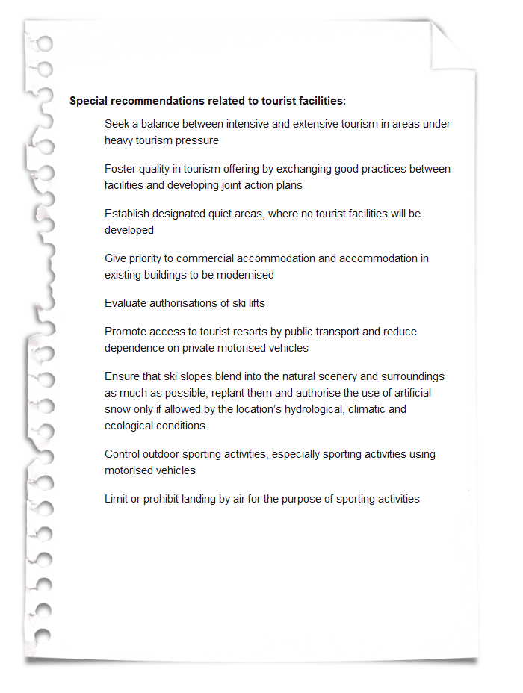
Source: Permanent Secretariat of the Alpine Convention 2013

