Mapping Snowdon Answer Sheet
Using Grid References and Keys:

- What is located at the grid reference 607562?

Clogwyn Station

- What is located at the grid reference 624531? Remember to use the key to find out what this symbol means.
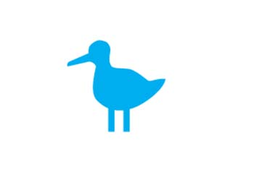
Nature Reserve

- Can you see a big blue bird at this location in real life?

No, it is only a symbol used to represent something in the real world.

- What is at grid reference 658542? Remember to use the key to find out what these symbols mean.

Parking

Viewpoint

- Look at grid reference 648525. What can you do here? Remember to use the key to find out what this symbol means.

You can camp. This is a symbol for a camp site.

- Find two more features that visitors might want to see in Snowdonia. What are they? What are the grid references for each feature?

Pupils’ answers will all differ.

Knowing Direction:

- You are standing on the summit of Snowdon. Which compass direction does the train journey follow to Clogwyn station?

North

- Is Llyn Llydaw to the west or east of Glaslyn?
East

- You are in Pen-y-Pas. In which direction will you walk if you take the Miners’ Track?
South

- Devise two more questions for your class to answer using the 8 points of the compass. Remember, you must know the answers yourself!

Pupils’ responses will all differ.

Using Scale:

Your task is to walk to the summit of Snowdon. Most people park at Pen-y-Pas and walk to the summit from there.

- Stage one: If you park at Pen-y-Pas and take the Miners’ Track to the Causeway at Llyn Llydaw, spot height 446, how far have you walked?
Approximately 2.5 km.

- Stage two: Continue to walk across the Causeway on the Miners’ Track, following the track to spot height 605 on the north side of Glaslyn. How far have you walked on the second stage of your journey?
Approximately 2.2 km

- Stage three: On this final stage of your journey you walk from spot height 605 along the path to the summit of Snowdon. How far have you walked on this third and final stage?
Approximately 1.6 km

- Which was the steepest stage of your journey? How do you know this?

Stage three of the journey. The contour lines were drawn more closely than in the previous stages of the journey.

