The Zambezi Expedition

- What were the member’s jobs and explain what they had to do?
- How did they travel to Africa?
- Why does it say the Portuguese town of Tete?
- What are rapids?
- Who were slave traders?
- Why do you think there were battles with Africans and slave traders?
- Why were the men on the verge of mutiny?
- What does it tell us about the character of David Livingstone?
- What does it tell us about what the conditions were like for Europeans?
- Why do you think the expedition failed?

Can you retell the story in your own words, using three of these sources to help you. Click on the description of each source to find out more information in the gallery.

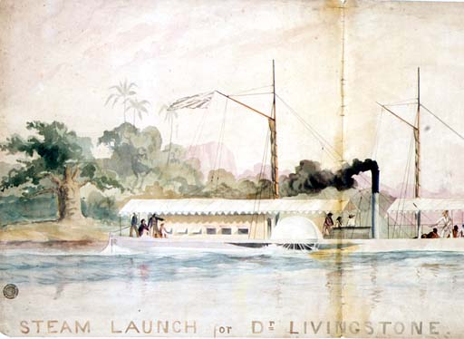
________________________________________________________________________________________________________________________________________________________________________________________________________________________
Steam Launch called Ma Robert

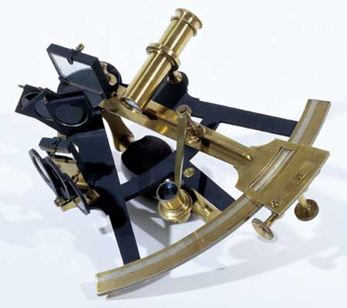
__________________________________________
__________________________________________________________________________________________________________________________________________________________________________________________________________________
Livingstone’s sextant

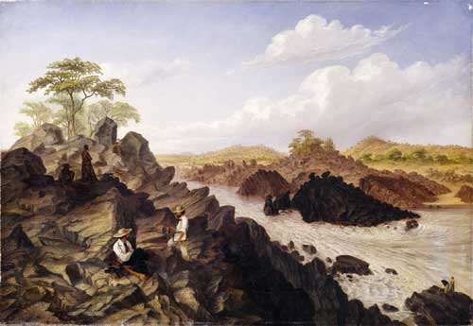
___________________________________
_______________________________________________________________________________________________________________________________________________________________________________
Thomas Baines watercolour of Rapids

________________________________________________________________________________________________________________________________________________________________________________________________________________________________________________________________________________________________________________________________________________________________________________________________________________________________________________________________________________________

