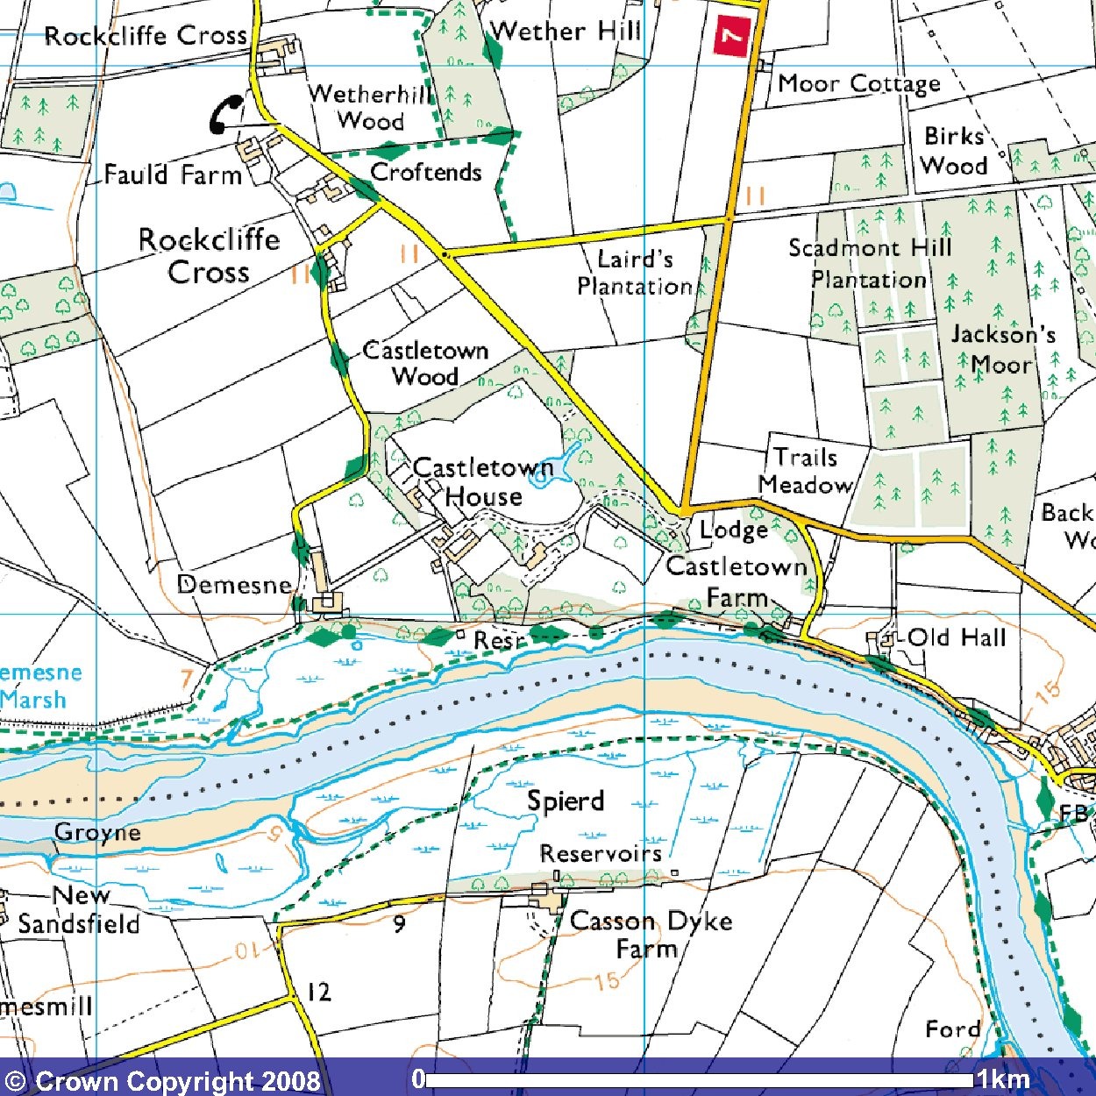
Choosing your site
B. Moor House Farm, Westlington, Carlisle, CA6 6AL
A. Castletown House, Rockliffe, Carlisle, CA6 4BN
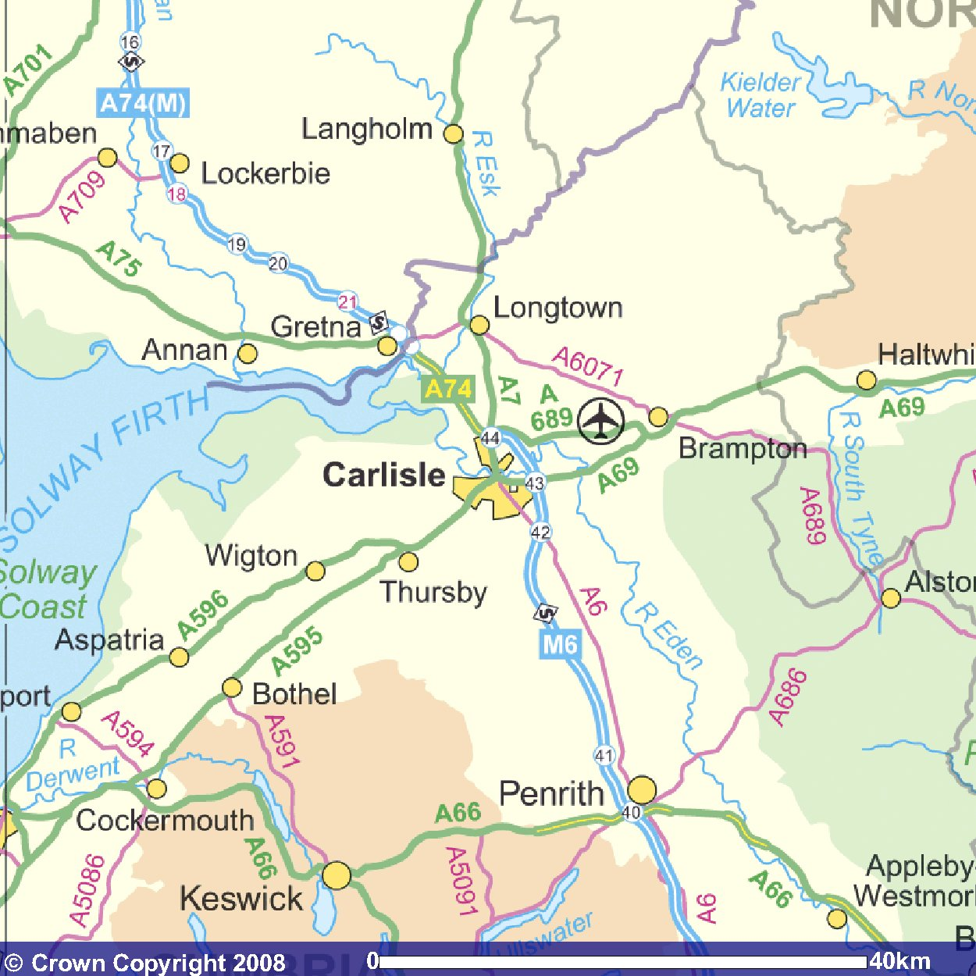
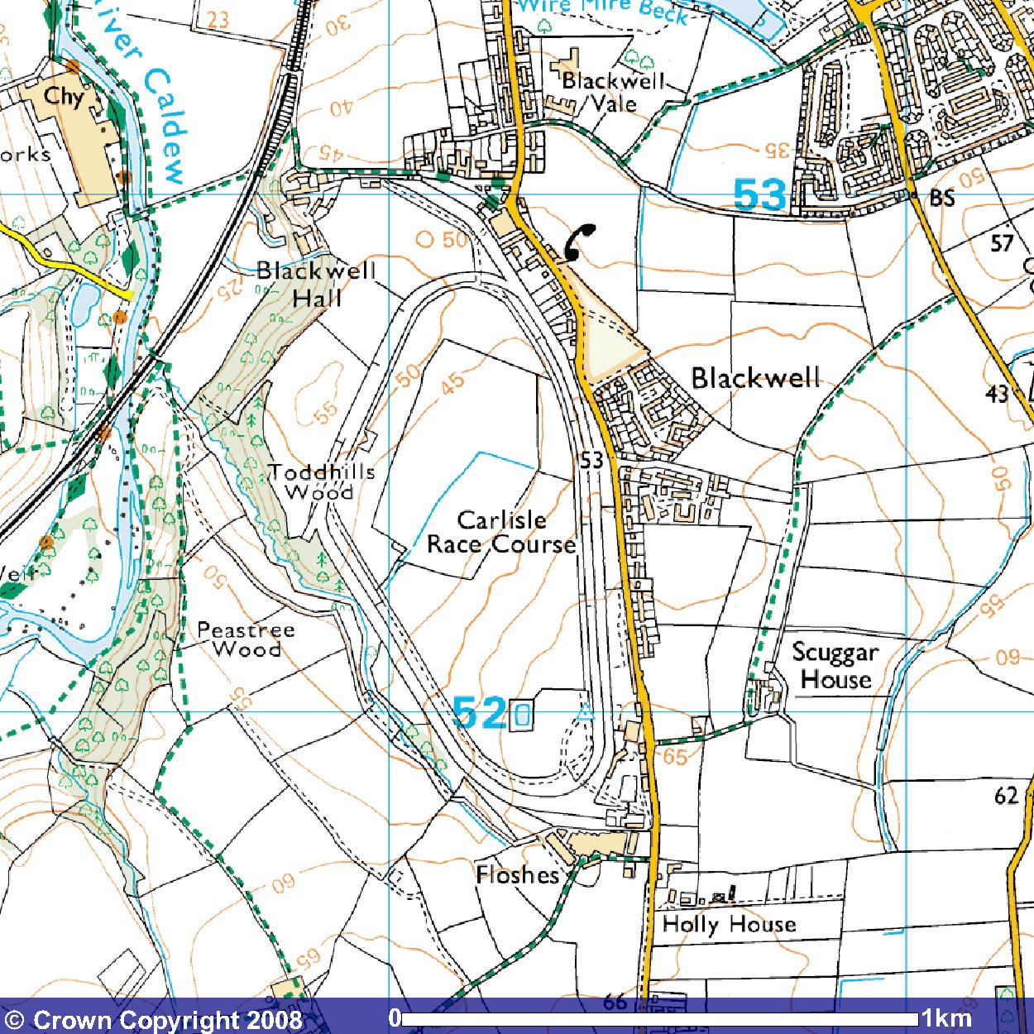
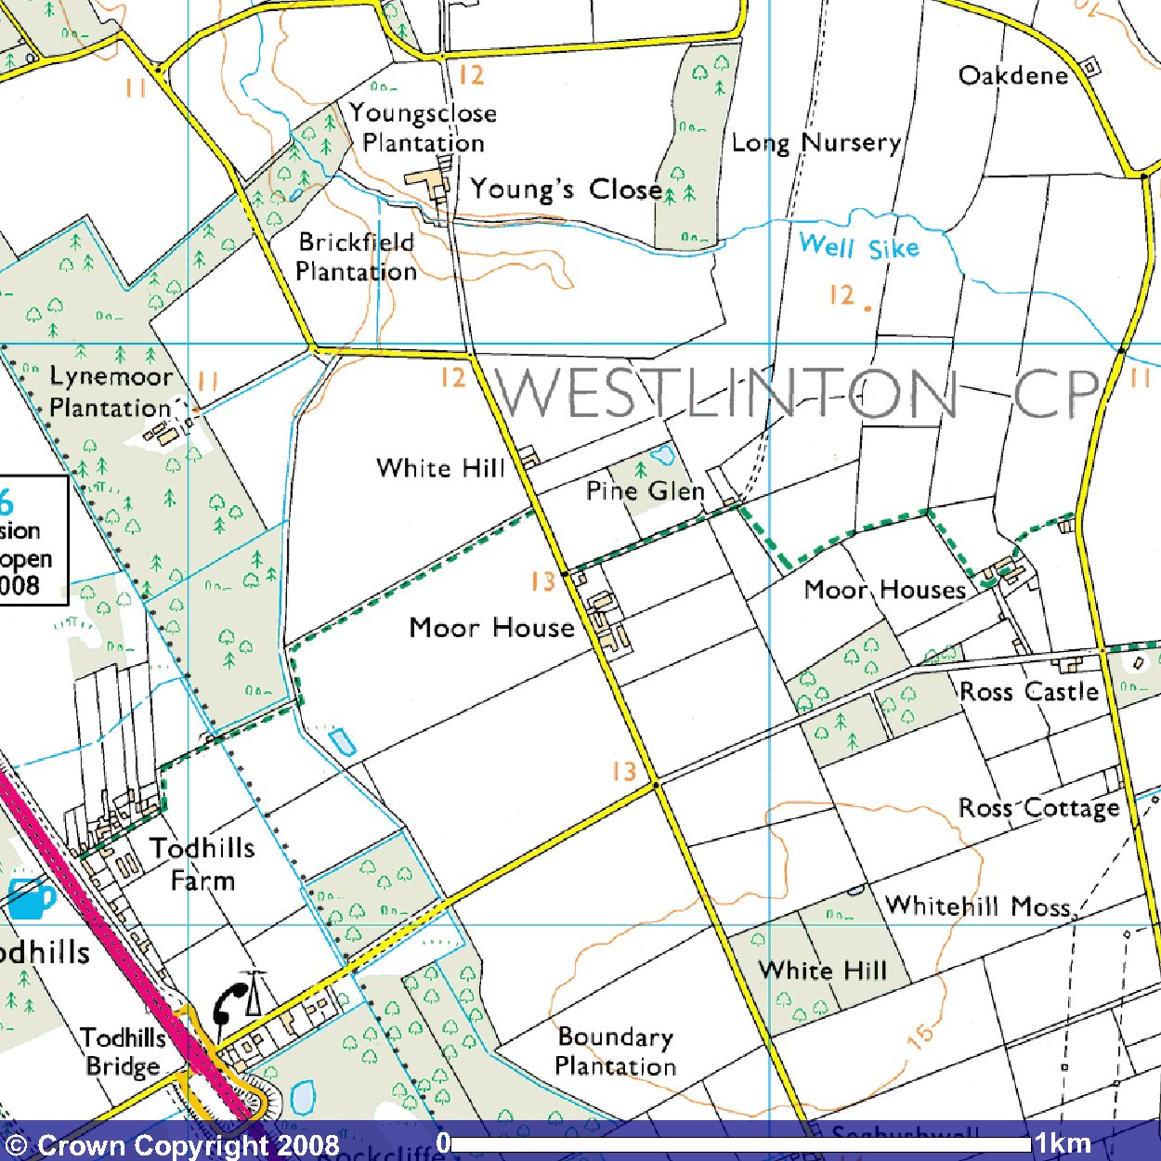
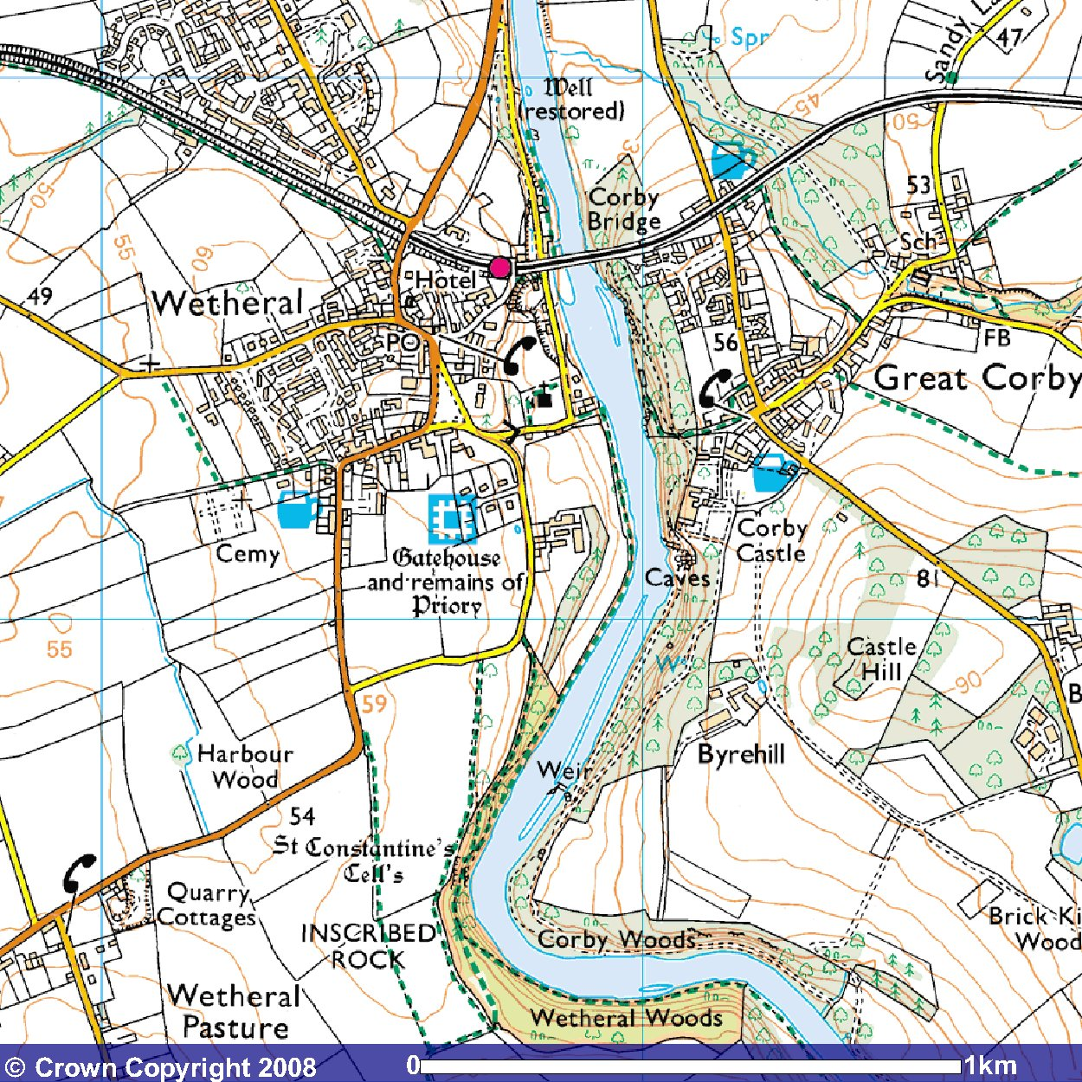
C. Wetheral Abbey Farm and Priory grounds, CA4 8EZ
D. Carlisle Racecourse, CA2 4TS
Images produced from the Ordnance Survey Get-a-Map service and reproduced with kind permission from Ordnance Survey and Ordnance Survey of Northern Ireland.

