The Post-glacial Timescale task
The term ‘post-glacial’ (meaning after the last glacial phase) refers to the relatively warm time the Earth has been experiencing since the ice sheets started to shrink back after reaching their large extent during the Last Glacial Maximum.
The diagram shown below is a general and simple representation of how the Earth’s climate has changed between 18,000 years ago and the present. (The reality is more complicated.)
For interpreting this diagram, you should interpret the ‘0’ on the right hand axis as indicating the average modern conditions (what our climate has been like for roughly the last 100 years). So, -4 means 4°C less than the modern average (not that the average air temperature was 4°C!). And the ‘2’ at the top of the scale means 2°C higher than the modern average.
- What do you notice about how average air temperatures have changed since their low point just over 18,000 years ago? Write down some of your observations here.

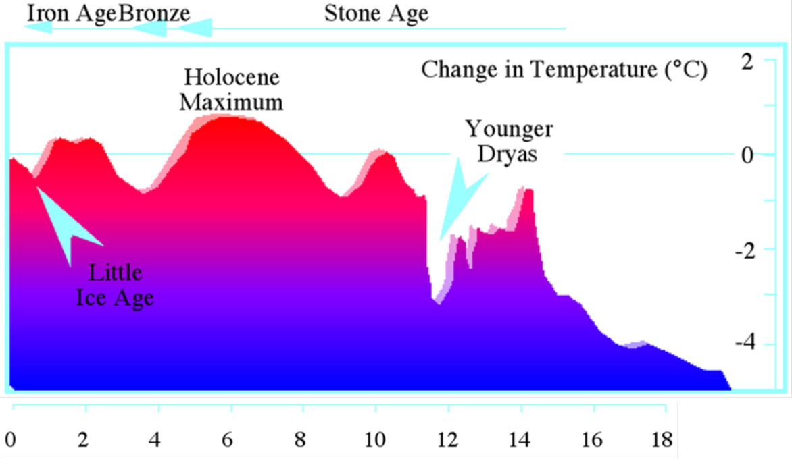
Thousands of years ago
Last Glacial Maximum
http://commons.wikimedia.org/wiki/File:Iceage_time_18kyr.png?uselang=en-gb

Notice that after the first phase of warming there was a brief return to cold, glacial conditions (this phase is called the Younger Dryas), and at this time glaciers returned to upland areas of the British Isles until temperature warmed up again.
- The Holocene Epoch starts at the point when temperatures rose quickly again after the Younger Dryas. Add a vertical line to the diagram above and label it as the ‘start of the Holocene’ (the geological epoch that we are currently in).
The ‘Stone Age’ refers to the time when prehistoric people used stone tools (before people knew how to make metal tools). The time when people were making bronze tools is called the Bronze Age, and this was followed by the Iron Age when people began to make iron tools instead.
- Looking again at the diagram on the previous page, what do you notice about the temperature during the Bronze Age?

- What was the temperature like during the time of the Roman Empire? (Around 2,000 years ago.)

From about the 14th century AD until the late 19th century, there were phases of relatively cooler temperatures than has been normal during the 20th century. This time is nicknamed the ‘Little Ice Age’ because glaciers in high mountain ranges expanded during this time. However, the ‘Little Ice Age’ was nothing like as cold as the last glacial.
Look at the sea level diagram shown below.
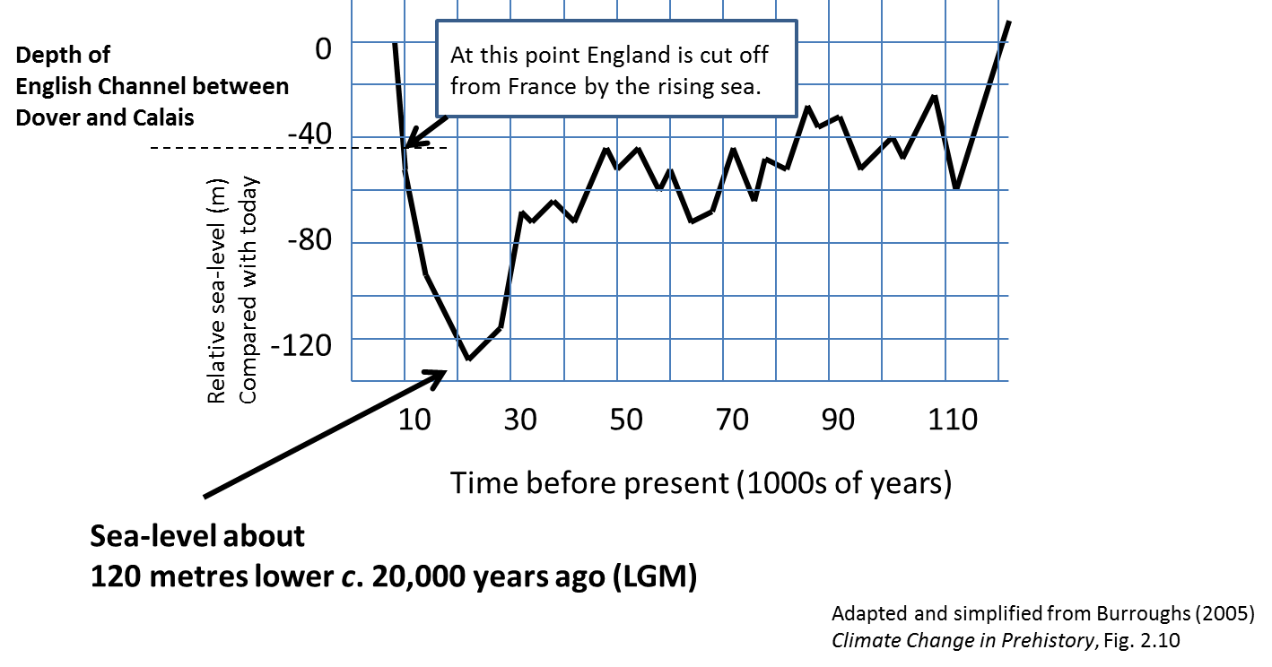
- Also add a vertical line to this diagram to show the ‘start of the Holocene’. (Note this line should be just before England became an island.)
- Comment below on why it is the case that this graph of sea level change also tells us about changes in the size of ice sheets on land.

