“Why can’t we get mobile reception, Sir?”

A group of students visiting The Magdalen Project in West Dorset from a school in central London couldn’t understand why they had such poor mobile phone reception in the centre and in the village nearby.

This was an issue that mattered to the students, and it was therefore turned into a quantitative fieldwork investigation by The Magdalen Project’s Director, Gyles Morris. This is a short investigation which brings home the relevance of Geography to everyday problems and students’ lives. It can be carried out in the school grounds, local area or as a short study on a residential trip to an unfamiliar area. The length and depth of the study can be adapted accordingly, and to suit students of different ages. The study requires both primary and secondary data collection:

1. Primary Data Collection
Students recorded the strength of their mobile phone reception in the area and plotted this data as isoline maps. The map below shows a 1 km sampling area around The Magdalen Project (indicated by the blue circle), and gives an example of how sample points can be selected along roadsides and footpaths to enable students to collect their data safely. The map used here is a free map from the Ordnance Survey’s online “Get-a-Map” service (www.ordnance-survey.co.uk/getamap), with symbols added using the Drawing toolbar in Word. Students used their map skills to locate each site and recorded the strength of their mobile phone reception (in bars) on the map.

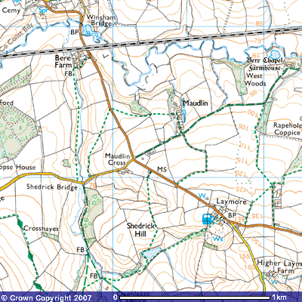

Image produced from the Ordnance Survey Get-a-map service. Image reproduced with kind permission of Ordnance Survey and Ordnance Survey of Northern Ireland.

Once the students had recorded their mobile phone reception, they were able to plot their isoline maps. This was done by hand, using copies of the above map (see example below, with text and key added using Adobe PhotoShop software), but could also be completed using GIS software such as ArcGIS (see second example below).

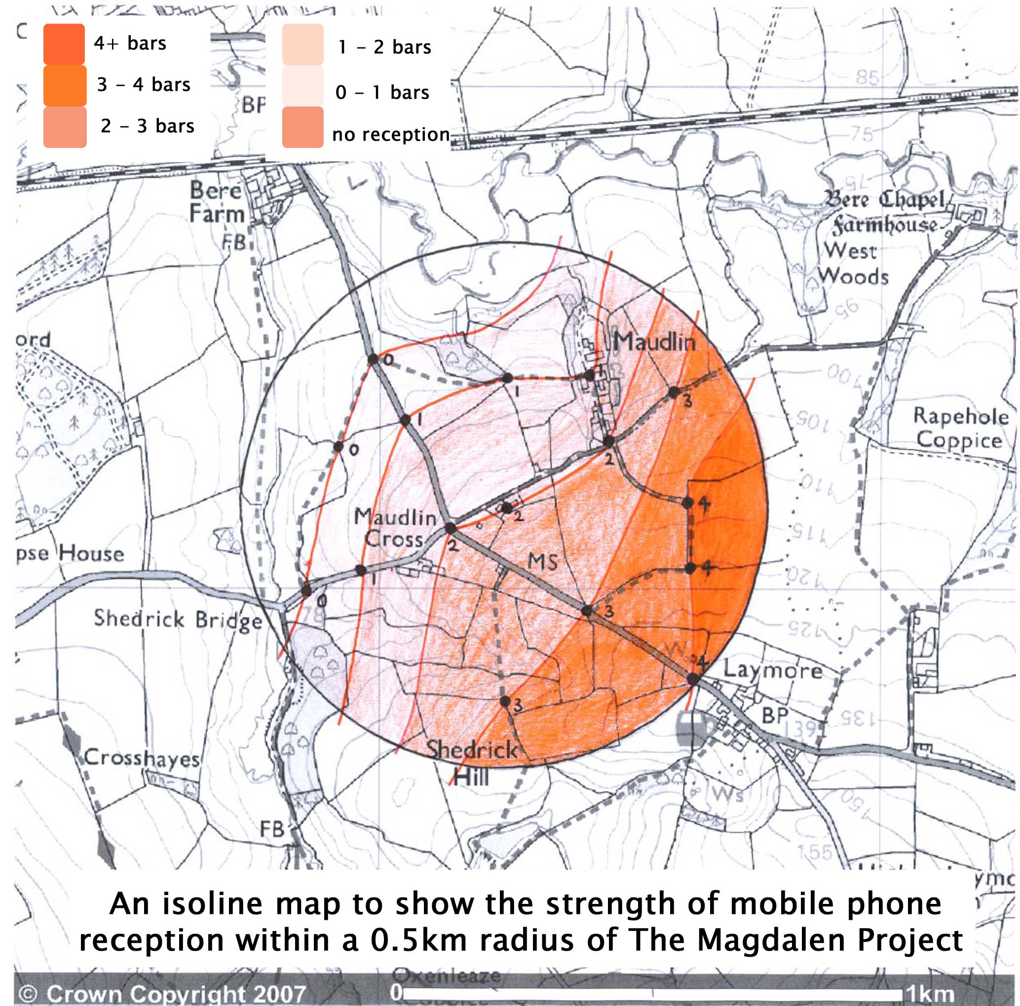

A hand drawn isoline map to show mobile phone reception. Values were attached to each sample point and lines drawn to join points of equal value.

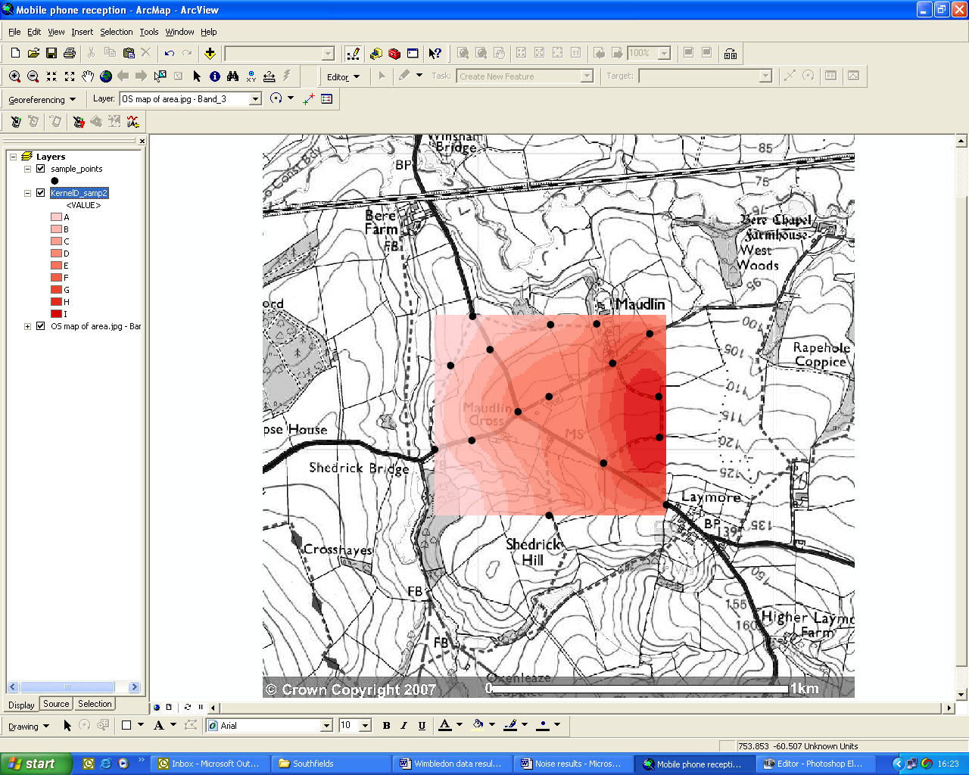
An example of the use of a GIS package to create mobile phone reception “hotspot” maps. Here, ArcGIS has been used.

2. Secondary Data Collection

- Relief
One factor that could contribute to variations in mobile phone reception in an area is the relief of the surrounding land. Students can study relief using the contours on OS maps, and can draw traditional relief cross sections by hand. Alternatively, the software package Memory Map (www.memory-map.co.uk) includes 3-D relief maps which are extremely visual and can be annotated with routes or text to identify features and analyse the impact that these may have on mobile phone reception. The package also comes with 1:25,000 and 1:50,000 OS maps, and aerial photography. It can be purchased online and it is possible to buy coverage of either individual regions or the whole of Great Britain. The first Memory Map screenshot below shows The Magdalen Project and its surroundings, comparing 2-D and 3-D maps on a 1:50,000 scale. The second shows an annotated 3-D map of the area, with the sample points and route taken highlighted. Using the software it is possible to calculate the distance of the route, enabling students to see how far they have walked. It is also possible to import location data recorded on a GPS into Memory Map, creating a route automatically and calculating statistics such as average walking speed.
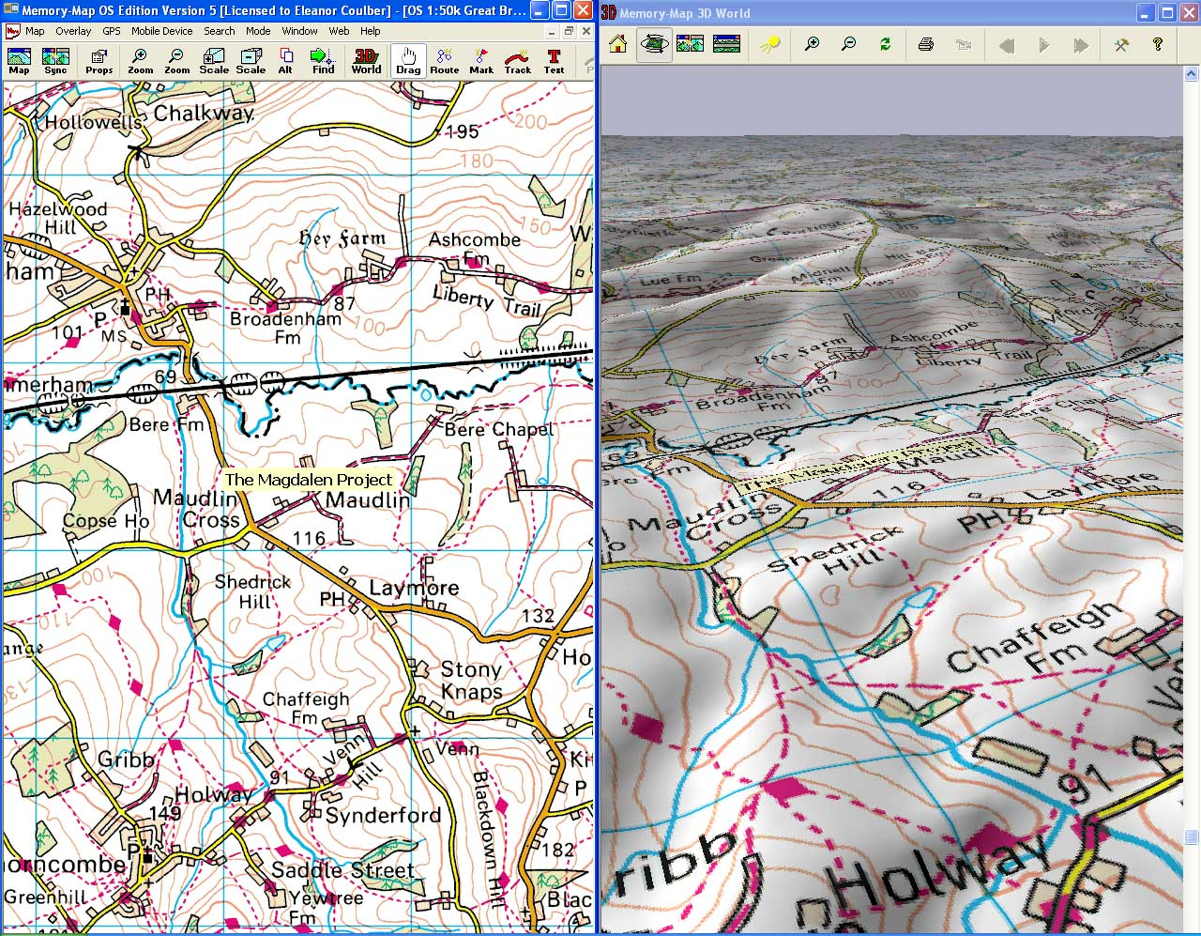

The Magdalen Project and its surrounding area in 2-D and 3-D.

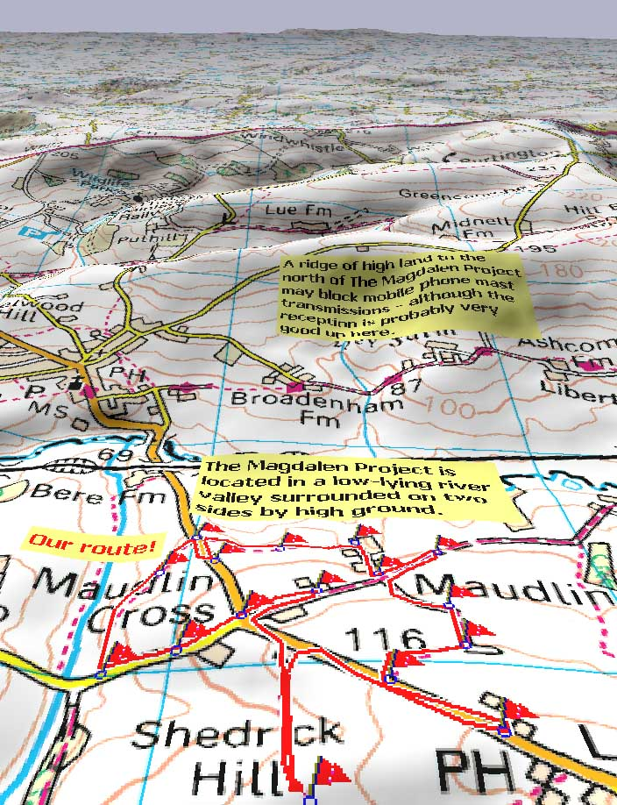
An annotated 3-D map of the area, showing the sampling points as flags and the route taken between these sites as a red line.

- Location of mobile phone masts
The Ofcom “Sitefinder” website (www.sitefinder.ofcom.org.uk) gives the location of mobile phone masts around Great Britain and Northern Ireland. This may be an important factor in determining the strength of mobile phone reception in the area under investigation. Typing a postcode into the Sitefinder search engine brings up a map of the area with the phone masts (“base stations”) indicated by a green triangle and summary data underneath. The screenshot below shows the map for the area surrounding The Magdalen Project, and indicates that there is one base station, operated by the Orange network, located to the East of the centre. The site of mobile phone masts can be incorporated into the annotated 3-D map and/or the isoline map to assist with analysis.

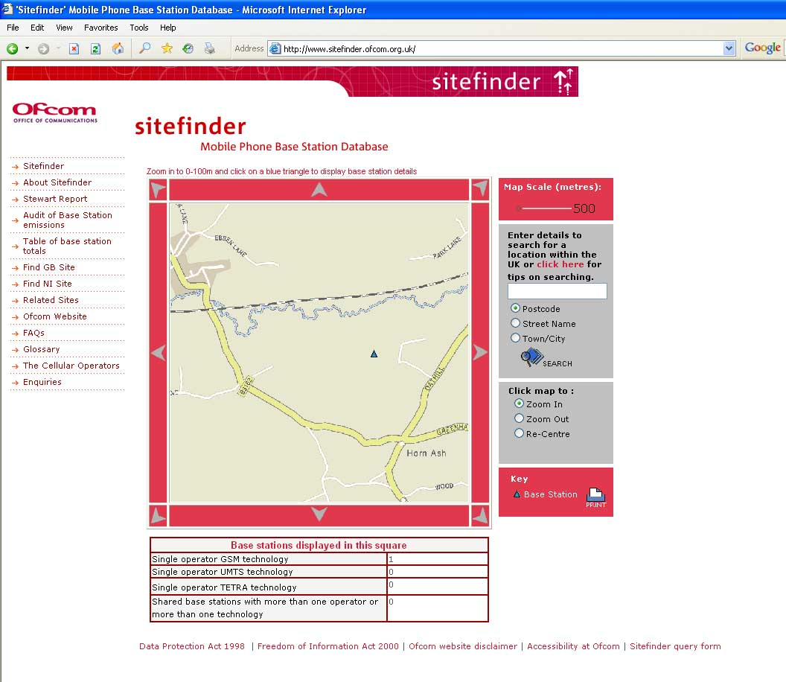
(c) Population density
How is the site of mobile phone masts determined? Why is coverage across the country so variable? One further factor that is worth investigating is whether the site of mobile phone masts (and therefore the strength of reception) is linked to population density. The Office for National Statistics website (www.statistics.gov.uk) has a section on Neighbourhood statistics, which provides population density maps and data at a Super Output Area level (areas smaller than wards that have been designated to enable improved local comparisons to be made). The map below shows the population density of Super Output areas in the West Dorset District (with the relevant area outlined in yellow). This doesn’t really help us a great deal, as variations within the area are not shown, but it does highlight the very low population density of this district as a whole, which could be highlighted further if a map of the whole country was created. In a more urban district or metropolitan borough, where Super Output Areas are smaller, it may be possible to make a more useful comparison using this method.

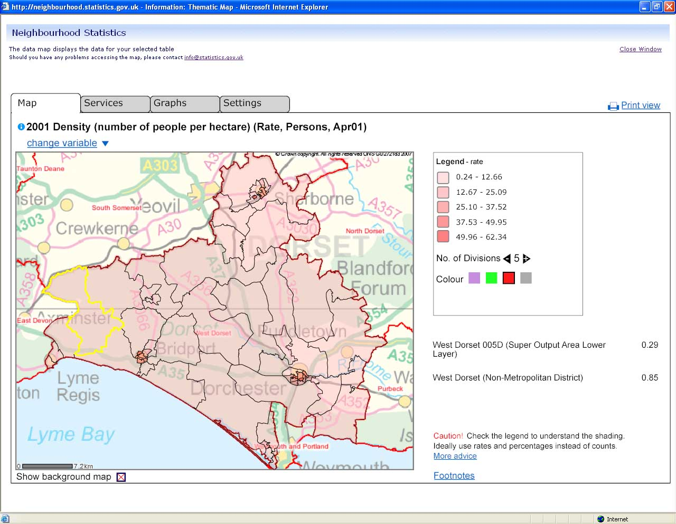
A map showing the population density of West Dorset District. Super Output Area 005D is outlined in yellow. Population data for West Dorset 005D Super Output Area.

In order to obtain more localised population density data, students could conduct a house survey either in the field or with the use of 1:25,000 OS maps. This will highlight population concentrations on a local scale, and findings can be compared with the site of mobile phone masts. The map below highlights the centres of population in the area of The Magdalen Project in relation to the location of the mobile phone mast. An extension to the study could involve students using their knowledge of settlements and map skills such as six-figure grid references, contours and scale to describe and measure the distances between the centres of population.

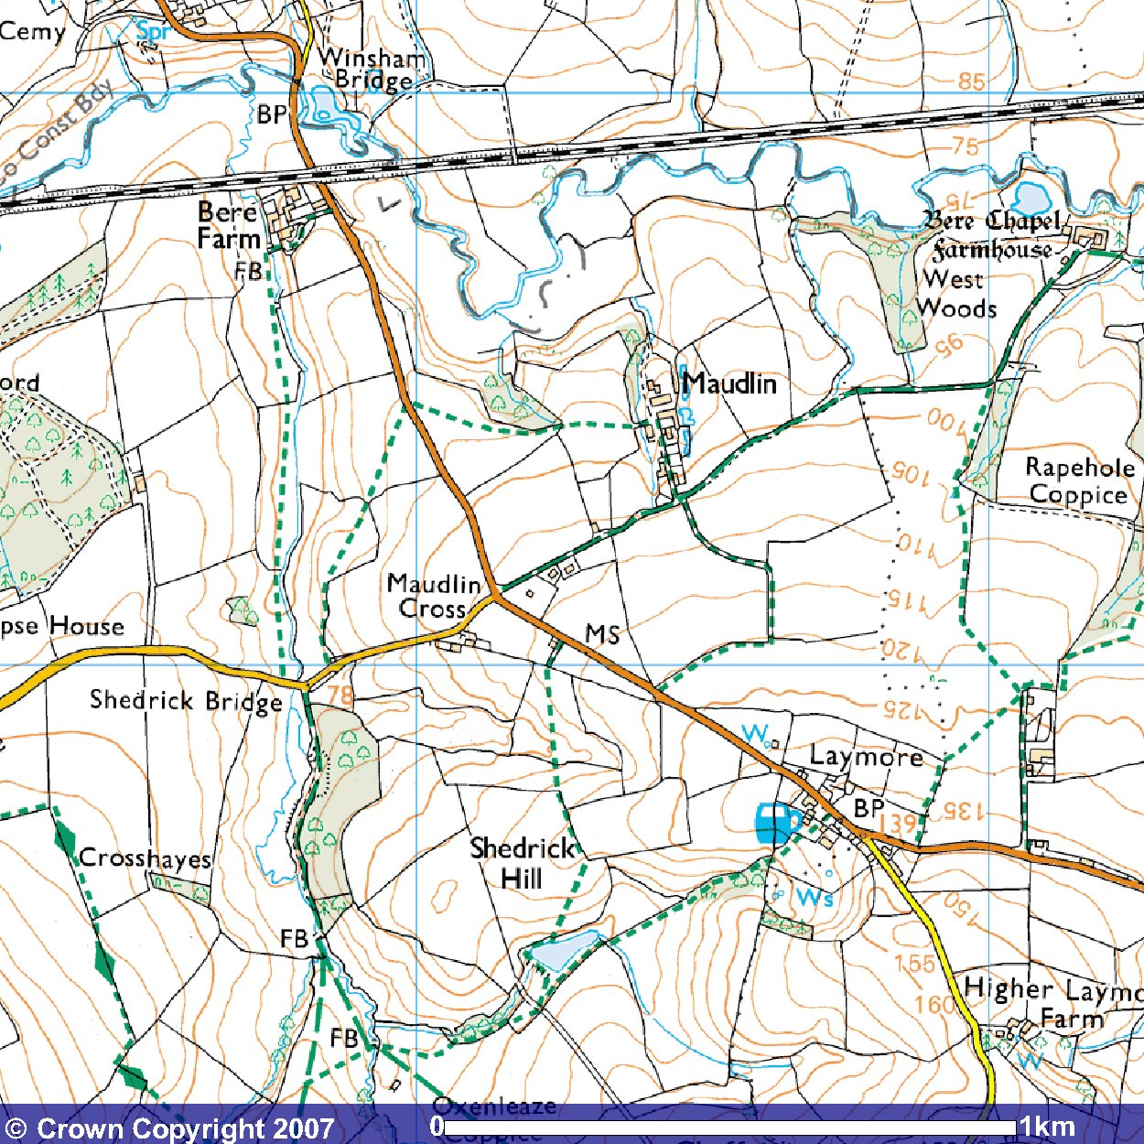
Centres of population
Site of mobile phone mast
KEY:

Image produced from the Ordnance Survey Get-a-map service. Image
reproduced with kind permission of Ordnance Survey and
Ordnance Survey of Northern Ireland.

3. Analysis
In this particular example, mobile phone reception strength is clearly linked to the site of the mobile phone mast, with reception increasing with proximity to the mast. The location of the mast itself may well be linked to demand, being sited between two centres of population. Further influences result from the relief of the land, with strength of signal declining in low lying river valley areas in the lea of the ridge to the north. Interestingly, further investigation has shown that mobile phone reception improves in the area surrounding the railway line, along which several masts are located to enhance communication along the rail network. This is not evident in the small area studied here, but could form part of a wider enquiry.

4. Follow up
This investigation lends itself to a number of wider studies. Three possibilities are highlighted below:

- Supply and demand
Many GSCE syllabuses touch on the issues of supply and demand and the provision of services. This fieldwork investigation could result in a case study of why the sites for mobile phone masts are chosen. Using the Sitefinder and Neighbourhood statistics websites, students can identify concentrations of mobile phone masts and link them to maps of population density, comparing rural and urban areas.

- Citizenship
What are the dangers of mobile phone masts? There is constant debate in the newspapers about the potential health risks from radiation (see for example, “Health concerns over mobile phone masts prompt review”, The Independent 13th May 2007). This fieldwork investigation could lead into an enquiry into this issue: What are the facts? What are the pros and cons of masts? Who has published the reports which state that they are safe/dangerous? Should mobile phone masts be located near to schools? Such an enquiry meets the requirements of the Citizenship curriculum for KS3 and could result in a class debate or presentations on the topic.

- Action!
Leading on from their fieldwork investigation and subsequent debate into the pros and cons of mobile phone masts, students could decide to take action! Do they want more mobile phone masts or fewer? Do they want to change the location of existing masts? Can they advise on the optimum location for masts? Letters or presentations to the council or mobile phone companies could highlight their findings using evidence from the field to support their arguments.

