Lesson two: Three peaks challenge weather forecast exercise

Read the weather forecast for the weather in the UK. Draw the weather symbol and add information to the boxes.

Weather Symbols

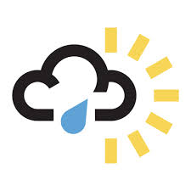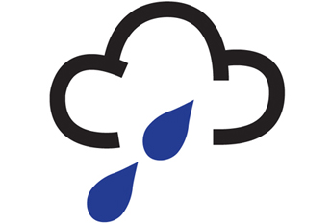

BEN NEVIS: Cold, frosty.
Temperature: 0°C. Possibility of snow

SCAFELL PIKE: Heavy rainfall, Temperature: 7°C. Poor visibility.

SNOWDON: Windy all day.
Temperature: 4°C. Light showers.

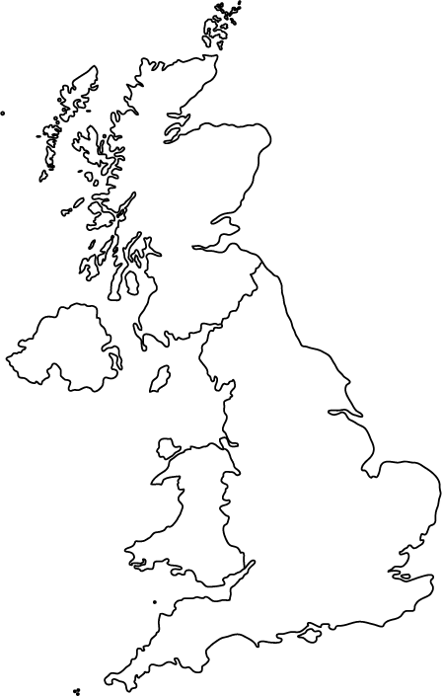
SCAFELL PIKE:
BEN NEVIS:

SNOWDON:

Imagine you a weather reporter for the TV programme ‘Three Peaks Challenge Special’. You are responsible for giving a weather forecast to climbers about conditions at Mt. Snowdon, Ben Nevis or Scafell Pike.
What information are you going to give the viewers? Remember, to include:
- Where you reporting from,
- What the weather is like: temperatures; rain/dry; misty/clear visibility
- How the weather might affect the climbs.

Create a photograph
of the place you are
reporting from.

