Resilience and Vulnerability in Climate Change and Farming
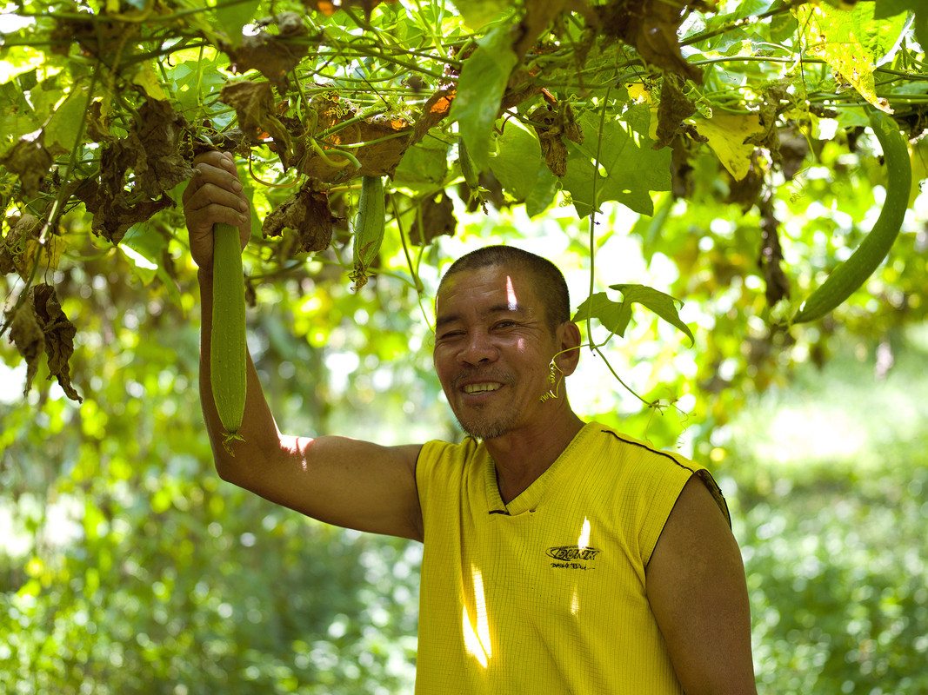
Meet Gerondio Ayson

Gerondio Ayson in his garden © Tessa Bunney, Oxfam.

Gerondio Ayson is 54 years old. He is a vegetable and rice farmer from Pamantingan, Esperanza, on the island of Mindanao in the Philippines. Gerondio attended one of Oxfam’s Field Schools where he learnt various ways to become resilient to climate change including intercropping.

“We have half an acre of land here and we are intercropping various vegetables all year round. At the moment we are growing cucumber, green beans, peppers, jute, loofah, green chili, eggplant, squash, and banana. I learned about intercropping from going to the sessions at the field school.
We have had to adapt our gardening techniques to deal with the changes in weather. For example, we can only water the plants at night because it’s just too hot in the daytime. We use only organic fertilizer, which we make ourselves as its better for the land and the plants, but also – it’s free!”
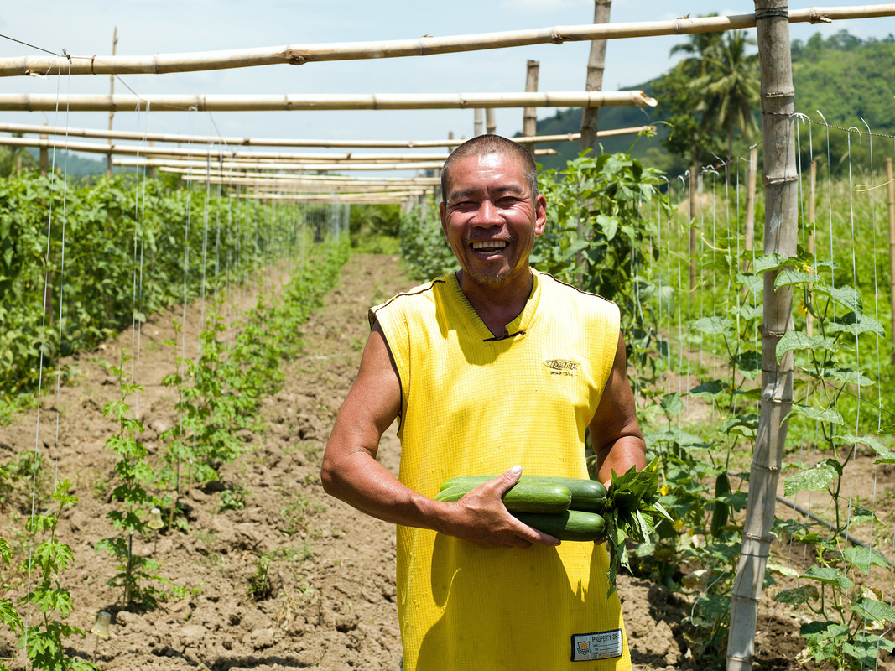Gerondio holds cucumbers in his vegetable garden, Tessa Bunney © Oxfam

“The biggest issues we face are the long dry periods and droughts. Last year March and April were really dry and this year December and January have been dry again, it was supposed to rain but it didn’t. We managed to survive because we have tapped the river and created our own irrigation system. Oxfam supported an irrigation project in this area and shortly afterwards the local government recognized that work and rehabilitated the dam…

“We are lucky because although we don’t own this land we can still choose what to plant and we just pay 25% of what we earn to the owner for the lease. We harvest our vegetables twice a week and take them to the market. Some of our vegetables are very profitable, for example, from one can of bitter gourd seeds (costing 1400 pesos) we can harvest four sacks of vegetables worth 4000 pesos and we can harvest the plants 22 times in one season”
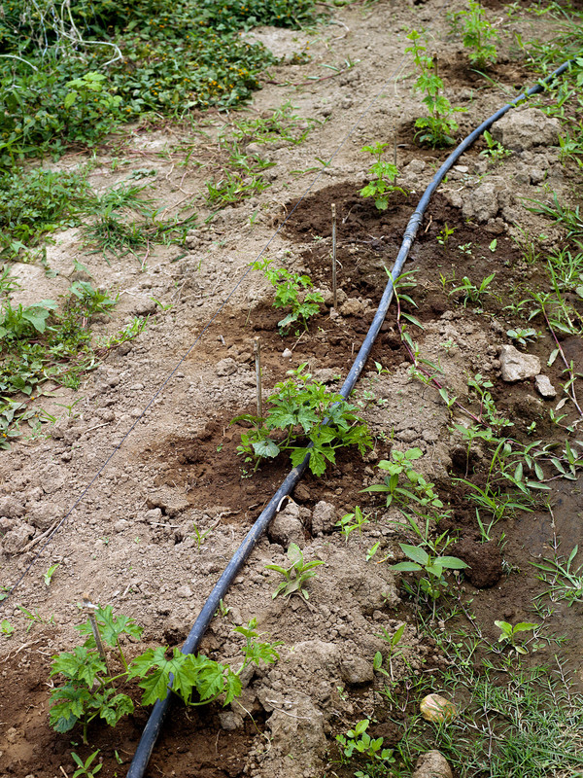
Gerondio’s homemade irrigation system © Tessa Bunny Oxfam

“We don’t have a set place at the market; instead we roam around to sell our vegetables, that way you get better money. We are famous at the market – everybody knows us and likes to buy our vegetables. We also deliver vegetables, which has been a great idea as some people can’t get to the market and really appreciate it. If you work hard growing vegetables you can make a lot of money. We have paid for all four of our children’s education and now we are also paying for three of our grandchildren to go to school too”.

“We have managed to improve our lives through growing vegetables. We bought a motorbike, which we use to deliver the vegetables and get to market, and we’ve also bought a new and better roof for the house. I was so happy the day the new roof was installed”.
“When I see my plants growing in my garden I think to myself, ‘This is money’.”

