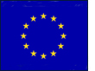
Mapping the EU

On the next page is a blank map of Europe. You will use this to display the information from the table of member countries that you have just completed.

Follow these instructions:

- Use an atlas to locate each country and label it neatly. You may need to use arrows from the outside of the map or a code for some of the smaller countries. If you use a code, make sure you create a key to go with it.

- You now need to colour code the countries according to when they joined the EU. You’ll need to divide the joining dates into categories – a maximum of five or six – and decide on a suitable colour ramp. Don’t forget to include a category for the candidate countries too.

- Complete the key next to the map with your labels and chosen colours.

- Colour the countries according to the key you’ve designed.



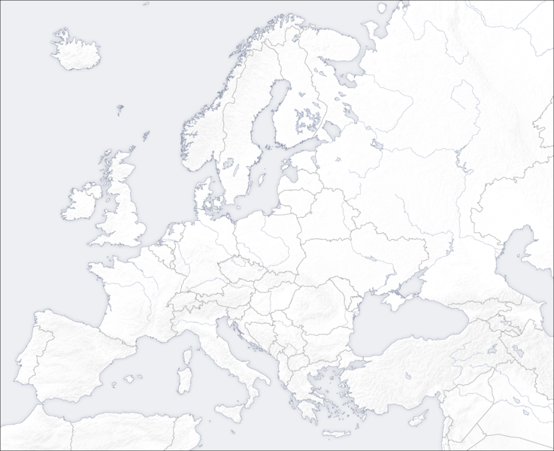

Key

