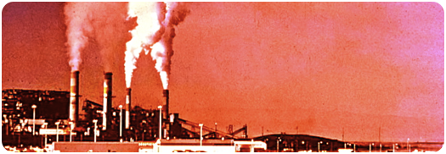
Geographers are interested in the process of global warming. Scientists are also interested in the process, but work on different parts of the process. Whilst this investigation is complicated there is wide agreement amongst those doing research that human beings are playing a role in the changing of global climate. Geographers are interested in the process and ways we can deal with the impact of that process, and scientists are interested in how the process occurs. The International Panel on Climate Change is the world’s scientific body which looks at unravelling the complex processes that are involved.
Whilst scientists are trained to work on certainties, societies do not operate in the same way. Human beings often try to avoid risk, which means that a parent, for example, is unlikely to leave a child unattended because there may be a chance of danger. In this way, scientists measure risk whilst politicians and
the population have to understand the risk and decide whether a situation is dangerous enough to have to do something about. Sometimes there may be no absolute certainty but there is still a reason to act, especially where the dangers of not acting far outweigh the consequence of not acting.
The earth is not a laboratory, and it is much more difficult to predict what will happen as the conditions on earth change. Still, scientists are conducting an enormous amount of work which is indicating that there is a connection between the changes in our climate and human use of fossil fuels. Scientists and geographers have also been tracking the changes to our environment and linking these changes with increased carbon in the atmosphere, the consequence of burning fossil fuels.
There is a large number of areas where climate change has and is continuing to have a negative impact on the planet.
Climate change is real and has consequences for the whole planet

Ban Ki Moon Secretary General of the United Nations is a strong supporter on action on climate change. Look at YouTube to see his comments on Earth Hour which is conducted throughout the world on 28th March.

Search for Earth Hour on Youtube.com
CLIMATE CHANGE

Flashpoint 2

climate change: real and PRESENT DANGER!

Scientists believe that our climate is changing and that our use of fossil fuels is one of the main reasons why. They also believe that there will be very serious consequences in our time.
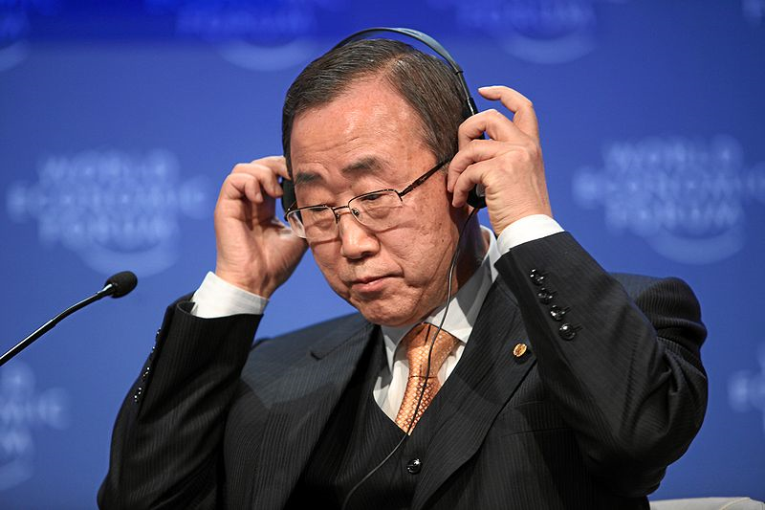

The Intergovernmental Panel on Climate Change (IPCC) has concluded that greenhouse gases from human action such as fossil fuel use and deforestation are the cause of most of the temperature increase since the middle of the 20th century. Simply put, greenhouse gases are being released into the atmosphere at such a rate that they are trapping the heat energy from the sun and increasing the temperature of the planet.
The research consensus is that earth’s temperature will rise somewhere between 1.1 and 6.4°C between now and the end of the 21st century.
This increase in heat energy will cause sea level rise and increased desert size with some moister areas also becoming more arid (dry). Glaciers are melting and this is causing the flow of rivers to become more unpredictable and millions who depend on farming are at risk of starvation. Changes in temperature and weather are leading to some areas such as areas in Spain and in Australia to become much more arid and becoming less suitable for certain crops. Insect and animal life is being threatened as ecosystems change.
Environments in delicate balance
are being disrupted which is
capable of causing mass extinctions
of animals.
Scientists are aware that the
earth is changing and they are now,
more than ever, convinced that human
action is one of the chief driving causes.
For geographers this means that
there will be new natural hazards
of all kinds, environmental change,
social change and a raft of
unexpected consequences.
Geographers, along with
governments, need to look out for
these changes and to make plans
to reduce their impact. Sea level
change, for example, has the
capacity to make more areas, and
often cities much more vulnerable
to flooding. Areas need to be zoned
so as to stop further building in
certain areas. Some places will
need to take other precautions.
Hospitals and schools might need
relocating etc. There is much to do.

Links
This website contains the main objections to climate change along with links to scientific responses:
How to Talk to a Climate Sceptic
The InterGovernmental Panel on Climate Change
Royal Society Guide on the controversies relating to climate change:
Word List
Greenhouse gases
Extinctions
Carbon Dioxide
Ecosystems
Temperature

Map showing predicted
Temperature change
due to global warming
during the next century.

Who to believe?
There is little disagreement about climate change amongst scientists. The IPCC is the
world’s premier body for climate investigation. On the other hand there are many for
whom the climate research stands to disadvantage and who would gain if the claims
of climate change could be discredited. As the issue is so large, people can become very passionate in what they believe and some scientists become concerned that public opinion is driven less by science and more by public personalities who have little individual experience of understanding of the issues. Some scientists dispute all the claims of the IPCC, but whilst they are very vocal, they are relatively few in number.

Science & climate change

What do the scientists believe? What does it mean

for the geography of the planet?

The Arctic ice cap has collapsed at an unprecedented rate this summer and levels of sea ice in the region now stand at record lows, scientists have announced. Experts say they are "stunned" by the loss of ice, with an area almost twice as big as the UK disappearing in the last week alone. ... Changes in wind and ocean circulation patterns can help reduce sea ice extent, but Dr. Serreze [American Arctic scientist] said the main culprit was man-made global warming.

The Guardian, 4th September 2007.

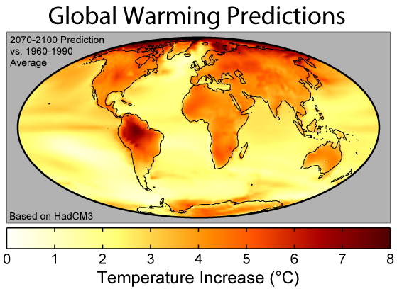

Images from Wikimedia Commons and licensed for use under Creative Commons License.

