THE STONE AGE

- Read and discuss the information and images below with your group.
- Record key facts about how trade was carried out during this time and reasons why on you section of the Trade Timeline using clear bullet points.
- Illustrate your work and caption any images.
- Be ready to present your section of the timeline to others and teach them what you have found out.

The Stone Age began roughly 2.6 million years ago; it began with the first production of stone tools and implements. The Stone Age ended with the first use of bronze and the start of the Bronze Age.

During this time, the geography of trade (the buying and selling of products we want and need) was very different to today. It was carried out at a much smaller scale, within small communities and over shorter distances. The Stone Age had three different stages (Palaeolithic, Mesolithic and Neolithic). The way in which trade was carried out changed considerably from the Palaeolithic to Neolithic phase.

During the Palaeolithic phase (old Stone Age), life was most simple and people were self-sufficient and so did not rely on exchanging food or items such as tools with others. People were ‘nomadic’ and travelled the land in search of food and shelter. They did not stay in one location and import what they needed as we do today. Humans hunted and gathered food day by day as they needed it and there was little left over to trade and exchange with other people or communities. They made items such as clothing and tools themselves. There was no farming or agriculture, and no merchants (traders) during the Palaeolithic stage of the Stone Age.

People and communities began to trade with one another during the Neolithic phase (new Stone Age) which began between 9000 and 6000 BC. The development of agriculture (growing crops and domesticating animals) occurred at this time and families settled in one location where they grew crops and reared animals.

People began to have a surplus (excess) of food that they were able to exchange with others. They also developed new farming tools and crafts that were of value to others and so traded these items too. Trade really began during this period as items were exchanged between different communities and across greater distances than before.

A new social class of merchants (traders) emerged. Merchants would travel thousands of miles by foot to find products to sell and they organized the trade of goods between communities. People began to take on different job roles such as farmers, builders, weavers, toolmakers, and traders and became involved in the production and exchange of goods.

Trade during the Stone Age cannot be described as ‘global trade’. This is because it was not carried out on a global scale. People traded goods across much shorter distances compared with today as places were not as accessible or well linked by communications and modern transport methods. The process of trading items took a lot more time as it was more difficult to find buyers and to transport goods by foot.
People did not have knowledge of, or contact with such distant places or populations as we do today and communication only happened through human contact. Also, goods were not able to be preserved, stored, packaged or sent across oceans over long distances to other countries or continents as they are nowadays. However, this period in history was a very important step towards organized systems of trade and the global trade of today.

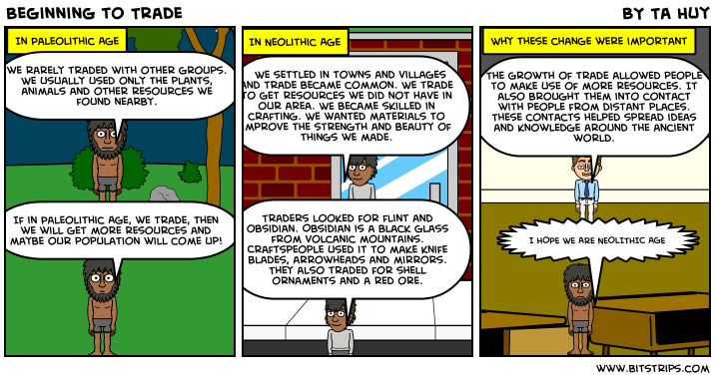

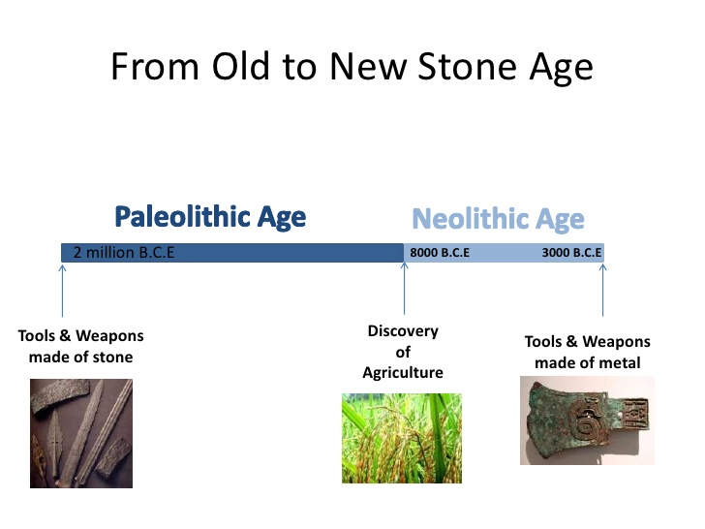

Stone Tools

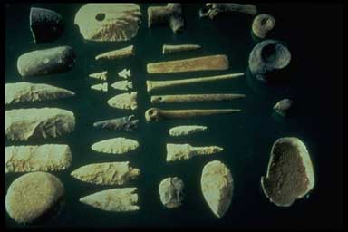
"National park stone tools" by U.S. National Park Service, Mississippi River Mussels: Tools From Mussel Shells. Licensed under Public Domain via Wikimedia Commons https://commons.wikimedia.org/wiki/File:National_park_stone_tools.jpg#/media/File:National_park_stone_tools.jpg

The 17th Century
- Read and discuss the information and images below with your group.
- Record key facts about how trade was carried out during this time and reasons why on you section of the Trade Timeline using clear bullet points.
- Illustrate your work and caption any images.
- Be ready to present your section of the timeline to others and teach them what you have found out.

The 1600’s (17th century) were a very important period in the history of global trade. Although in centuries before the 17th century, trade did occur by boat largely up and down rivers and in more accessible coastal waters, and also across the land such as the Silk Route which connected the far and Middle East with Europe.

However, it was during this period that trade across the oceans became more possible. More seaworthy boats were built which meant items could be traded across greater distances.

From the 15th to 19th century a network of global trade emerged. Goods from China, India and Southeast Asia were transported across the Atlantic, Indian and Pacific oceans to Europe and visa versa. The goods were luxury and only afforded by the wealthy, for example spices, tea, silk, porcelain, sugar and tobacco. People now had access to new and exotic products they were unable to get at home, within their region of the country, or local area. The journeys of products across oceans during this time took months and therefore only items that were imperishable could be traded.

The sugar trade took off during the 1600’s and the British and French owned sugarcane plantations in the Caribbean and South America. The sugarcane was grown and harvested in the Caribbean and South America, before being transported to a mill where the juice was extracted and processed into sugar. Blocks of sugar were packed into ‘hogsheads’ containers and shipped across the Atlantic Ocean to Europe where it was sold to wealthy families. However, there was a much more negative side to this trade with people in Africa being forcibly taken and traded as slaves to provide labour for these plantations. Most historians today estimate that according to the shipping records available, between 9 and 11 million people were taken out of Africa by European slave traders and shipped to the other side of the Atlantic to work as slaves.

European countries such as England became richer during this period as they made profit from the sale of slaves, sugar and other expensive items that were sourced in other countries. Trade became an increasingly important part of the country’s wealth and merchants (traders) became very well respected.

A map drawn in the 17th Century to show Dutch trade routes across the North Atlantic Ocean

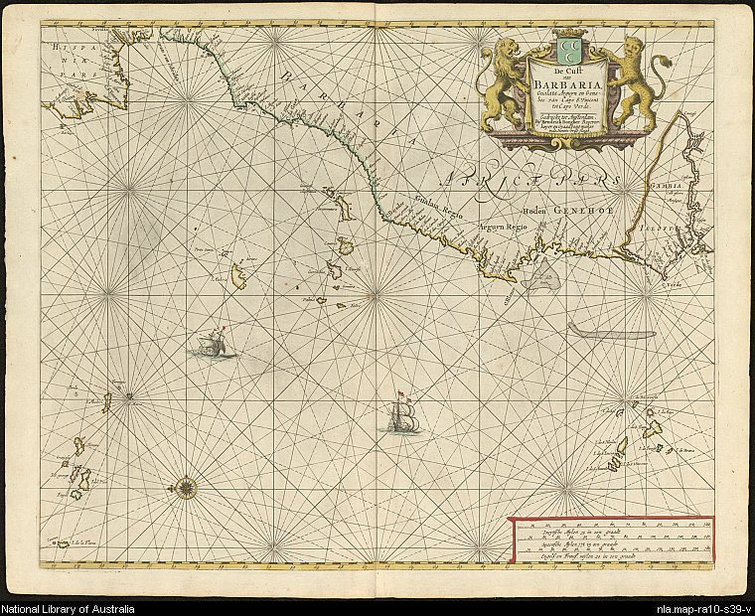
http://nla.gov.au/nla.map-ra10-s39

A sail ship used for transporting goods in the 1600’s
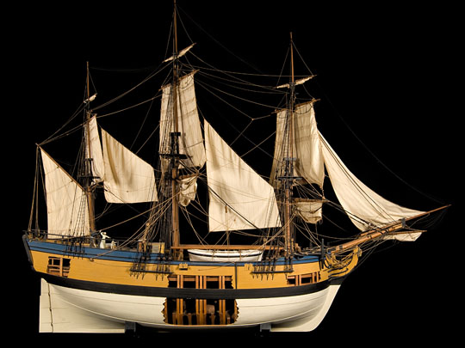
Source: http://americanhistory.si.edu/onthewater/exhibition/1_3.html

A ‘Hogshead’ used for packing traded goods in the 1600’s
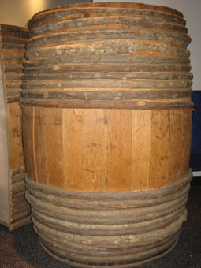
Source: http://americanhistory.si.edu/onthewater/exhibition/1_3.html

Map of Trade Routes (1400’s-1800’s)

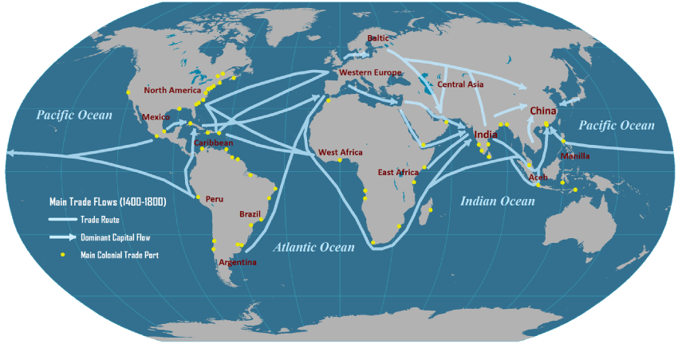
Source: http://people.hofstra.edu/geotrans/eng/ch5en/conc5en/tradeflows14001800.html

The 21st Century
- Read and discuss the information and images below with your group.
- Record key facts about how trade was carried out during this time and reasons why on you section of the Trade Timeline using clear bullet points.
- Illustrate your work and caption any images.
- Be ready to present your section of the timeline to others and teach them what you have found out.

Over time transport, technology, and communication systems have improved and become more advanced. Improvements in these three areas have meant that nowadays trade is able to occur on a global scale and in a more organized and efficient way than ever before. The three most traded items in the world are oil (a 2600 billion dollar industry), natural gas (a 161 billion dollar industry), and coffee (a 20 billion dollar industry).

Global trade links different locations worldwide. Millions of exchanges of money, goods and services take place every day between different countries to supply populations with products they want and need. Global trade connects producers, manufacturers, sellers and buyers from all over the world. As Martin Luther King Jr famously said, “In the morning we drink coffee provided for us by a South American, or tea by a Chinese, or cocoa by a West African. Before we leave our jobs we’re already indebted to more than half the world”.

Products from overseas (imports) are no longer a luxury for very wealthy families as they were in the 1600’s, but are accessible to all and a normal part of life in the 21st century. Trade now takes place at a faster rate than ever before as large volumes of goods can be transported across huge distances over air, land or sea. Lorries, fast trains, steam-powered ships and aeroplanes all transport a wide range of traded goods globally at lower costs than in the past. Super-tankers can carry massive loads of shipping containers (up to 19,000 containers each).

Global trade has become more reliable over time due to improved technology and communications. The Internet, telephone and use of credit cards have meant instant communication is possible between buyers and sellers. Modern language translation services allow people involved in trade from different countries to communicate regarding their products. Navigation systems track goods on their journeys across the globe, making transportation of expensive goods more reliable and safe. In the past, only imperishable goods could be traded, but now perishable goods can be refrigerated on their journey and transported more quickly than in the past.

Today it is common for global companies that sell their goods or services worldwide to have their headquarters in one country, their manufacturing based in another, and then sell their products globally. For example, Apple Inc. has in headquarters in Cupertino, California, does most of it’s manufacturing in China, and sells products in countries all over the world.

Global Companies sell goods and services in countries all over the world
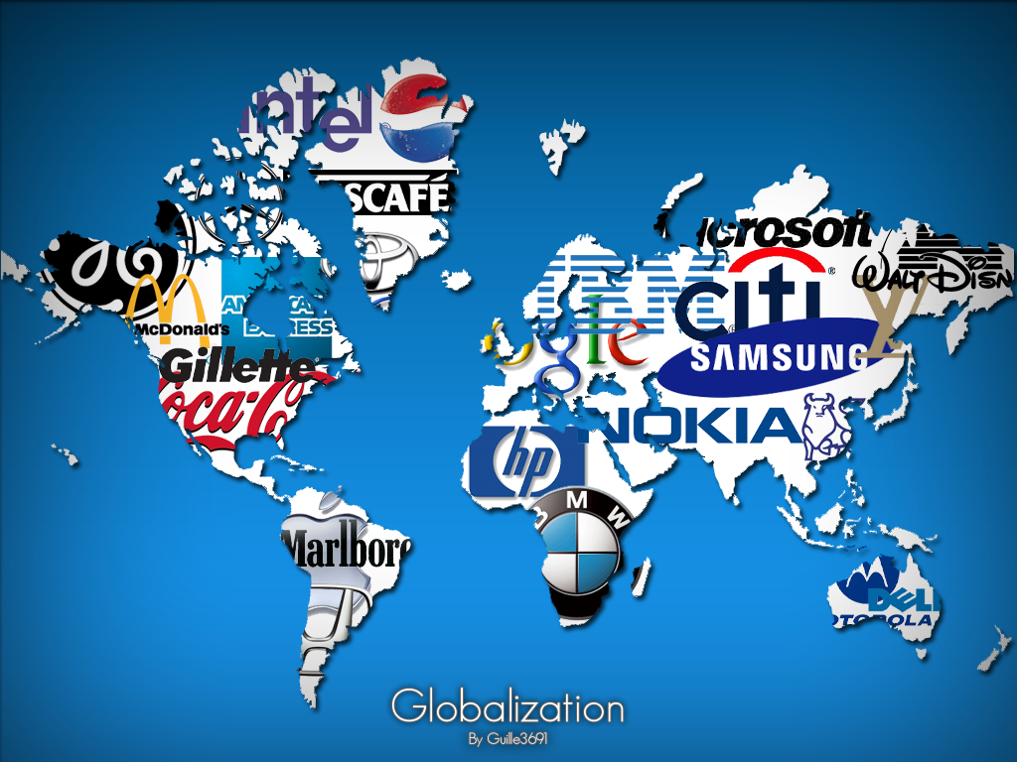
Source: https://fahadman.wordpress.com

A super tanker loaded with traded goods
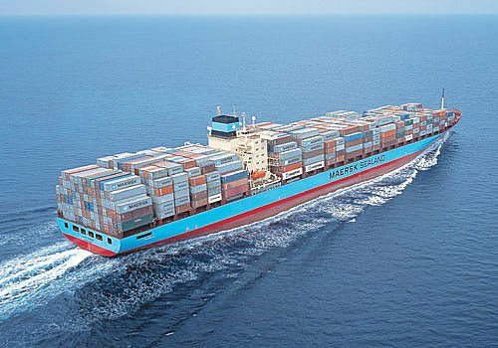
Source: http://www.etcinternational.com/blog/bid/57802/Ocean-International-Maritime-Global-Logistic-USA-Trade-Growth

The Port of Shanghai, China is the largest port in the world 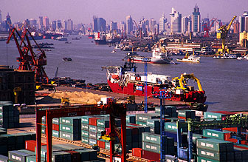
Source: http://www.marineinsight.com/marine/top-10-biggest-ports-in-the-world-in-2011/

