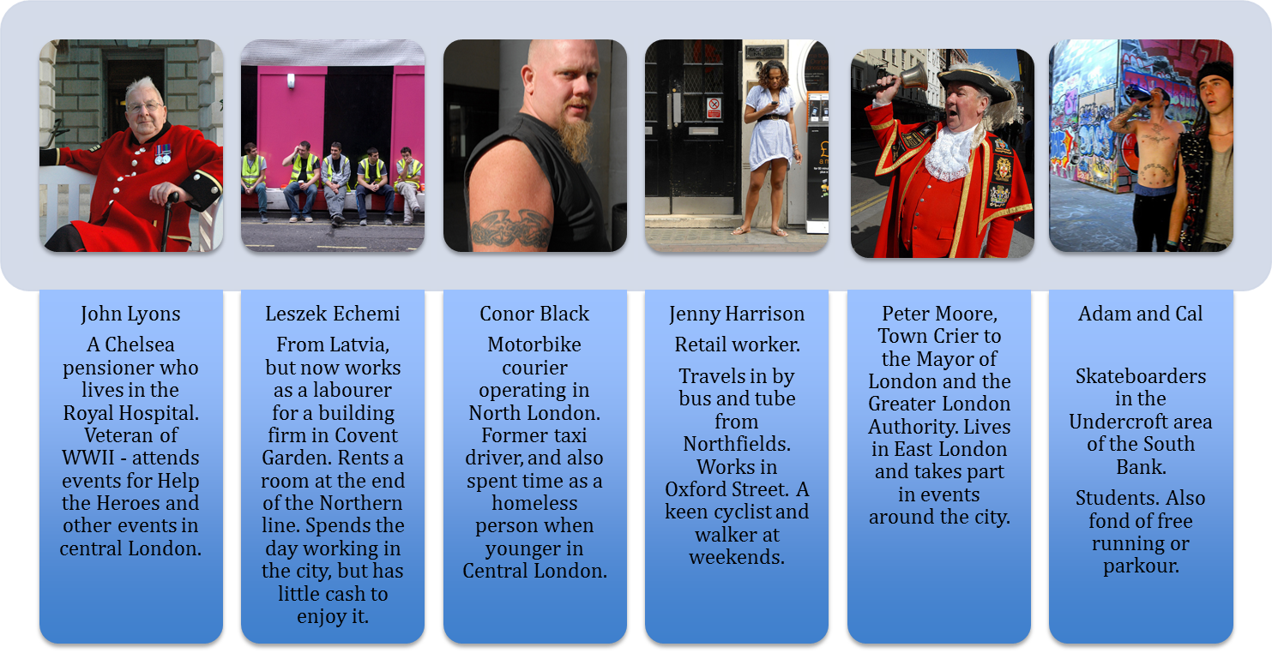

Images used in cards – Copyright: Bryan Ledgard - https://www.flickr.com/photos/ledgard/ and used with permission

