Plastic pollution in the oceans

Fact Sheet & Teacher’s Notes

Lesson 1: Mapping the plastic pollution problem (the human and physical processes)

Starter
Setting the scene

Setting the scene for students:

- Plastics are a group of materials created through human ingenuity, dating back to at least the early 1900s with polystyrene and styrofoam dating from the 1950s.
Teaching tip

Two suggestions for the starter exercise are to watch either: (1) a ‘sixty seconds’ activity at:
http://www.21stcenturychallenges.org/60-seconds/what-is-the-great-pacific-garbage-patch/ or (2) a thought-provoking starter photo-stream with striking images at: http://www.flickr.com/photos/49507650@N03/sets/72157623850787575/

- The arrival of disposable plastic bags in the 1970s, and the rise of bottled water mass consumption in developed and emerging economies, have contributed to the rise of ‘throwaway plastic’.
- Plastic waste has entered the world’s oceans in increasing volumes – emerging from point sources all over the world, such as sewer outlets and rivers emerging from large urban areas. Plastic pollution is a problem that has truly ‘gone global’ on account of ocean circulation.
Specification advice

Edexcel, OCR, AQA, WJEC and IB centres will all find relevant material in this scheme of work. The ideas covered in this document span the inter-linked topics of marine bio-diversity ocean circulation, globalisation impacts & sustainability initiatives.

- Fragments of plastics have been carried by planetary-scale currents to the remotest corners of the world including both Arctic and Antarctic once-pristine wilderness areas.
- Materials has also been corralled at higher densities into five enormous garbage patches far from any shore- line, right in the middle of the world’s major oceans.
- Broken into ever-smaller particles by wave attack, plastic pollution is a problem that sometimes becomes less visible as the particles fragment right down to a microscopic level – but it is a problem that does not go away. Indeed, the tendency of large fragments to shatter into smaller pieces can create even greater health hazards for marine organisms that unwittingly ingest the plastic.
- Action is needed at a range of scales to address the degradation of oceans and shorelines by plastic debris.

Main activity
(1) Plastic consumption trends
Key terms

Attrition A physical process that involves particles that are being carried by the wind, water or ice being broken apart into smaller and more rounded fragments. Some plastics are also broken apart by the process of photo-degradation caused by light absorption.

Gyre A slowly moving spiral of oceanic currents created by a high-pressure system of air currents. A gyre can form a place for ocean debris to accumulate. The North Pacific Garbage Patch is estimated to be bigger than the size of the State of Texas.

Marine ecosystem The term ecosystem describes a grouping of plants and animals that is linked with its local physical environment (for instance through use of soil nutrients). The oceans, covering two-thirds of our planet, are home to distinctive ecosystems composed of fish, aquatic plants and sea birds – as well as tiny but very important organisms such as krill and plankton.

Ocean conveyor A global ocean circulation between deep, colder water and warmer, surface water that strongly influences regional climates around the world.

Plastic is an essential material for society. It even helps us meet many of the other big 21st Century challenges that we face, for instance by providing materials that aid food and water production, such as polytunnels or irrigation pipes. Plastics are now part of everyday life. Credit cards, mobiles, asthmas inhalers, Lego bricks, biros: all come from plastic.

However, a third of all the plastic we use is purposely designed as ‘throwaway’ (with an expected usefulness of less than one year). The economics of plastic production support this unsustainable approach to resource use: plastic is inexpensive, durable, and is thus frequently designed without any intention to reuse it, as it has low manufacturing costs attached (unlike some metals).

During the last 60 years, the amount of plastic waste has risen from 5m tonnes / year in the 1950s to 260m tonnes / year in 2010. More plastic was produced globally in the ‘noughties’ than during the entire 20th Century (the start of which marked the very ‘birth’ of plastic). (Source: Richard Thomas / Plymouth).

The problem has been exacerbated by the global trade in cheap commodities driven by low wages in parts of the world such as China – as well as an insatiable appetite amongst consumers in developed and emerging economies for ‘cheap and cheerful’ goods such as toys, as well as for elaborately-wrapped products and bottles of water. Many products are wrapped in more layers of plastic than they need to be; some bottled 'sports' drinks have elaborate designs with multiple plastic parts, such as a plastic jacket fitted over the bottle itself (and so making these items harder to recycle).

- In the USA, 2 million plastic bottles are used every 5 minutes.
- Of the 13 billion plastic liquid containers that were used in the UK alone last year, just three billion were recycled. What became of the remaining ten billion empty bottles? Many will have been destined for landfill. A significant number of others undoubtedly found their way to the Pacific Ocean, carried by run-off and sewer discharge from urban areas.
The plastic bag problem
Teaching tip

Read more in the Geography in the news article: Drastic plastic bag bans
Plastic bags are made of petrochemicals, a non-renewable resource. Introduced in 1977, their manufacturing and transport to markets requires energy. When one tonne of plastic bags is reused or recycled, the energy equivalent of 11 barrels of oil is saved, according to US Environmental Protection Agency. They represent a needless waste of a valuable non-renewable resource.

Plastic bags do not biodegrade. Instead, they are break into smaller fragments due to attrition and light-assisted photo-degradation. Plastic breaks apart into smaller and rounder fragments that contaminate soil, waterways, oceans and enter the food web when ingested by animals. When a plastic bag enters the ocean it becomes a harmful piece of litter.

- In recent years, the growth of the middle–classes in ‘Bric’ economies (Brazil, Russia, India and China and other Asian nations has greatly increased levels of commodity consumption – and thus of plastics.
- The global economic recession has recently pushed many people in developed world economies towards greater use of so-called 'thrift' or ‘99p' stores where cheap plastic throwaway goods are the norm – especially products with a very limited shelf life such as cheap batteries.

Our oceans are now full of plastic waste, some fragments of which can be dated as far back as the 1940s.

Main activity
(2) Ocean circulation

The world’s oceans are dynamic systems where important surface and deeper flows of cold and hot water can be identified (Figure 1).
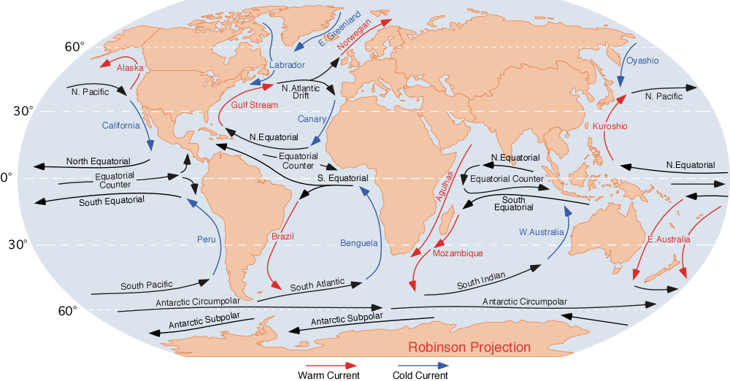

Figure 1 Surface & deep water currents (Source: Wiki Commons)

- The combined effect of wind patterns and the Earth’s Coriolis force (a function of its rotation) produce surface gyres – circular currents in the oceans, moving clockwise in the northern hemisphere and anti-clockwise in the southern hemisphere (Figure 2). Surface water is also pushed westwards in ocean basins as a result of Earth’s rotation, with the water then deflected north or south by the continents (refer back to Figure 1).
- The deep ocean currents are not affected by surface winds but are instead driven by changes in the density of water produced by variations in water temperature and salinity. The currents are collectively described as the thermohaline circulation or ocean conveyor (Figure 3).

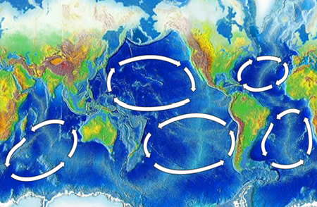
Left:
Figure 2
Surface gyres (Source: Wiki Commons)

Below:
Figure 3
Deep ocean currents (Source: Hugo Ahlenius, UNEP/GRID-Arendal)

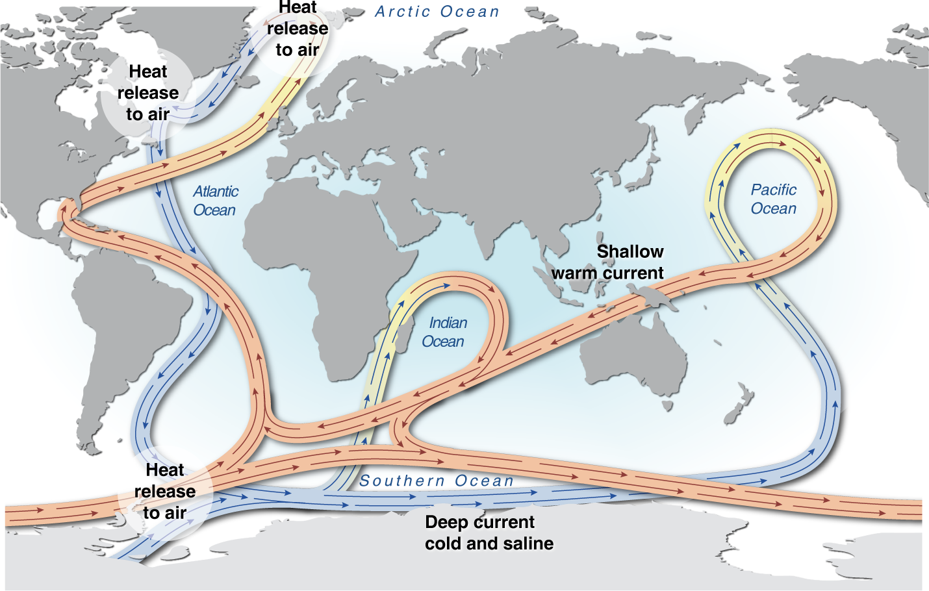

The operation of planetary-scale surface currents and the ocean conveyor results in marine pollution quickly being spread to areas far away from the original source. Some of the remotest shorelines on the planet are now spoiled by pollution that has been carried half-way around the world.

Main activity
(3) What is the global plastic pollution pattern?

Complex physical factors such as the operation of ocean currents make it hard to predict exactly which locations will see marine life becoming worst affected by any pollution event, or by the long-term accumulation of waste such as plastics. However, a number of impacts of plastic pollution have now become clearly visible. Scientists and marine experts have identified major concentrations of plastic waste in the gyre regions of the world's oceans.
Teaching tip

There are many online film sources that can be used to help students gain a better understanding of very complex phenomena such as the ocean conveyor and the gyres. A great place to start would be this short film by Charles Moore (Algalita Marine Research Foundation):
http://www.ted.com/talks/capt_charles_moore_on_the_seas_of_plastic.html
short lecture by http://www.guardian.co.uk/world/2010/jan/29/haiti-quake-generations-un-decades

Watch reconstruction film at: http://vimeo.com/10679645

- A yachting competition across the Pacific led veteran seafarer Capt. Charles Moore of the Algalita Marine Research Foundation to discover what some have since deemed the world's largest ‘landfill’ - actually a huge water-bound swath of floating plastic garbage twice the size of Texas. The plastic becomes trapped for several years in an enormous ‘slow whirlpool’ called the northern Pacific Gyre (there are actually two distinct garbage patches, in the western and eastern regions of the north Pacific, respectively). Moore said after his return voyage: ‘There were shampoo caps and soap bottles and plastic bags and fishing floats as far as I could see. Here I was in the middle of the ocean, and there was nowhere I could go to avoid the plastic.’

- In 1999, researchers counted one million pieces of floating plastic per square mile in the North Pacific Gyre, most of it in the form of tiny fragments. These fragments are the remains of plastic bottles and bags that have been broken down by attrition and other erosion processes. They are captured and kept in place by the North Pacific Gyre circulatory ocean current. The current’s flow creates giant pools of 'rubbish soup' (Figure 2). This refuse has been flushed into the ocean by run-off and sewer discharge from thousands of different cities all over the world. With so many origins, it becomes a very difficult pollution problem to tackle at source. Plastic is now believed to constitute 90 per cent of all rubbish floating in the oceans and the UN Environment Programme estimates that every square mile of ocean contains 46,000 pieces of floating plastic.
Specification advice

The IB Specification requires knowledge of sources and distribution of pollution in the ocean if centres are studying this as an optional topic for paper 2. Good understanding of the gyre currents would be likely to impress examiners.

In addition to the garbage patches, some high-profile discoveries of plastic pollution have been made in important wilderness regions:

- Dr Simon Boxall, lecturer in Oceanography at the University of Southampton, made the worrying find of a high level of plastic rubbish on a remote Arctic island over 1000km from the nearest town or village, taken there from all countries bordering the Atlantic by the ocean currents. Muffin Island is one of the most remote places on planet, yet plastics from Norway, Spain and the USA litter its beaches. This is a pollution problem does not have boundaries.
- Plastic pollution of the Hawaiian islands, such as Tern Island, has been widely filmed and studied - and provided an important stimulus for the recent consumer-led drive to reduce plastic bag dependency in the UK.

Students must not make the mistake of thinking that the rest of the oceans are relatively free of litter thanks to the gyres and landfall on selected beaches. Some studies have found microscopic plastic ‘dust’ to be more numerous than phytoplankton in many parts of the world’s waters. Plastic dust is ubiquitous in UK coastal waters coastal waters, for instance. The entirety of the world’s oceans has been affected by this problem. The ocean conveyer belt – the 'water motorway' that runs through the entire world water system – continues to distribute and redistribute plastic waste all around the planet.

Plenary
Duck story
Teaching tip

This is a fun way to end the first lesson. Ebbesmeyer’s work has been widely reported on and it is possible to easily find many additional sources of information about this story online. His own website is:
http://beachcombersalert.org/

Sixteen years after they first leapt overboard into the Pacific Ocean, a flotilla of small plastic ducks (along with some beavers and turtles) recently made landfall on Britain’s beaches. 29,000 plastic bath toys were released when their container was washed off a Chinese cargo ship in 1992, subsequently providing an un-paralleled data set for researchers with an interest in ocean circulation. Curtis Ebbesmeyer is one such scientist who has been tracking the ducks. Their movement has been inputted by Ebbesmeyer into a computer model called OSCUR (Ocean Surface Current Simulator). Developed by James Ingraham, OSCUR uses air pressure measurements as a means of calculating the direction and speed of wind across the oceans – and consequent surface currents.

After some ducks first washed up in 1993 near Sitka, Alaska – a full ten months after their great escape - the scientists used OSCUR to correctly predict that the remainder would follow the North Pacific Ocean Gyre currents. The Gyre currents did indeed induce a mass westward flocking of tiny plastic water fowl to Japan. From there, they promptly doubled-back to Alaska, thereby completing an approximately oval circuit (one that roughly marks the extent of the filthy Pacific Garbage Patch). Upon their return to Alaska (by now it was the end of the 1990s), many of the ducks escaped the Gyre before haplessly drifting north, decelerating into the Bering Strait to become trapped in slow-moving pack ice (Figure 4).

Ebbesmeyer foresaw the frozen fowls patiently sitting it out for five or six long years before next reaching the North Atlantic, where warmer waters would finally thaw the ice and bring liberation; further adventures might then reasonably be expected to take place in Canada, Greenland and New England - ending with the Gulf Stream ushering a warm north-westerly paddle towards the British Isles. All of this has now come to pass, exactly as Ebbesmeyer predicted. If you should find one of the ducks on a British beach, the hardly little critter will have travelled 35,000 km.

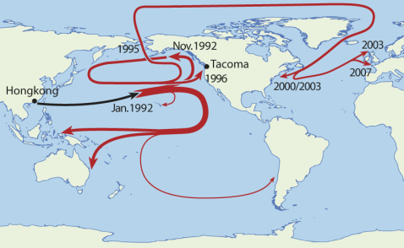

Figure 4 The Pacific orbital path taken by the ducks
(Source: http://followthecontainer.com/?p=1113)

