Mapping London
Lesson Three

Present Maps

“The city is a machine for teaching people to be city-dwellers. But first it necessitates submission, which it extracts by means of its scale, but also its complexity, its confusions – its tangle.”
Will Wiles (2014)

Enquiry question: What do maps of London 2014 tell us about the city?

Subject content areas:
- Locational knowledge: London Underground and the relationship to central London. Key locations along the network.
- Place knowledge: London as a city. Central London and key tourist landmarks.
- Human and Physical Geography: Transport and communications. Tourism from other parts of the world. Landmarks in the city of London.
- Geographical Skills and Fieldwork: Opportunities for fieldwork for schools based in London. Internet research. Google Maps and Google Earth being used for 3D visualisations.

Downloads
- Thirdspace different Londons (PPT)
- Thirdspace (JPEG)
- Role Cards sheet PDF | MSWORD
- Homeless City Card (JPEG)
- Visitors to London (JPEG)

Starter
Show a London Tube map as a starter – this could be an image, or you may have the map as a leaflet or printed format, or as an app on a mobile device. The map was first developed in 1931 by Harry Beck, and is based on electrical circuitry. The actual orientation of the lines on the diagram does not match the actual routes of the lines, or the position of the stations.
The map has gone through a lot of changes over the years, as can be viewed on this animation. Go to the Doug Rose website http://www.dougrose.co.uk/map_pages/map_animation.htm

Watch this short video, which shows the differences between the underground map and the real topography. Go to the Fourthway website
http://fourthway.co.uk/realunderground/
This distortion is something that we have become accustomed to as we look at the map of the Underground.
Share any underground stories that students may have.
Does it matter that the underground map does not match the actual locations on the surface?

Could also show them examples where the tube map has been changed to show other things such as the Great Bear, or this Sony music example. Go to the Ads of the World website http://adsoftheworld.com/media/print/sony_walkman_london?size=original

Main Activity
What kinds of maps are there which attempt to show London?
Explore the Pinterest board here:
http://uk.pinterest.com/geoblogs/mapping-london/
- Which of these maps do you think are the most successful in representing London?
- Which of these maps would you find most useful when exploring London today?
- Which maps do different groups of people need? Are there groups of people who are not represented here, or who might have difficulty moving through the city?

Thirdspace Activity
Richard Bustin is a Geography teacher at Bancroft’s School in Essex. He has written some materials related to the way that people experience cities in different ways depending on their own circumstances.
These different ways are summed up in the Thirdspace presentation (PPT), which has been created as part of the unit.
Use this to explore the different ways that London is experienced by the people who live there. Depending on your school location and the personal experiences of students, there will be different levels of engagement with the city.

Question for discussion:
- Does London still welcome those seeking to improve or change their lives?
- How do maps change our perception of the city?

Use the Role Cards sheet (DOC) to guide discussions on the maps which these people would use most often, or find most useful.

Plenary
One of Richard’s ideas is that the experience of London will be different to tourists than it will be for residents. Each year millions of people are added to the permanent residents as tourists.
If we look at the top ten most visited UK attractions, most of those are also in London. Go to the Telegraph website http://www.telegraph.co.uk/travel/destinations/europe/uk/10677294/British-Museum-leads-rise-in-visits-to-British-attractions.html

This word cloud represents the ideas that around 30 geography teachers suggested when they were asked what things they would most visit if they only had a short time in London.
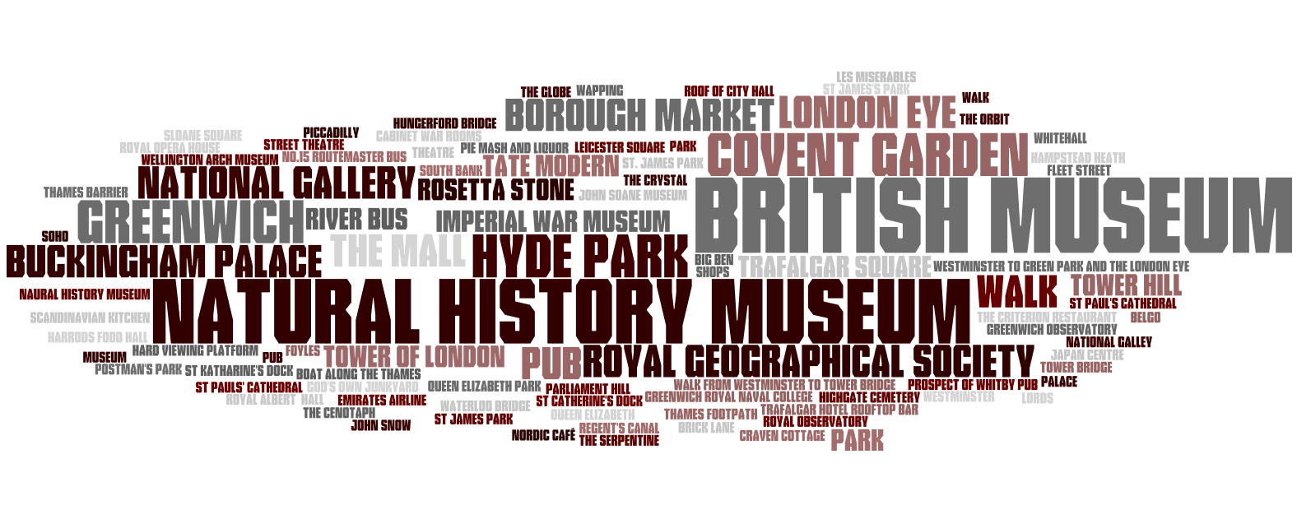
Create one for your own group, using one of a range of word cloud generator options that exist e.g. TagCrowd, Wordle, Tagxedo
You may also be aware of an app for your tablet that will do something similar e.g. WordFoto, WordPack

Extension activity
Although a little fiddly, this website allows students to create their own tube lines with stops which they name themselves. They could make one to sum up their learning ‘journey’ through the unit, for example. Got to the Beno website
http://beno.org.uk/metromapcreator/#

Additional reading

Changing the London Tube map? Go to the BBC website
http://www.bbc.co.uk/news/uk-20982436
List of ‘alternative’ tube maps. Go to the Londonist website
http://londonist.com/2011/03/a-guide-to-alternative-london-tube-maps.php

Go to the Geographical Association websites.
An article by Richard Bustin is available in ‘Teaching Geography’ for subscribers: http://geography.org.uk/journals/journals.asp?articleID=817
And also one in ‘Geography’
http://geography.org.uk/journals/journals.asp?articleID=846

A PPT of a presentation that Richard delivered at the Geographical Association conference in 2010. Go to the Geographical Association website
http://geography.org.uk/cpdevents/annualconference/derby2010/

Source for Will Wiles quote. Go to the Aeon website http://aeon.co/magazine/living-together/the-chaos-and-tangled-energy-of-living-cities

