Teachers – insert a picture of the local area into this space. Photos could be found at www.flickr.com – just type the name of your local town into the search box and copy and paste the image.

You are going to carry out some fieldwork into the local area to try and discover some aspects of the local history. Use this booklet to lead you through the activities and to record your findings.


Teachers – insert a street map of the local area into this space. Google maps is a good source of street maps and can be found at http://maps.google.co.uk. You will need to ‘print screen’ and then paste it into the document. Try to leave room around the edge for student’s notes.
Street names can be an important clue as to the history of a local area. As you walk around the local area locate, highlight and make a note, on the map below, any street names which you think could suggest something about the history. When you get back to school you can check out some of your theories to see whether or not you were correct.

Teachers – Copy and paste the map from the ‘Street name search’ page into this space. Drag the ‘blobs’ in the box to the right into the places where the photos were taken so that pupils can locate the positions of the photos easily. Don’t forget to colour code each photo.
Locate these ‘blobs’ on the map in the appropriate places.

Have a look at the photographs on the next few pages which were taken at some point in the past, their locations are shown on the map below. Go to each location in turn and try to take a photo from exactly the same position. Compare the modern day setting with the photo from the past and make a note of any similarities and differences.

Teachers – you will need to find a selection of ‘old’ photos which you will need to locate on the map above so that pupils can find their modern day equivalents. Suggestions of places where you can find photos are in the teacher’s fact sheet which accompanies this unit.

Similarities and differences?
Stick your photo here.

Stick your photo here.

Similarities and differences?

Stick your photo here.

Similarities and differences?

Stick your photo here.

Similarities and differences?

Stick your photo here.

Similarities and differences?

Stick your photo here.

Similarities and differences?

Stick your photo here.

Similarities and differences?

Stick your photo here.

Similarities and differences?

Stick your photo here.

Similarities and differences?

Teachers - The local museum is likely to have a wealth of information and is also likely to welcome pupils to investigate its archives. Some museums have ready made worksheets whilst others require the teacher to spend an hour or so looking at the exhibits before coming up with a series of activities. Whichever the option, it is worth the effort as it probably the best resource for investigating local history. Some examples of different activities can be seen in the Aylesbury example.

Being a good geographer is all about observation - looking at the environment and being able to interpret what you can see.
In pairs, you are going to take a short walk and observe the environment around you. In the box below draw a mental map of your route. As you walk, take photographs and make notes about anything which might tell you about the local history of your area.

A mental map of the local area showing aspects of local history
Pupils might need a little bit of guidance as to what is meant by a ‘mental map’. They should try to incorporate their feelings about the places – to do this they could create their own key.
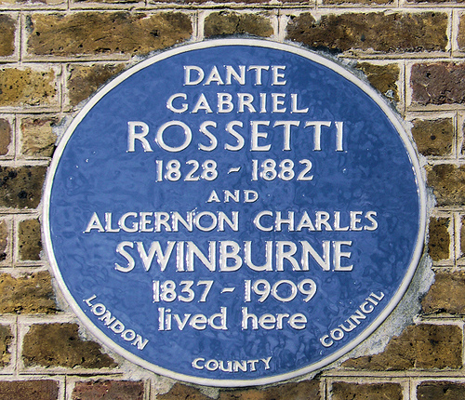
In the lesson about local people, you found out about famous people from local history who have been commemorated with a blue plaque.
Put a copy of your map in the space below. You are going to walk your ‘blue park trail’.
Is there a pattern to the distribution of blue plaques?
Why might this be?
Image by Flickr user flem007_uk and licensed for reuse under Creative Commons Licence.

Religious buildings can often tell us a large amount about the history of a place. Here, you are going to investigate Teachers insert the name of the religious building and the date it was built.

With your mobile phone, or a digital camera, take some photos of different parts of the religious building which you may be able to date. For example, can you find and take a photo of the oldest gravestone you can find? Are there any dates which are carved into the stone of the building? Do any of the stained glass windows tell part of a story? Stick your photos in the space below.

Teachers – You may want to alter the things that you want the pupils to photograph depending on the religious building which you have chosen to investigate. Also, it may not be appropriate for photographs to be taken, in which case pupils could sketch the different elements which tell the story of the building.

