Resources List | Starting Value | Event Impact and New Value | Event Impact and New Value | Event Impact and New Value | Event Impact and New Value | Event Impact and New Value | Final Value
Coffee   | 100
Copper   | 100
Iron   | 100
Oil   | 100
Wheat  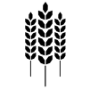 | 100
Coal  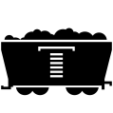 | 100
Tin   | 100

