Why is stem cell research controversial?
The stem cells most often used in research are taken from lab-created human embryos 4 or 5 days old. Many people believe that even at such a young age the embryos have a right to life and that it is morally wrong to experiment on them.
Campaigners would prefer research to be carried out using adult stem cells.
In May 2008 there was a vote in parliament to decide whether medical research using hybrid embryos should be banned. These are combined human-animal embryos which it is hoped may improve scientists’ understanding of complex diseases like Parkinson’s. The vote went against the ban.


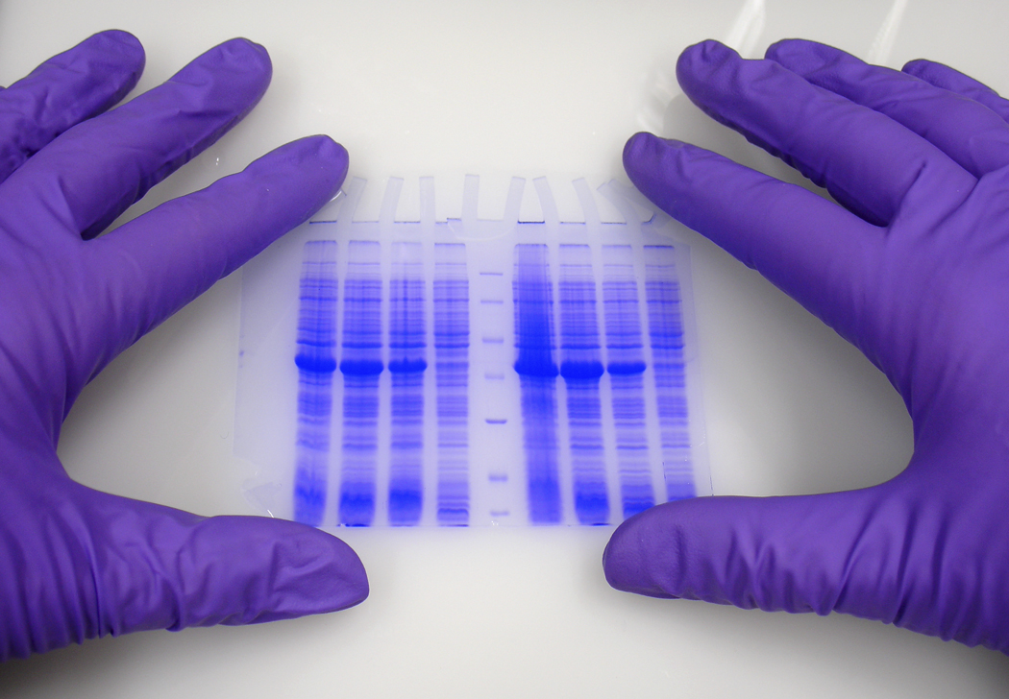
What are stem cells?
Stem cells are cells that are still in the very early stage of development, before they have been allocated a particular function in the body.
This means that they have the potential to develop into any type of cell, for example a heart cell, bone cell or liver cell.
Stem cells can be found both in adult organs and in embryos, but the stem cells used in research are usually embryonic stem cells as these have a greater potential to develop into any type of cell (they are pluripotent).
Embryonic stem cells can be grown in culture in the lab relatively easily.
Why do stem cells matter?
As stem cells have the potential to develop into any type of cell in the body, by introducing them into damaged or diseased organs it is hoped that they may take over the function of the cells that are no longer working.
There are many different applications for stem cell therapy. Scientists believe that one day it may be possible to treat all of the following conditions using stem cell therapy:
- Parkinson’s disease
- Alzheimer’s disease
- Heart disease
- Stroke
- Arthritis
- Diabetes
- Burns
- Spinal cord damage
Recently, stem cell research has also been combined with gene therapy to try to correct inherited disorders.
One day, it is hoped that it will be possible to remove stem cells from a patient, grow them in culture and then return them to the body to carry out repair work. This means they are less likely to be rejected by the person’s immune system.

How is South Korea involved in stem cell research?
It is no longer just Europe, Japan and North America that lead the way in science and medicine. The economic rise of Asia means that countries like South Korea, China and India are now just as likely to make medical breakthroughs.
South Korea has become associated with stem cell research. There are a number of reasons for this:
- South Koreans don’t tend to question the morals of using embryos for research as much as in some other parts of the world.
- South Korean scientists tend to work collectively and collaboratively, sharing their findings.
- There is a strong work ethic in South Korea and scientists work extremely hard.
- Scientists are revered in South Korea. It is a popular and trendy subject which attracts the best students.
- Many South Korean women volunteer to donate their eggs for research for free, resulting in a large supply. There is even a waiting list for donations. In the US and UK eggs are paid for.
- It has been claimed that South Korean scientists are good at intricate stem cell work because they use narrow metal chopsticks to eat – which are a bit like scientific implements!

