Who lives in the Everest region?

Sherpa people

The people of the Everest region are mainly the Sherpa who live in an area called the Solu-Khumbu district. The district lies in the northern part of the Sagarmatha National Park which was established in 1976.

The word Sherpa means ‘people from the East’ and refers to their origins in Eastern Tibet. Early Sherpa settlements are thought to have been established in the 16th century. Subsistence farming was their main livelihood, supplemented by trading activities. Historically, Sherpa food is derived from high altitude crops such as potatoes, barley and buckwheat. Nepali foods like lentils and rice are also a staple of the Sherpa diet. The Chinese takeover of Tibet in the 1950s meant that trading across the Nangpa La pass was no longer possible. The route was used by Tibetan traders who would bring down yaks, salt and dried sheep meat from Tibet and return with goods from India, such as rice, corn and millet. This coincided with the first Western mountaineering expeditions in the region, which led to the introduction and rise of trekking tourism in the area.
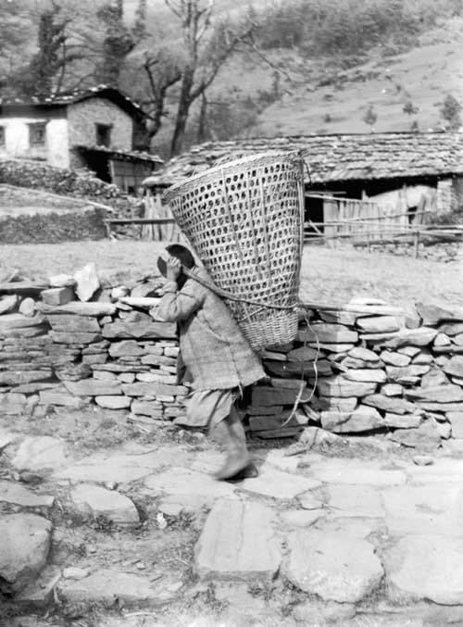

Tourism is recognised to be of great importance to the well-being of communities of the Solu-Khumbu region, both in employment and income opportunities. But against this background there are many social and economic problems. These include the effects of tourism on religious traditions and monastic life, although recent research now suggests a more complex picture; that many Sherpas have managed to adapt to tourism successfully and without any great loss of culture. However, the environmental effects have been far greater.

Sherpa culture is distinctly different from the other ethnic groups of Nepal. Sherpa religion and culture have evolved from years of myths, stories and religious practice, and have always been subject to a wide range of influences. Since the expeditions to Mount Everest, Sherpas have become a ‘celebrated people’ and received a great deal of international fame. The Sherpa themselves are aware of this fascination with their culture and have been able to direct this interest towards the building and repair of local monasteries. However, lifestyles have changed from one village to the next, from wealthier to poorer households and it is women rather than men who have taken on greater farming and domestic responsibilities. It is usually the women and less wealthy who are likely to maintain the ‘traditional’ link with the past. Many examples, such as the refurbishment of Tengboche Monastery and a culture and climbing museum dedicated to the many climbers that have climbed Everest show a positive world view of Sherpa culture.

Nepal’s porters
Nepal’s people have always moved goods around the high alpine reaches of the Himalayas. The ‘traditional porter’ continues to work for local people. The job is not well paid and the loads are heavier but it is not so dangerous as it is usually carried out between villages at a lower altitude (although this has been changing with more hotels and restaurants being built up at altitude). What is new is the modern trekking and tourism economy in which they now work. It is a valuable industry that provides jobs in one of the world’s poorest countries on the one hand, while at the same time porters have been working under appalling and dangerous conditions.
The high altitude porters are often Sherpas who carry loads above base camp on expeditions. Most trekking porters are poor farmers from lowland areas, and are as unused to the high altitudes and harsh conditions as western trekkers. Many people don’t know this and a myth seems to have been created that porters are superhuman, that they carried massive loads in harsh conditions and they are used to cold and high altitudes meant nothing to them.
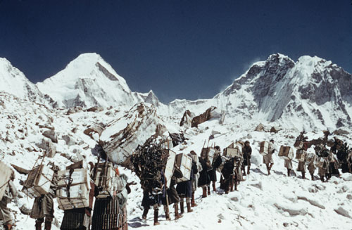

There are around 100,000 trekking porters working in Nepal in a good trekking season. They mostly come from the lower altitude middle hills and are typically poor farmers who need the cash. They often carry above the tree line into snow conditions, at altitudes up to and above the height of an expedition base camp. As a result they are at high risk of hypothermia, frostbite and Acute Mountain Sickness. This occurs when trekkers gain altitude too quickly and don’t drink enough water. The symptoms can range from bad headaches or nausea to pulmonary oedema, a dangerous accumulation of water in the lungs.

In 1997, the International Porters Protection Agency (IPPG) was formed after a young Nepali mountain porter fell sick and was dismissed while still at high altitude. After being paid off and sent down on his own, he died at the side of the trail. The aim of the IPPG is for every porter to have access to adequate clothing, boots, shelter and food, appropriate to the altitude and weather, plus medical care when ill or injured. The organisation also raises awareness of the problems endured by trekking porters and to educate and change the practices where necessary. This applies to trekking companies and their employees, (especially the leaders and sirdars who are directly in charge of porters), trekkers and the porters themselves.

A recent campaign by Tourism Concern ‘Trekking Wrongs; Porters’ Rights has led to a dramatic increase in the number of UK ‘porter friendly’ trek operators. As a result of this, 40 of the 81 tour operators contacted by Tourism Concern now have policies to provide essential protection and humane working conditions.

Websites
International Porters Protection Group www.ippg.net
Tourism Concern www.toursimconcern.org.uk

