Plastic pollution in the oceans
Lesson 2 Starter activity

Work in pairs
- Study the photograph and the photographer’s diary.
- Identify the direct cause of the bird’s death.
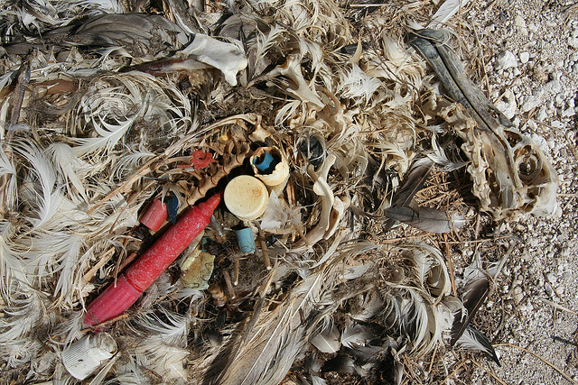
- Complete the activity below
Photographer’s diary

“So we were on Tern Island, right in the middle of the Pacific … we saw a lot of this kind of thing … some chicks manage to regurgitate the ingested plastic, I found regurgitated fishing gloves and a toothbrush, but often it just killed the chicks. We found lighters, bottle caps, toys, pens, markers, toothbrushes and miles of fishing line in dead chicks. I kept the pen from this bird for use as a teaching aid.”

Activity: This photograph was taken in a remote wilderness area, 1000s of km from any major populated area. Last lesson we learned about the global human and physical factors that have led to the pollution of wilderness areas. Can you list or draw the chain of events that led to this bird’s death?

Space for your answer

