Life in a Kenyan City
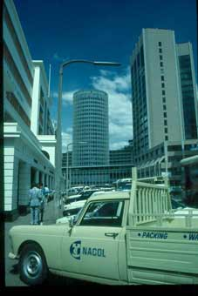
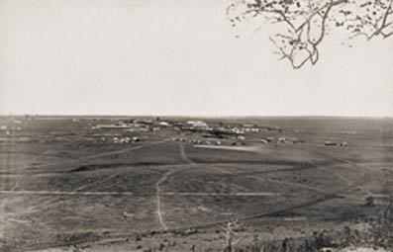
These photographs show Nairobi in 1900 and then in 1991.
© RGS-IBG
© C Pereira
Basic Facts about Nairobi:
- Nairobi is the capital city of Kenya and is found in the central highlands of the country.
- It was built in 1899 by the British who were building a railway line from Mombasa to Kisumu. They wanted Kenya’s capital city to be in the middle of the country.
- Nairobi means ‘stream of cold water’ in the Maasai language.
- The people who live there are usually very rich or very poor.
- Most people who live in Nairobi are poor and live in shanty towns (these are areas of poor housing that are on land that nobody else wants to use).
- The houses in shanty towns don’t usually have running water or electricity.
- There are also very wealthy areas in the city with skyscrapers, beautiful hotels and expensive houses.
- Nearly 3 million people live in Nairobi and the population is growing all the time as many people from villages migrate there.
- The city has changed a lot since it was first built. The population of the city is much higher, there are many more areas of poor housing and the city is much larger than it used to be.

People believe they can earn money there and then send it back home to the village
But why do people actually move to Nairobi?
People believe there are more jobs there
People believe it is easier to get a good education there, because there are more schools.

People believe life in the city is more comfortable. There are lots of things to do and lots of places to visit.

