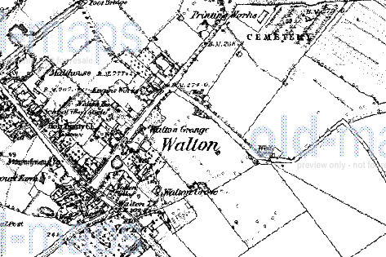
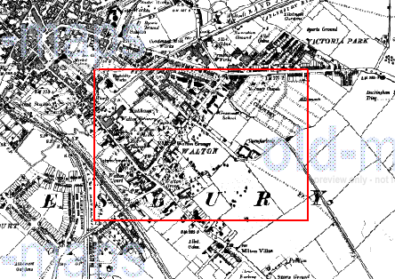
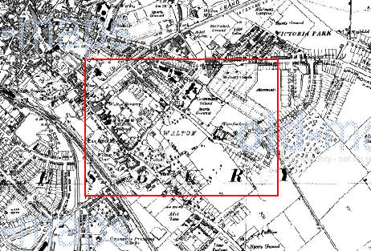
1884
1926
1938
In 1884 Walton was a separate village from Aylesbury. It had a large manor house – Walton Grange – which was on the site of what is now Aylesbury High School. The village was surrounded by fields and there was a well at the end of Turnfurlong. Next to the cemetery, which is still located there, there was a printing works.
Images from the Old-Maps website: www.old-maps.co.uk

