Kenyan Green Beans – who is interested?

The Kenyan farm worker
The Kenyan exporting company
The Kenyan landowner

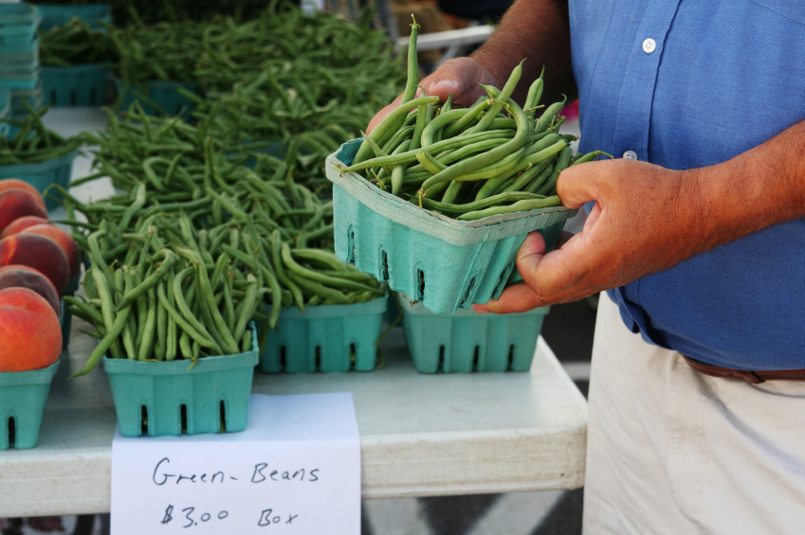

The airline transport company
The Kenyan government

The UK importing company
The UK government

The UK supermarket owner
The UK supermarket customer

Each of the people or organisations shown above has an interest in the green beans. Some people believe that Kenya should stop growing green beans for UK customers. Think carefully and write a comment for each person or organisation explaining how they would feel if Kenya did stop growing green beans for export to the UK. You can write out your own ideas or use the template if your teacher provides it.

_______________________________________________________________________________________
The Kenyan government
_______________________________________________________________________________________

The Kenyan landowner
_______________________________________________________________________________________
_______________________________________________________________________________________
The Kenyan farm worker

_______________________________________________________________________________________
_______________________________________________________________________________________
The Kenyan exporting company

_______________________________________________________________________________________
_______________________________________________________________________________________
The airline transport company

_______________________________________________________________________________________
_______________________________________________________________________________________

The UK importing company

_______________________________________________________________________________________
_______________________________________________________________________________________

The UK supermarket owner
_______________________________________________________________________________________
_______________________________________________________________________________________
The UK supermarket customer

_______________________________________________________________________________________
_______________________________________________________________________________________

_______________________________________________________________________________________
The UK government
_______________________________________________________________________________________

