The Caatinga
- The Caatinga is a semi-arid scrub forest (similar to a desert environment) situated in the North-east of Brazil.
- It is extremely rich in natural resources.
- It is populated by thorny shrubs and stunted trees.
- There are few species of animals; although it is home to the three banded armadillo.

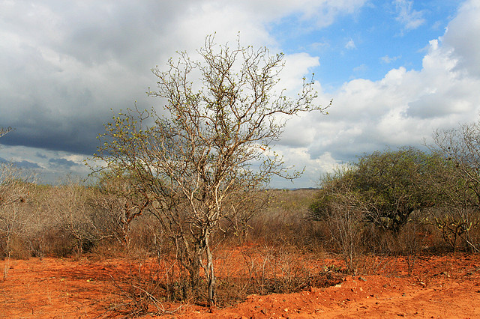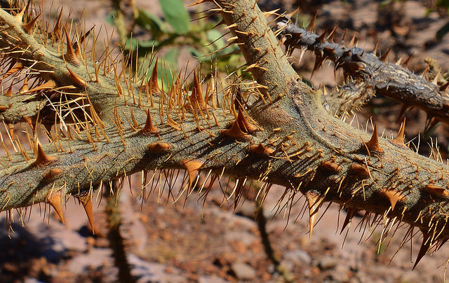
Caatinga © Maria Hsu, Flickr Thorny twig © A. Duarte, Flickr

The Cerrado
- Covers 20% of Brazil.
- The largest tropical savannah region in South America.
- Home to over 10,000 species of plants.
- Home to the endangered jaguar.
- Grassland, shrubbery and trees.
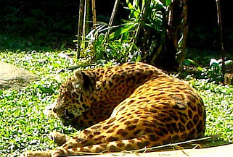
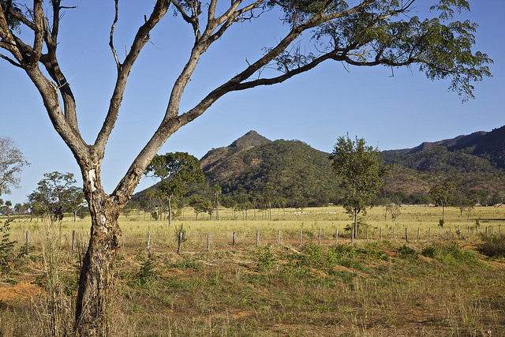
Cerrado © Francisco Aragao, Flickr Onca Pintada © Rafael Acorsi, Flickr

The Pantanal
- The world’s largest wetland (20x the size of The Everglades in Florida).
- The Pantanal is located in Brazil, Bolivia and Paraguay.
- Home to a huge number of plant and animal species.
- 80% of the land is submerged in the wet season, so there is a huge amount of aquatic life.

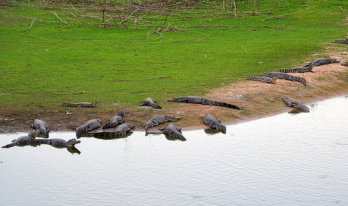
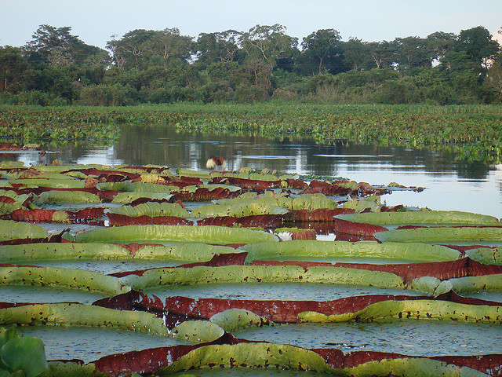
Pantanal © Rafael Milani, Flickr Alligators in the Pantanal © A. Duarte, Flickr

The Mata Atlantica
- Also known as the Atlantic Forest.
- Large area of forest that runs along the Atlantic coastline of Brazil.
- Home to over 2000 species of plants, birds, mammals, reptiles.
- Home to the rare golden lion tamarind monkey.

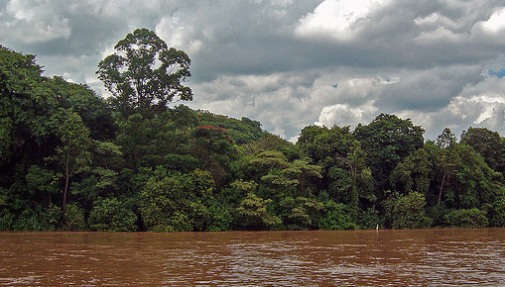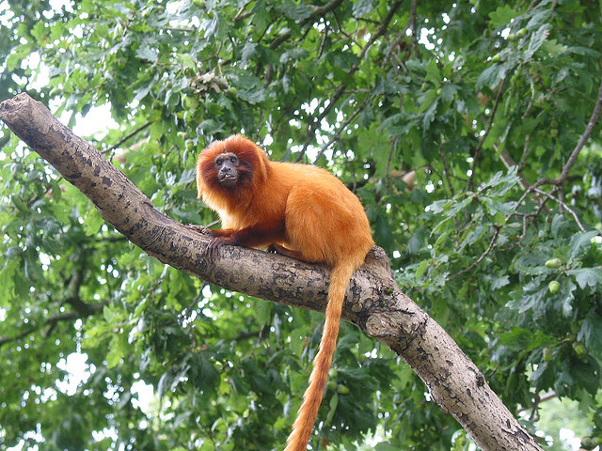
River, Forest and Clouds © Jose Roberto V Moraes, Flickr IMG_4982 © Roland Harvey, Flickr

The Pampas

- Flat, fertile grasslands that are in areas of lowlands found in the south of Brazil.
- Used to graze animals.

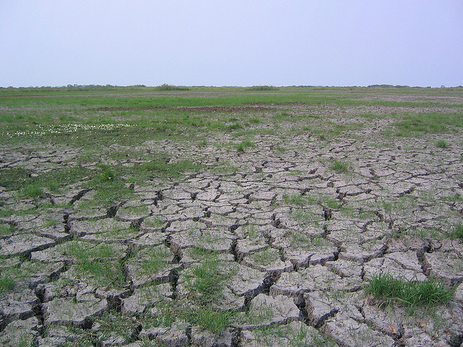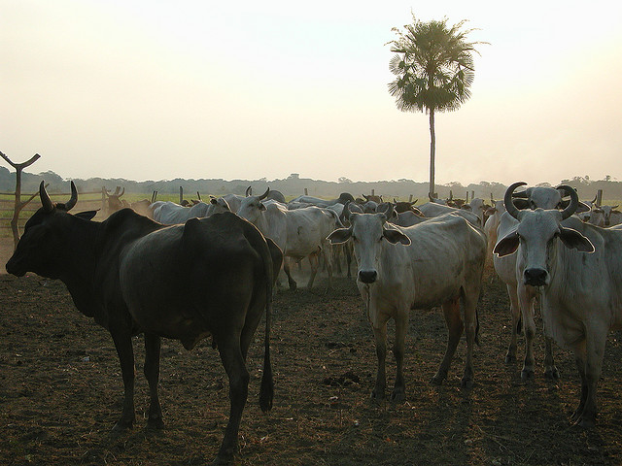
The Pampas © Phil Whitehouse, Flickr Cows, Amazon Pampas © Jordan Tam, Flickr

Tropical rainforest (Amazon rainforest)
- A huge region that spans Brazil, Bolivia, Peru, Ecuador, Colombia, Venezuela, Guyana, Suriname and French Guiana.
- Home to one in ten known species on earth.
- Area of dense forest and the Amazon River.

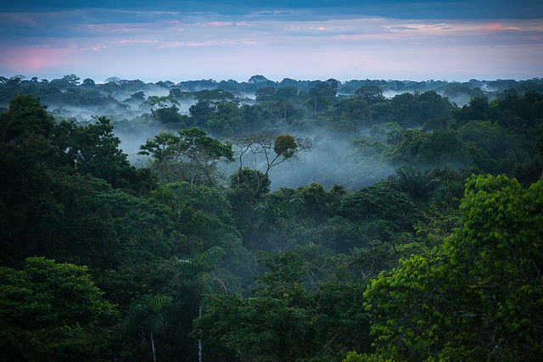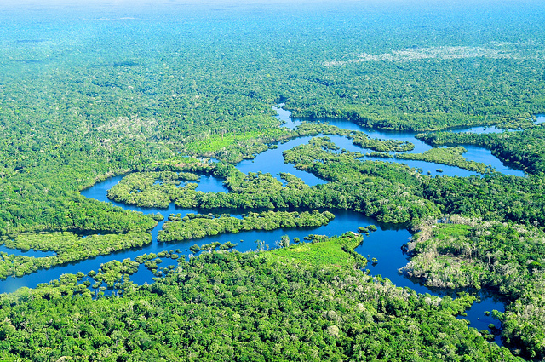
A morning in the Amazon Rainforest © Aluarts, Flickr Amazon Rainforest © Cifor, Flickr

