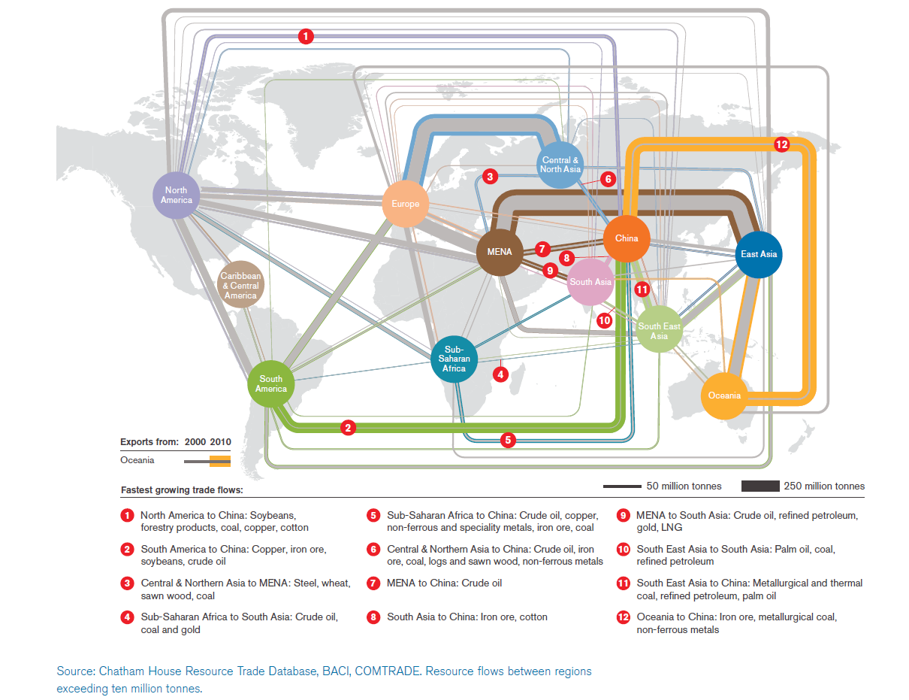

Homework activity
(a) Describe the pattern of flows shown in 2010. (10 marks)
(b) Using examples, suggest reason for the changes in exports to China shown between 2000 and 2010. (15 marks)

Classroom activity
Study the infographic and discuss the patterns and trends shown.

