CLIMBING MOUNT EVEREST

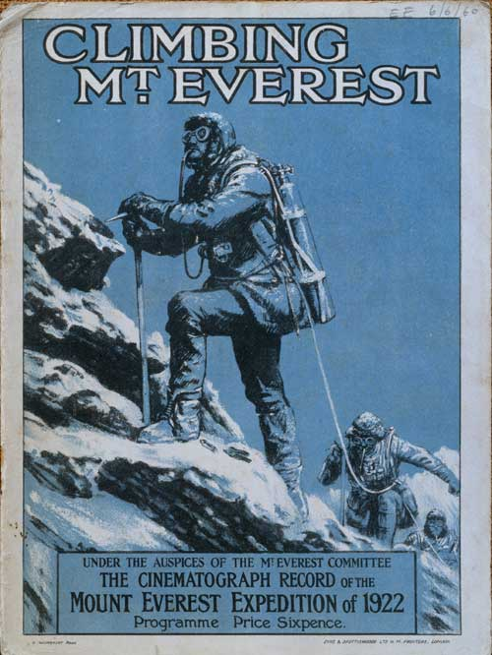

Role: Leader

Responsibilities: Communication, keeping everyone on your team informed and up to date

Task: What will the weather be like? When is the best time to go and how will you get there?
Other team tasks:
- What clothing and equipment will you need? What were they made out of? What materials are clothing made out of today?
- How can you make water safe to drink? What types of food can be easily carried, cooked and eaten? How will you pack your food so you don’t have lots of rubbish?
- What happens to the body in high altitude? How does the bottled oxygen equipment work? How does this compare to modern equipment?
- How will you make sure that the porters are properly clothed and equipped? What happens if one of the porters becomes ill? What words of Nepali can you teach your team?
- How will you make sure that no-one else gets news of your team? Think of a code so only your newspaper can understand your messages

Role: Leader

Responsibilities: Communication, keeping everyone on your
team informed and up to date

Task: What will the weather be like? When is the best time

Role: Climber

Responsibilities: Clothing and equipment

Task: What clothing and equipment will you need? What were they made out of? What materials are clothing made out of today?

Other team tasks:
- What will the weather be like? When is the best time to go and how will you get there?
- How can you make water safe to drink? What types of food can be easily carried, cooked and eaten? How will you pack your food so you don’t have lots of rubbish?
- What happens to the body in high altitude? How does the bottled oxygen equipment work? How does this compare to modern equipment?
- How will you make sure that the porters are properly clothed and equipped? What happens if one of the porters becomes ill? What words of Nepali can you teach your team?
- How will you make sure that no-one else gets news of your team? Think of a code so only your newspaper can understand your messages

Role: Climber

Responsibilities: Eating and drinking
Task: How can you make water safe to drink? What types of food can be easily carried, cooked and eaten? How will you pack your food so you don’t have lots of rubbish?

Other team tasks:
- What will the weather be like? When is the best time to go and how will you get there?
- What clothing and equipment will you need? What were they made out of? What materials are clothing made out of today?
- What happens to the body in high altitude? How does the bottled oxygen equipment work? How does this compare with modern equipment?
- How will you make sure that the porters are properly clothed and equipped? What happens if one of the porters becomes ill? What words of Nepali can you teach your team?
- How will you make sure that no-one else gets news of your team? Think of a code so only your newspaper can understand your messages

Role: Doctor

Responsibilities: Keeping the team fit and healthy
Task: What happens to the body in high altitude? How does the bottled oxygen equipment work? How does this compare with modern equipment?

Other team tasks:
- What will the weather be like? When is the best time to go and how will you get there?
- What clothing and equipment will you need? What were they made out of? What materials are clothing made out of today?
- How will you make sure that the porters are properly clothed and equipped? What happens if one of the porters becomes ill? What words of Nepali can you teach your team?
- How can you make water safe to drink? What types of food can be easily carried, cooked and eaten? How will you pack your food so you don’t have lots of rubbish?
- How will you make sure that no-one else gets news of your team? Think of a code so only your newspaper can understand your messages

Role: Reporter/Photographer

Responsibilities: Keeping your newspaper informed of the team’s progress

Task: How will you make sure that no-else gets news of your team? Think of a code so only your newspaper can understand your messages

Other team tasks:
- What will the weather be like? When is the best time to go and how will you get there?
- What clothing and equipment will you need? What were they made out of? What materials are clothing made out of today?
- How will you make sure that the porters are properly clothed and equipped? What happens if one of the porters becomes ill? What words of Nepali can you teach your team?
- How can you make water safe to drink? What types of food can be easily carried, cooked and eaten? How will you pack your food so you don’t have lots of rubbish?
- What happens to the body in high altitude? How does the bottled oxygen equipment work?

Role: Lead Sherpa

Responsibilities: In charge of all the Sherpa porters, contributing local knowledge and experience

Task: How will you make sure that the porters are properly clothed and equipped? What happens if one of the porters becomes ill? What words of Nepali can you teach your team?

Other team tasks:
- What will the weather be like? When is the best time to go and how will you get there?
- What clothing and equipment will you need? What were they made out of? What materials are clothing made out of today?
- How can you make water safe to drink? What types of food can be easily carried, cooked and eaten? How will you pack your food so you don’t have lots of rubbish?
- What happens to the body in high altitude? How does the bottled oxygen equipment work?
- How will you make sure that no-one else gets news of your team? Think of a code so only your newspaper can understand your messages

WEBSITES

Climate

http://www.travel-himalayas.com/about-himalayas/climate-himalaya.html

Clothing

http://www.pbs.org/wgbh/nova/everest/exposure/gear.html

Equipment

www.mounteverest.net/page/gearandstuff.htm

www.mounteverest.net/expguide/gear.htm

www.mounteverest.net/expguide/equip.htm

www.mounteverest.net/expguide/campgear.htm

Food

www.mounteverest.net/expguide/food.htm

Altitude + Oxygen

www.mounteverest.net/expguide/wwoz.htm

http://www.mos.org/Everest/exhibit/physiology.htm

http://www.mos.org/Everest/howhigh/howhigh.htm

Sherpa people and language

http://www.pbs.org/wgbh/nova/everest/history/sherpasworld.html

http://www.pbs.org/wgbh/nova/everest/history/nepalese.html

Porters and impact of tourism

http://www.tourismconcern.org.uk/campaigns/campaigns_porters.htm

http://tv.oneworld.net/tapestry?story=97

