Views of Antarctica

People’s views and responses to the great wilderness of Antarctica have been as diverse as the landscape. Here are some of the early views that were recorded before it became a destination for tourists. The British Antarctic Survey and the Arts Council also sponsor an Artists and Writers Programme. The purpose of the visits is to enable the writers and artists to experience the Antarctic in order to convey a better understanding of its unique features. Of great importance is the way in which these artistic activities complement scientific research and provide a different way for the public to appreciate the important contribution that Antarctica makes to the way in which the Earth functions.
British Antarctic Expedition 1910 - 1913
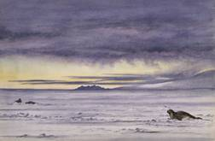
“There is spiritual work to be done here…surely God means us to find out all we can of his works…and if it is right to search out his works in one corner of his Creation, it is right for some of us to go to the ends of the earth to search out others.” Edward Wilson

Edward Wilson was the surgeon and geologist who travelled with Scott in 1902 and died on the British Antarctic Expedition, 1910 to 1913. He completed many sketches and watercolours of Antarctica. While some saw the Antarctic as scientific, for Wilson, painting the birds and animals of Antarctica was an act of worship.

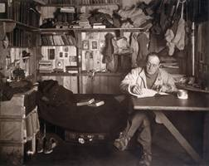
The seductive folds of the sleeping bag.
The hiss of the primus and the fragrant steam of the cooker…
The crunch of footsteps which break the surface crust…
The crisp ring of the ponies’ hoofs and the swish of the following sledge…
The gentle flutter of our canvas shelter
The drift snow like finest flour penetrating every hole and corner – flickering up beneath one’s head covering, pricking sharply as a sand blast…
The eternal silence of the great white desert…
The blizzard, Nature’s protest – the crevasse, Nature’s pitfall – that grim trap for the unwary – no hunter could conceal his snare so perfectly.

(Captain Scott, 2 February 1911)

Captain Scott writing in his diary.
He had his own small compartment
in the hut at Cape Evans, decorated
with photographs of his family. As
the expedition settled into the
Antarctic, Scott compiled a list of his
impressions of polar life.
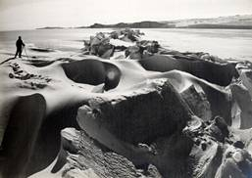
The photographer Herbert Ponting emphasised the scientific aims of the expedition. His first public announcement on the 1910 expedition was that Scott and his party had given their lives for science. He believed that his visual records should be considered alongside geological or meteorological observations, as a contribution to the knowledge of Antarctica.

The Imperial Trans-Antarctic Expedition 1914-1917

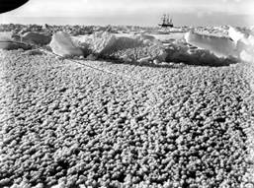
The photographs of the Imperial Trans-Antarctic Expedition, 1914 to 1917 captured the story and drama that unfolded with all 28 men surviving two years in the Antarctic after their ship, the Endurance was caught in pack ice and eventually crushed in the Weddell Sea.
The photographer, Frank Hurley, recorded the day to day routine that the men established for survival.

“A fine crop of ice flowers have sprung up on the lead and were illuminated by the morning sun, resembling a field of pink carnations.”
Frank Hurley’s diary, August 24, 1915
“This is not a pleasant job. We have to dig a hole down through the coal while the beams and timbers groan and crack all around us like pistol-shots. The darkness is almost complete, and we mess about in the wet with half-frozen hands and try to keep the coal from slipping back into the bilges. The men on deck pour buckets of boiling water from the galley down the pipe as we prod and hammer from below, and at last we get the pump clear, cover up the bilges to keep the coal out and rush on deck, very thankful to find ourselves safe again in the open air.”
Frank Worsley writing about having to go down in the bunkers of the Endurance and clear ice a few days before the crew were forced to abandon ship.
“There are no spoons, etc., to wash, for we each keep our own spoon and pocket-knife in our pockets. We just lick them as clean as possible and replace them in our pockets after each meal.”
A crew member writing about daily rituals at Ocean Camp.

“It’s a hard, rough, jolly life, this marching and camping; no washing of self or dishes, no undressing, no changing of clothes. We have our food anyhow…sleeping almost on the bare snow and working as hard as the human physique is capable of doing on a minimum of food.”
Crew member

