Learning from the Past: Sichuan and Tangshan compared

Task
Using the information from the Flashpoint 3 sheet and the PowerPoint “Learning from the Past,” sort the statements below under two headings:

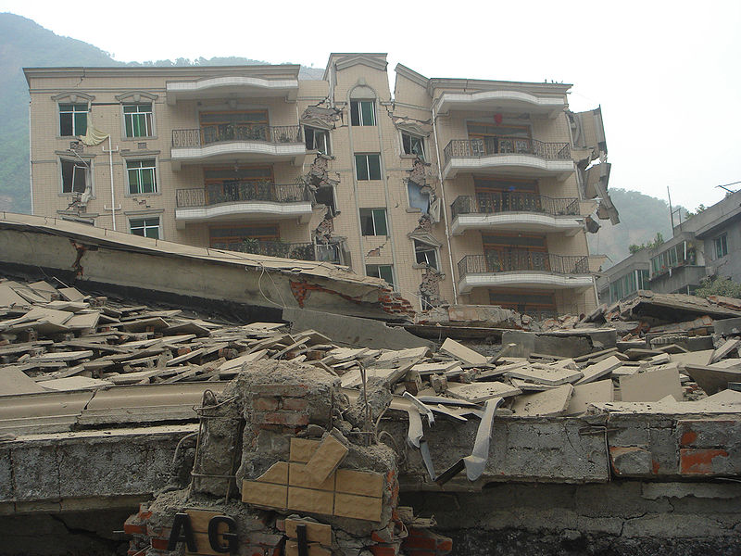

Tangshan Earthquake, 1976

Sichuan Earthquake, 2008

Sort the following statements:
The rescue effort was swift and large machinery, equipment and large numbers of personnel were used.

Earthquake struck at 3.42a.m.
The earthquake happened in a high risk area.
There were approximately 70,000 deaths.
The earthquake happened in a low risk area.
The buildings were constructed of poor materials – one storey brick with heavy concrete roofs.
There were 240,000 (perhaps more) people killed.
The earthquake struck at 2.28pm
The response was slow as there was no machinery. People were rescued with simple tools or bare hands.
Many buildings were constructed of poor materials and were not constructed according to codes of building, particularly schools.



Image from Wikimedia Commons and licensed for use under Creative Commons License.

