Mapping London Factsheet

This unit explores a number of different ways that the city of London has been represented in map (or other visual) form over the centuries that the city has been in existence.
Students will be familiar with maps created by Ordnance Survey, but a whole range of other mapping types have been created to show particular aspects of the city.
Each lesson allows opportunities to explore these different maps. There are too many to cover them all, so teachers should take care to choose maps which they have already assessed for their value, but also offer the choice for students to discover new representations of the city.

Mapping London is mentioned in the documents relating to the London Curriculum’s Geography documents. Visit Greater London Authority website https://www.london.gov.uk/sites/default/files/A4_GEOGRAPHY_subject.pdf

This includes the following references to mapping, which will be covered in part by this unit:

- Students will explore the story of London and its geography, told by a range of contemporary, historical and alternative maps.
- They will build Ordnance Survey map skills as they develop a geographical knowledge of their city and its people, and the locations of its world-famous landmarks.
- Students can discover the human and physical features that made London a suitable place for a settlement thousands of years ago, alongside the growth and urbanisation of London during the last two centuries and its modern-day diversity.

Each lesson is based on an enquiry question.
Each lesson is listed below along with some appropriate reading and references.

Lesson 1
Past Maps
How has London been represented in the past?

Google image search: ‘London Maps’ and explore the different variations – what are the ‘constant features’ that are in most of them?

Visit YouTube website - Animation: London Evolution Animation: https://www.youtube.com/watch?v=NB5Oz9b84jM

Compare with some of the earlier maps of the city
- John Snow’s Cholera map – modern day health variations in the city – this has now been remade in ArcGIS Online for example: Visit ArcGIS website http://www.arcgis.com/home/webmap/viewer.html?webmap=f02dc5b9d9d84c55a79264e0d338bf88
- Early version of London underground map and how it evolved
- Booth’s Poverty Map – refer to modern day maps which explore similar ground such as Illustreets, Ollie O’ Brien’s recreation of Booth’s map, and also 32 Stops by Danny Dorling – Lives on the Line. Visit Mapping London website http://life.mappinglondon.co.uk/
- TV programme: Secret History of our Streets. Visit the Open University website http://www.open.edu/openlearn/whats-on/tv/ou-on-the-bbc-the-secret-history-our-streets - could possibly produce a version for a local street
- Investigations by students – possible curation of Pinterest boards is mentioned. This is a visual bookmarking tool, which requires an account to be set up beforehand
- Royal Geographical Society (with IBG) historical maps of London

Lesson 2
Changing Maps

Meander at the start of EastEnders – could people identify the city from there?

What processes have changed London, and how have maps themselves changed?

London’s map has changed over the years – a look at two events that led to the opportunity to change.
Great Fire of London
Who else used this map? Navigators in Luftwaffe bombers during WWII
Visit bomb sight website http://www.bombsight.org/#15/51.5050/-0.0900
- Impact of the blitz on London – changing landuse and infill of the city following the removal of areas by bombing

One focus for this work is the area around St. Paul’s Cathedral
- This is an area which is now actually protected from future change, and even the view to St. Paul’s from a number of directions is protected so that it cannot be blocked by future buildings.
- Some buildings have had to be adapted so that they do not get in the way – this is partly the reason for the distinctive shape of the Leadenhall Building (the ‘cheesegrater’ as it is sometimes called)

Students may want to explore the different views of St. Pauls that are protected.

These can now be recreated using the new Google 3D views which are available in London on Google Maps and Google Earth. A guide to accessing these is provided in Lesson 4

Lesson 3
Present Maps
How can we get a different view of London?

Consider the London Underground and how the network shown on the classic Tube map relates to the surface, and the topography differences – this is perhaps a distortion that we have become accustomed to.
- Do all maps distort reality?
- What is missing from maps? Will future maps be able to show these missing things?

Look at these tourist maps of pictures that have been taken by Eric Fischer. Visit Flickr maps website https://www.flickr.com/photos/walkingsf/4671589629/in/set-72157624209158632
How do the experiences of locals and tourists vary?

We reference the work of Richard Bustin here: Thirdspace – does London still welcome those seeking to improve or change their lives? How do maps change our perception of the city?

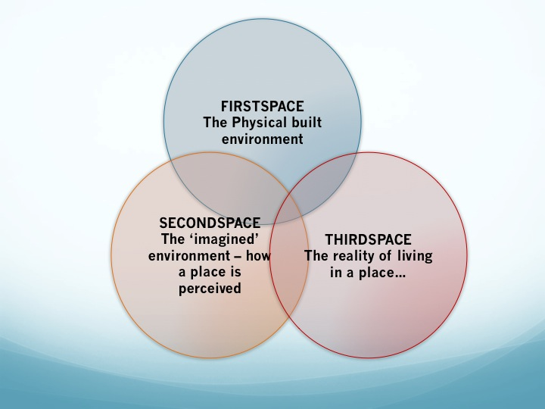

Lesson 4
Future Maps
What will maps of London look like in the future?

Which areas of London are changing the fastest? – You could make reference to the Queen Elizabeth Olympic Park and the changes that have taken place there – and future changes with Crossrail etc.
Visit Queen Elizabeth Olympic Park website http://queenelizabetholympicpark.co.uk/
Visit crossrail website http://www.crossrail.co.uk/

We use the Urban Observatory site here, which allows a comparison between cities shown side by side. This comparison is now possible due to modern mapping and the availability of data that are up to date. Visit Urban Observatory website http://www.urbanobservatory.org/ A guide to using the site is provided as part of the lesson materials. This uses an online app which is easy to make sense of. For more on the background to the app, visit the 192021 site http://192021.org/

Lesson 5
Maps that are not maps
How can we ‘show’ what London looks like without a map?

There are plenty of maps available today which do not follow the traditional rules of map making. New software means that maps can be created by those who do not have any specific cartography skills.

Google Earth, for example, is constructed from a huge mosaic of images, but is often used by teachers in the same way that they might use maps. Infographics are increasingly being used to display information, and word clouds have also grown in popularity since their introduction.

We will use Londonmapper, which has over 300 cartograms showing specific data sets for London. Visit London Mapper website
http://www.londonmapper.org.uk

There are also plenty of maps on the Mapping London website, which has been curated by Ollie O’ Brien and James Cheshire from CASA at University College, London. Visit Mapping London website
http://mappinglondon.co.uk/
This provides plenty of interesting maps to stimulate discussions with students.

Lesson 6
Doing the knowledge
How well do you know London?

This is the assessment piece for the unit, and offers a flexible activity which can be used in different ways.
For schools in London, they can carry out fieldwork in the area around the school, or potentially pair up with another school in the city to share and compare student work.
It is based on the ‘knowledge’ that all London cabbies have to complete before they are given a license to operate.

Students will be asked to create an annotated map of an area of London using some of the tools that they have been introduced to during the unit.

