Adjectives | Hong Kong word mat | Geographical terms
windy | Hong Kong word mat | Peng Chau
blue | 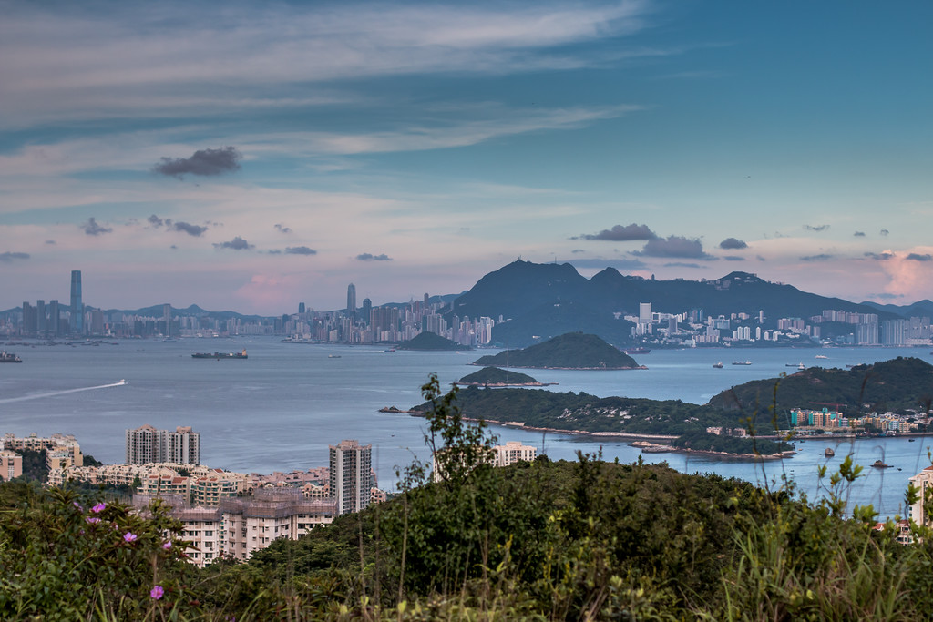  Hong Kong or Victoria Harbour is a seaway between Kowloon [top left] Hong Kong Island [top centre right], and other islands like Lantau [foreground] where this photograph is taken looking over Peng Chau [centre-right].  [Please change this photograph if you wish to support vocabulary development]  The words for all pupils are in bold type, most students are in normal type and some pupils are in italic font.  This word mat was originally published as an idea on www.sln.org.uk/geography Chris Durbin ESF, Hong Kong | apartment block
breezy |  | bay
busy |  | city
calm |  | coast
cloudy |  | container
crowded |  | Equator
dark |  | ferry
dense |  | forest
developed |  | harbour
wet |  | hill
forested |  | island
green |  | junk
grey |  | peak
hilly |  | port
hot |  | sea
humid |  | ship
light |  | shrub
near |  | slope
open |  | skyscraper
rainy |  | Tropic of Cancer
rocky |  | village
rounded |  | Key place names
rural |  | Hong Kong
shaded |  | China
soaring |  | South China Sea
spacious |  | Hong Kong Island
spectacular |  | Kowloon
steep |  | Lantau Island
sunny |  | New Territories
urban |  | The Peak
warm |  | Victoria Harbour

