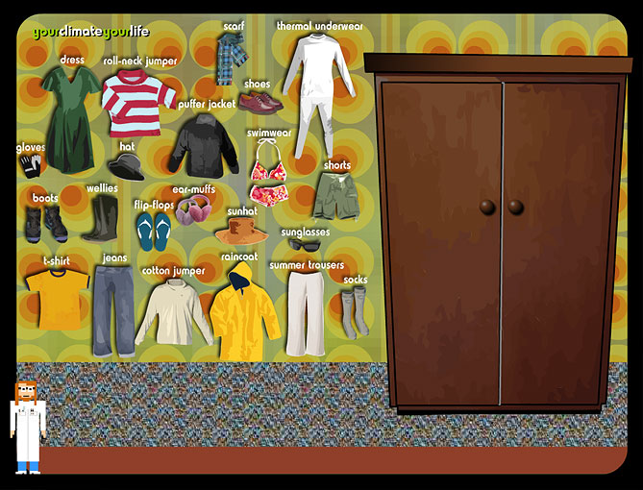
Clothes for the climate

Imagine you have a friend from another continent visiting the UK for one year. What ten items of clothing will they need and why?

- What do your choices tell us about the climate in the UK?
- What clothes do you have in your wardrobe?
- How does our climate affect the choices you make when you’re shopping for clothes?

