The story of Sir Ernest Henry Shackleton
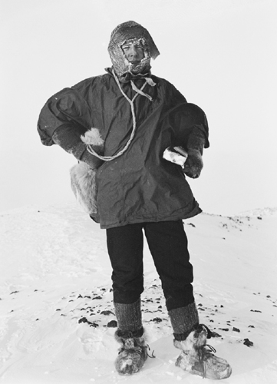
Ernest Shackleton had a dream. He wanted to be the first person to walk to the South Pole. Shackleton’s first Antarctic expedition was in 1901. He travelled with another famous explorer, Robert Falcon Scott. They got within 500 miles of the South Pole – nearer than anyone else – but had to turn back because of bad weather.
Shackleton was determined to try again. He was a popular leader and liked to make his colleagues laugh. They called him ‘The Boss’ and would follow him anywhere. It took Shackleton five years to raise the money for another trip. In 1908 he led another party to conquer the South Pole.
The journey was named the Nimrod Expedition, after the boat they sailed in. ‘Nimrod’ is a word from the Bible that means ‘Hunter’ and in a sense that’s what Shackleton was doing: hunting the fame and fortune that would be bestowed on anyone who conquered the South Pole.
His first triumph was to be the first person in the world to climb the extinct volcano Mount Erebus. It gave his team a much-needed boost, because unexpected bad weather had made conditions very difficult. A bad snowstorm – a blizzard – had caused one of Shackleton’s men, Philip Brocklehurst, to get frostbite in his feet: his feet had become so cold that they had, literally, frozen. It was a serious blow.
The rest of the men carried on towards the South Pole. The weather was severe: temperatures fell fast and snow blew into their faces, almost blinding them, and their food was running out. Shackleton decided that the only sensible and safe thing to do was to turn back. He and his team were just 97 miles from the South Pole and had travelled nearer to it than any other people on earth. Just 97 miles from their goal. He said, “Better a live donkey than a dead lion.” Shackleton decided that he wanted to put the safety of his men ahead of his own personal fame and fortune. It was the right decision to make.
On 14 December 1911 the Norwegian explorer Roald Amundsen became the first man to reach the South Pole. Earnest Shackleton didn’t give up trying but he never did make it to the South Pole. He is remembered today as an extraordinary man and great leader.
The new trek will begin in October this year, exactly 100 years after the Nimrod expedition. Henry Worsley, Henry Adams and Will Gow are looking to re-trace the whole 900 mile journey to the South Pole on skis.
Patrick Bergel and Tim Fright will join them to travel those last 97 miles in memory of their ancestors, finally completing the journey to the destination that Shackleton and his team never reached.
Shackleton was a great leader: with that came great responsibility for the men who trusted him and followed him.

Shackleton’s 10 steps to being a great leader
1. Never lose sight of the ultimate goal, and focus energy on short-term objectives.
2. Set a personal example with visible, memorable symbols and behaviours.
3. Instil optimism and self-confidence, but stay grounded in reality.
4. Take care of yourself: maintain your stamina and let go of guilt.
5. Reinforce the team message constantly: “We are one – we live or die together”.
6. Minimise status differences and insist on courtesy and mutual respect.
7. Master conflict – deal with anger in small doses, engage dissidents, and avoid needless power struggles.
8. Find something to celebrate and something to laugh about.
9. Be willing to take the “Big Risk”.
10. Never give up – there’s always another move.

