The Zambezi Expedition 1858 – 1864

Aboard the paddle steamer, Pearl, were the members of the Zambezi expedition; David Livingstone, his brother Charles who went as a photographer, John Kirk, a botanist, Richard Thornton, a geologist and Thomas Baines, the official artist.

The members of the Zambezi expedition set sail in March 1858. While everyone else recovered from seasickness, Mary Livingstone continued to vomit. She was pregnant again. Her husband was going to take her and their youngest son, six year old William to the Zambezi, while the older children remained with their grandparents in Scotland. But now Mary would return to Scotland.

The boat reached the River Zambezi on 14 May and almost immediately everyone began to fall out with each other. Charles Livingstone who was the photographer held grudges over little things and then influenced his brother to criticise the others, such as the young geologist, Richard Thornton and the artist, Thomas Baines who was also in charge of the stores. Charles accused Thomas of stealing sugar and other supplies, and Livingstone dismissed both Richard and Thomas.

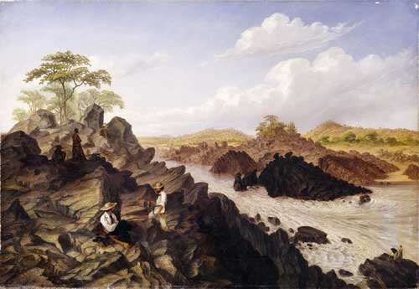
The steamer that was to take them along the Zambezi, the Ma Robert, started to leak and took too much fuel. Near the town of Tete, the expedition members had to continue on foot. They found rapids along the river which meant that no boats could travel along it.
(Thomas Baines watercolour of Rapids. 1859)

Instead, they travelled along the River Shire. When they reached the upper Shire, they met Arab slave traders, and became involved in battles with Africans and slave traders. At this point, Mary Livingstone joined her husband, but contracted malaria and died on the banks of Zambezi in April 1862.

The final part of the expedition was taken up by Livingstone trying to launch a steamer on Lake Nyasa to stop slave traders getting access to the Shire Highlands by crossing the lake of the River Shire. He decided to drag the steamer over many miles of sandbanks, bringing the men on the verge of mutiny.

In 1864, the expedition was ordered home by the British government who were disappointed by the results of their explorations.

