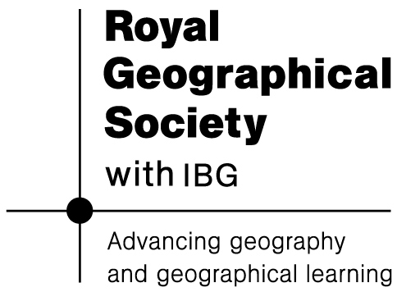
Lesson 1
Does the rise of the ‘global middle class’ mean that poverty is becoming a thing of the past?

Starter
What does ‘global middle class’ mean?
Specification advice

Edexcel, OCR, AQA, WJEC and IB Diploma centres will all be investigating aspects of the development gap between countries, globalisation, trends in resource consumption and sustainable development. These topic areas touch one another closely, especially within the context of A2 synoptic geography (and IB Higher Level Paper 3 Global Interactions). Information given here will be useful for students following all of these courses.

Historically, the phrase ‘middle class’ came to describe a socio-economic group sandwiched between the workers (or ‘working class’) and the ‘ruling’ class in European countries. Today, the idea of a ‘global middle class’ is used to describe a growing mass of people who no longer experience the absolute poverty still endured by one billion people globally. However, they have not yet achieved the affluent lifestyles of the ‘western world’.

Opinions vary on what exactly defines this ‘middle class’. Essentially it describes those who are left with disposable income after essentials (shelter, heating, food) have all been paid for. At the bottom end of the middle class income range, this might include someone who can afford to buy a non-essential can of Coca-Cola. At the upper end of the income range, it means having enough money to buy a fridge, smartphone or even a cheap car.
Key terms

emerging economies Middle-income nations that are undergoing industrialisation and rapid domestic market growth. They show high annual growth in their GDP.

newly industrialised countries (NICs) Middle-income nations where exports and average earnings have risen at high rates. The ‘first wave’ of NICs were identified during the 1970s and included the ‘Asian Tigers’ (Hong Kong, Singapore, South Korea and Taiwan). They have recently been joined by many more in a ‘second wave’ that includes the rising India and China.

development gap A term used to describe the polarisation of the world’s population into ‘haves’ and ‘have-nots’. It is measured using economic and social development indicators.

According to organisations like the United Nations and the Organisation for Economic Co-operation and Development (OECD), the global middle class incudes people who earn or spend between US$10 to US$100 per day. That is the equivalent of an income between US$3,650 and $US36,500 a year.

Estimating people’s income or spending is not easy, however. Different countries use different currencies. Also, money goes further in some places than others. Income figures for different countries are therefore adjusted to take into account purchasing power parity (PPP). For example, the average income in China is roughly US$7,000 but this becomes US$10,000 when adjusted for PPP.
Key terms

BRIC nations An acronym for Brazil, Russia, India and China. These countries have large economies, large populations and have had high growth in recent years.

demographic dividend A phase in the growth of a country’s population that offers high potential for growth. A country’s fertility rate falls during the demographic transition. The result is fewer dependent children and relatively more productive teenagers and adults in the population. A large body of young, aspirational people can be a locomotive for economic growth.

purchasing power parity A measure of average wealth that takes into account the cost of a typical ‘basket of goods’ in a country. In low-income countries, goods often cost less, meaning wages go further than in a high-income country.

There is also a slightly poorer class known as the world’s fragile middle: the almost 3 billion people in the developing world living on between US$2 and US$10 per day, ‘putting them above the poverty line but often still struggling for the financial security that is a middle class hallmark’ (Financial Times, 13 April 2014). Many of these people are projected to see their incomes rise to above US$10 a day by 2030, barring any limits to growth (see themes explored in lesson 2).

The Brookings Institution estimates that there are currently 1.8 billion people in the $US10-100 global middle class, but this will grow to 3.2 billion by the end of the decade as the fragile middle see their incomes rise and join them.
Teaching tip

Play this short film (2 min): http://www.bbc.co.uk/news/business-22956470The

Big Mac Index provides an interesting way of comparing different countries: http://www.economist.com/content/big-mac-index

Global middle class fact file

- The new global middle class in China, India and Brazil have propelled their economies to equal the size of the industrialised G7 countries. By 2050, they are forecast to account for nearly half of world output, far surpassing the G7.
- Asia is almost entirely responsible for this growth. Its middle class is forecast to triple to 1.7 billion by 2020.
- By 2030, Asia will be the home of 3 billion middle class people. This would be 10 times more than North America and five times more than Europe.
- There is also substantial growth in the rest of the emerging world. The middle class in Latin America is expected to grow from 181 million to 313 million by 2030, led by Brazil. And in Africa and the Middle East, it is projected to more than double, from 137 million to 341 million.

Source: BBC http://www.bbc.co.uk/news/business-22956470
‘The rise of the global middle class’ 13 June 2013
Main activity
(1) Charting the rise of the global middle class

One of the most remarkable feats in human history has been the lifting of about one billion people out of absolute poverty in the past couple of decades. Much of the growth has taken place in Asia and Latin America - over 500 million people have been lifted out of poverty in China alone. But Africa has a growing share of the new global middle class too.

According to the Financial Times (13 April 2014), the tough question is: why are the major changes happening now? For most of the post-war period, the surprise was why poorer countries didn't grow more quickly than rich ones. Then growth really appeared to take off after the 1990s (Table 1). Possible answers include:

- Richard Freeman of Harvard University attributes it all to the ‘great doubling’. The global labour force (people linked with the free market world economy) doubled to 3 billion people when China, India and Eastern Europe re-joined the world economy. This argument suggests that this helped boost productivity and wealth creation on a planetary scale
- China's ‘open door’ policy took off in 1992, India turned outward (and embraced globalisation) after a 1991 balance of payments crisis. Once communism fell in the Soviet Union, people living in former Soviet satellite states started to become ‘globally networked’ too.
- Economic theory says that because they are further from ‘the technology frontier’, emerging economies are now really seeing the benefits from existing scientific know-how, and thus are growing more quickly than rich, developed ones, which grow only by innovating.

Table 1: Rising incomes in Asia 1990-2011

 | Per capita income (US$) 1990 | Per capita income (US$) 2011 | Average growth rate (%) 2000-11
Indonesia | 621 | 3494 | 15
Malaysia | 2418 | 9656 | 8
Philippines | 719 | 2370 | 8
Thailand | 1495 | 4972 | 9
South Korea | 6153 | 22424 | 6
Taiwan | 7521 | 20100 | 4
China | 314 | 5444 | 17
India | 374 | 1489 | 11
Source: World Bank
Teaching tip

Use Table 1 (above) as the data stimulus for the following homework essay: Compare the development progress for the countries shown. Suggest reasons why the data vary so much from country to country.

A lot of attention has been focused on the BRIC group and, just recently, the MINT group (Mexico, Indonesia, Nigeria and Turkey). Both acronyms were coined by Jim O’Neill, a senior economist who was previously an employee of Goldman Sachs (see Table 2).

Table 2 BRIC and MINT country profiles

 | Population size | Middle class credentials
Brazil | 194 | The size of the middle class grew from 31 per cent of the population in 2000 to 47 per cent in 2012. Many are high-earners of more than $US20,000 a year.
India | 1,210 | One in twenty are middle class, but it could be one in five by 2025. Its retail market is worth almost US$700 billion annually.
China | 1,347 | One in five are middle class and they spent US$1.5 trillion in 2012, making China the world’s largest market for cars and mobiles.
Mexico | 112 | 65 per cent are middle class, each spending $US9,000 annually (Mexico is the USA’s second-largest export market). Average wage is US$2.11 an hour.
Indonesia | 238 | The consuming class, or middle class, of people earning more than US$10 a day is predicted to grow from 45 million today to 135 million by 2030.
Nigeria |  | The middle class make up about 23% of the Nigerian population, according to African Development Bank (AfDB) data. Nigeria’s per capita GDP increased from $390 in 2001 to $2,800 in 2014.
Teaching tip

Use Table 2 as the stimulus for independent research. Students working individually or in small groups can each prepare a 5-minute presentation on one of the countries shown, to be delivered either as a talk or PowerPoint presentation.

Main activity
(2) Are global poverty reduction targets being met?

The Millennium Development Goals (MDGs) are eight specific goals to be met by 2015 that aim to combat extreme poverty across the world.

- Eradicate extreme poverty and hunger
- Achieve universal primary education
- Promote gender equality and empower women
- Reduce child mortality
- Improve maternal health
- Combat HIV and AIDS, malaria and other diseases
- Ensure environmental sustainability
- Develop a global partnership for development

These goals were created at the UN Millennium Summit in New York in 2000. The Millennium Declaration, adopted by the world leaders, promised to: ‘free all men, women, and children from the abject and dehumanizing conditions of extreme poverty.’ The declaration was adopted by 189 nations and signed by 147 heads of state. At the UN MDG Summit in September 2010, world leaders reaffirmed their commitment to the Goals.

Progress towards these targets has been uneven. In East Africa, in countries like Kenya and Tanzania, considerable progress needs to be made. Yet on a planetary scale, the rise of the global middle class (and the fragile middle just below) means that major progress has been made towards the eradication of extreme poverty.

Key facts include:

- Poverty rates have been halved globally, and about 700 million fewer people lived in conditions of extreme poverty in 2010 than in 1990.

- The proportion of people in developing countries living in absolute poverty (on US$1.25 a day of less) has fallen from 41% to 26% between 1990 and 2010 if China is not included in the data.

- When China is included, the figures are 47% and 22% - even more impressive. This shows that change in China has played a key role when it comes to global targets being met (see case study of China, below).

- However, poverty remains widespread in sub-Saharan Africa and some parts of Southern Asia. The poverty rate in sub-Saharan Africa fell only 8 percentage points over the same period. Find out more at: http://www.un.org/millenniumgoals/pdf/report-2013/mdg-report-2013-english.pdf

Case study: Rising incomes in China
Teaching tip

Watch the lecture given by Felix Preston, which includes much of the material about China provided here:

http://www.21stcenturychallenges.org/challenges/mobile-middle-class/

In China, extreme poverty dropped from 60 per cent in 1990 to 16 per cent in 2005 and 12 per cent in 2010. How has this been achieved?

- China’s economy was industrialised in 1978 after decades of central planning.
- As a result of rapid industrialisation, 50% of China’s 1.3 billion people now lives in cities.
- An additional 250 million people will join them by 2020.
- The disposable income of urban citizens in China rose threefold between 2000-2010. Much of this was spent on larger living spaces and on energy consuming technologies. Increasingly, urban residents use 3.7 times as much energy as rural residents.

Increasingly, young Chinese workers reject the kind of low-pay factory work that their parents were prepared to endure. China’s economy is now shifting, with central government planning and guidance, towards more opportunities for even higher-skill, higher-paid work (meanwhile, the less desirable ‘sweatshop’ jobs have migrated towards Bangladesh).

Table 3 Changing China 2000-2010
 | 2000 | 2005 | 2010 | Trend
Urban population (millions) | 459 | 562 | 666 | +107
Cars per 100 families | 0.5 | 3 | 13 | x26
Air conditioners per 100 families | 30 | 81 | 112 | x4
Refrigerators per 100 families | 80 | 91 | 97 | x1.2

The data in Table 3 (above) provide a sense of how people are ‘moving up’ in society. In the Year 2000, fewer than 1 in 200 families in China had access to a car. Today, it is closer to 13 in 200. This represents a tremendous increase in consumption and it reflects the wider growth of China, which is now predicted to overtake the USA to become the largest economy in 2014 (Financial Times, 03 May 2014). As part of this process, China has drawn in resources from all around the world to help fuel its growth (Figure 1).

However, it is also worth noting how low individual consumption levels still are in China compared with the USA, where the car ownership level is 187 vehicles per 100 households! Although China may soon be the largest economy in terms of total size, it is still ranked at 83rd globally (2013 values) in terms of per capita income when adjusted for PPP.
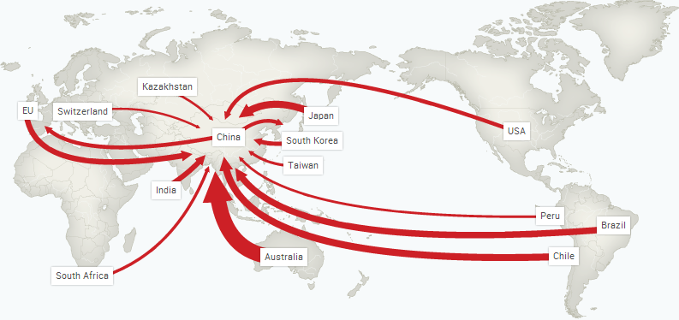
Figure 1 China’s imports of metals 2000–2010, proportional value
Source: Felix Preston presentation

Is growth in China sustainable? This theme will be returned to in the next lesson. Already there is tremendous pressure on transport systems in China, and it is hard to see how millions more cars can be accommodated in the coming years. This story applies to the energy needed to power air conditioning units and refrigerators too. Water supply is another important security concern.

Topic update: how much progress have the fragile middle made?

The Financial Times series ‘The fragile middle’ (April 2014) analysed the extent to which the gains made by the lower middle class (those people whose income is closer to US$2 per day) could be lost in the event of a protracted downturn in the global economy or a supply crisis over, say water. Figure 2 shows growth has slowed in many countries.

Figure 2 Fluctuating economic growth 2003-2013

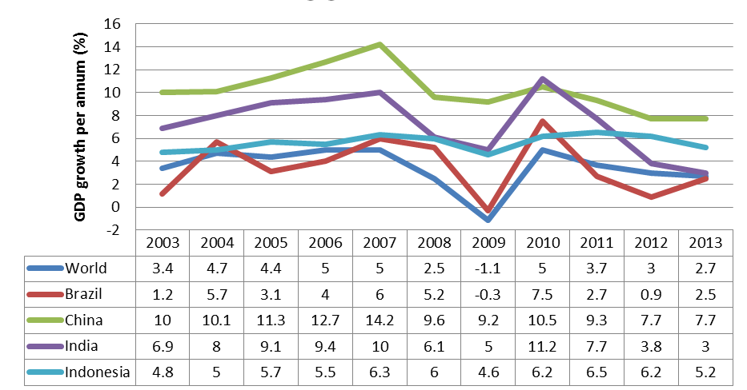

- Growth in India has recently stalled despite its favourable demographics. Some commentators see a political failure to create the right climate for foreign investment.
- Brazil has slowed too. Its manufacturers have struggled to match prices against Chinese competition in overseas markets. There is a large, growing consumer class but rising social unrest led to widespread rioting in urban areas in 2013.

In charting the rise of the global middle class, it is important to remember this is a relatively new, rather than well-established, trend. As such, there are any number of potential ‘shocks’ that might lie ahead, as we explore in the next lesson.

Plenary
21st Century Challenges for the fragile middle

- What are the greatest 21st Century Challenges that might derail growth and potentially strip away some of the gains made by the middle and fragile middle classes?
- In preparation for next lesson, give students (working in groups of three) sixty seconds to discuss and nominate the greatest challenge. Expect climate change and energy shortages to be popular choices, but they may also see that food and water security are essential. In reality, all of the major geographical challenges are inter-linked.
- Figure 3 is taken from an A2 exam paper and shows one student’s attempt to show the linked challenges. Positioned at the top is ‘rising affluence’. Is anything missing / could anything be improved?

Figure 3: extract from A2 exam paper for discussion
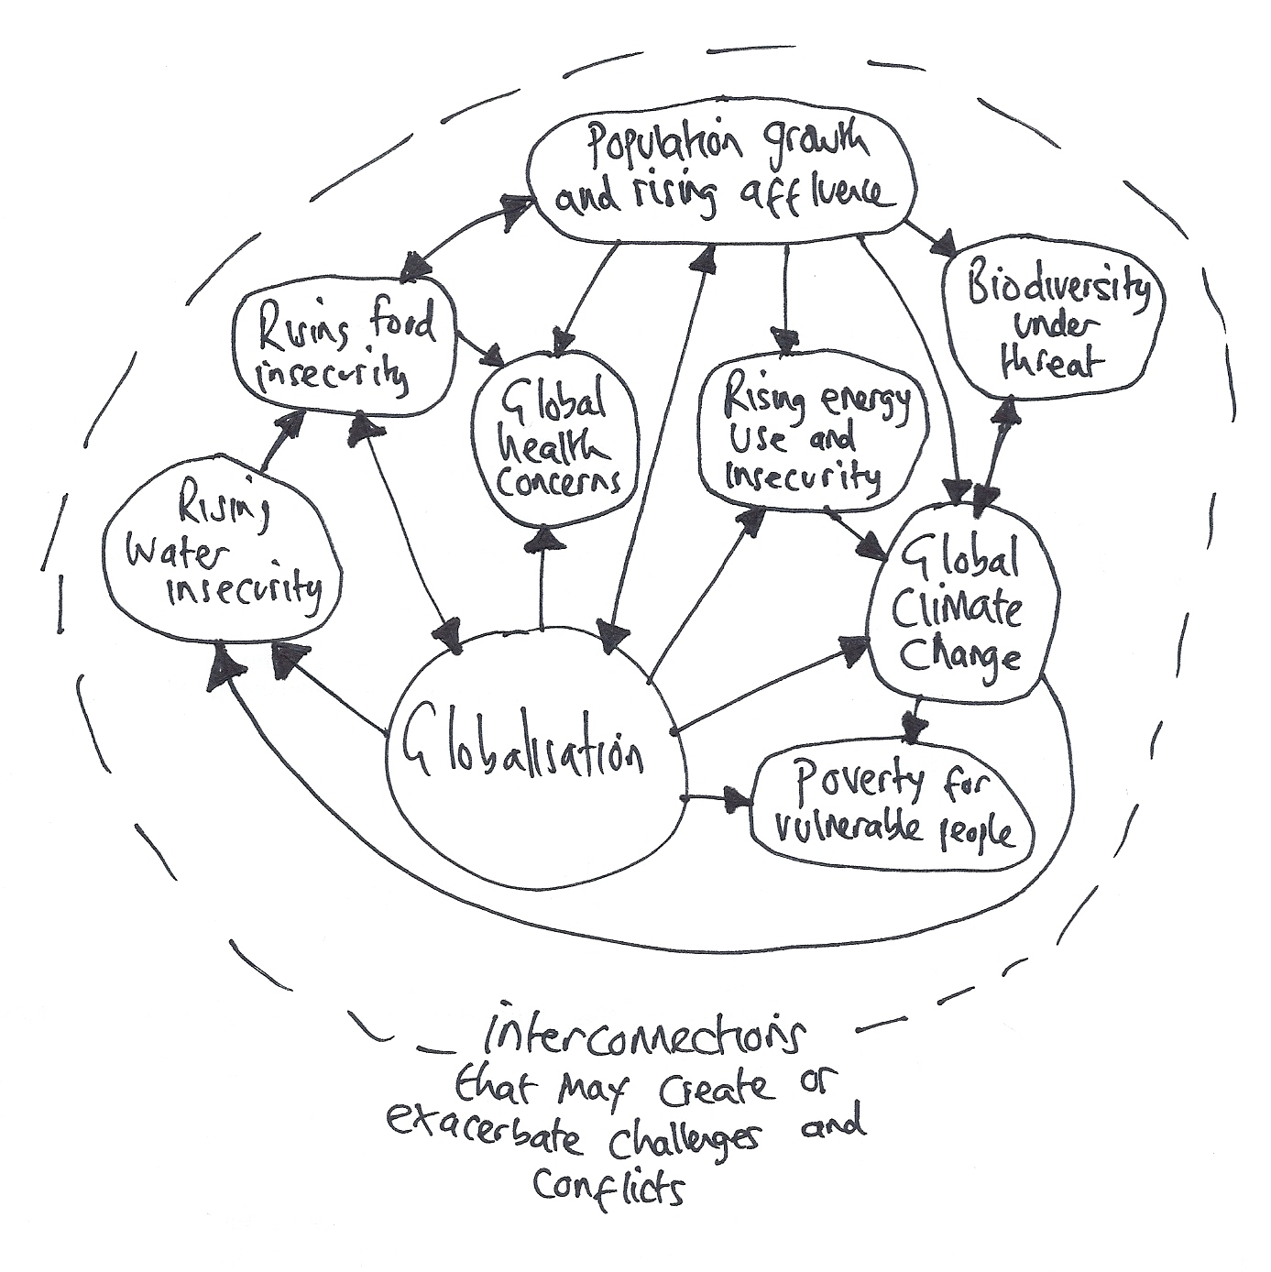

Lesson 2
Rising consumption and the sustainability challenge

Starter
Population growth or rising consumption: which poses the greatest threat to the sustainability of natural resources?
Key terms

natural resource Some part of the physical environment that has been used to satisfy human needs and wants. Natural resources may be renewable (sustainably managed forest, wind power and solar energy) or non-renewable (fossil fuels).

human resources The working-age people found in a place who can generate wealth with the skills and capabilities they possess.

carbon footprint The amount of carbon dioxide produced by an individual or activity.

ecological footprint A crude measurement of the area of land or water required to provide a person (or society) with the energy, food and resources they need to live and to also absorb their wastes. For someone in the UK, it is about the size of six football pitches (the global average is one third of this).

Natural resources are those things that occur naturally in the environment which humans have deemed useful and which can be used to improve people’s quality of life (both welfare and wealth). These include food, metals, energy, and also water.

Certain resources, such as the biomass that provides food, are renewable, provided conservation principles are applied to their management. However, the permanent loss of certain animal and fish populations, or areas of cultivatable land, due to unsustainable hunting, fishing and agriculture, may mean that in practice these have sometimes ceased to be renewable. Water sources like aquifers and inland lakes can be similarly mismanaged.

Non-renewable resources, including minerals and fossil fuels, exist in finite amounts. The best that can be hoped for is that we can slow down the flow from these stocks, or to hope that a technological fix will allow new reserves to be discovered / recovered.
Specification advice

Students of all A-level boards ought to be able to take a look at all of the combined geographical factors that impinge upon sustainable development – and offer an evidenced viewpoint as to whether they think it is really achievable. AQA mark schemes call it ‘thinking like a geographer’. Edexcel mark schemes call it ‘assessing a viewpoint’.

Population growth, of course, puts pressure on resources (it stands to reason, if there are more mouths to feed and more homes to heat). In the 1970s, a high profile group of academics, known as the Club of Rome, developed the limits to growth model. Drawing on ideas from two centuries earlier, these ‘neo-Malthusians’ were very concerned with population growth (the fertility rate was still very high in much of the ‘global south’). In one scenario, the Club of Rome foresaw global population rising to well over 12 billion before catastrophically reducing, on account of food and resource shortages.
Today, population growth has thankfully slowed. In Bangladesh, the fertility rate is now less than 3 births per woman. As a result, global population growth is expected to rise to no more than 9 billion by 2050 (with much of the rise actually attributable to increasing longevity and fewer deaths, rather than an additional 2 billion live births).

Unfortunately, reduced population growth does not necessarily mean that the ’limits to growth’ will no longer be reached. This is because it is perfectly possible for a population to exceed the carrying capacity of its environment without further population growth. Increased, existing numbers of people will be consuming more water, food calories, energy and materials.

People existing on below US$2 per day are generally unable to meet anything other than very basic needs of food, water, rudimentary shelter and heat from burning biomass (globally, as many as 1.3 billion people still have no access to electricity). In contrast, people earning upwards of US$2 a day may have a little money left over to buy themselves consumer items, such as clothes, and thus begin to shift towards a more energy-intensive lifestyle.

It is this scenario that is now playing out in countries like Indonesia and Brazil. The era of great population growth may be over, but the era of mass consumption has truly arrived (in his classic development model, Walt Rostow identified the stage of ‘high mass consumption’ as the developmental phase that follows industrialisation, or ‘take off’).

Key statements from the Royal Society report on consumption

- Population and consumption determine the rates at which natural resources are exploited and the ability of the Earth to meet our food, water, energy and other needs now and in the future;
- Current patterns of consumption in some parts of the world are no longer sustainable;
- The combination of unsustainable consumption and the number of people on the planet can directly affect our capacity to support natural biodiversity.

Teaching tip
Allow students to read and absorb this material for a few minutes before inviting a brief discussion of the key issues. They should also keep a glossary of key terms.

For further reading, see Geography Review 27:1 (2013) ‘Everybody’s talking about consumption’.

Also, use this fantastic interactive website, if time allows: http://resourcesfutures.org/#!/introduction

Main activity
(1) Are current trends in resource consumption sustainable?

As A-level and Diploma students will doubtless already be aware, sustainable development is equated with non-exhaustive resource consumption. This approach leaves future generations with stocks of non-renewables to utilise. Conservation principles are therefore applied to the management of renewables, such as water, agricultural land and forest.
Key terms

sustainable development A ‘roadmap’ for development that aims to ensure that the current generation of people should not damage the environment in ways that will threaten future generations’ quality of life. In addition to environmental stewardship, sustainable development also encompasses social and economic sustainability for communities.

rare earths A collection of seventeen different chemical elements not often found in concentrated and economically exploitable forms. These natural resources are very important for a whole range of industrial processes including mobile phone manufacturing.

Figure 4 Value of imports 1998-2010

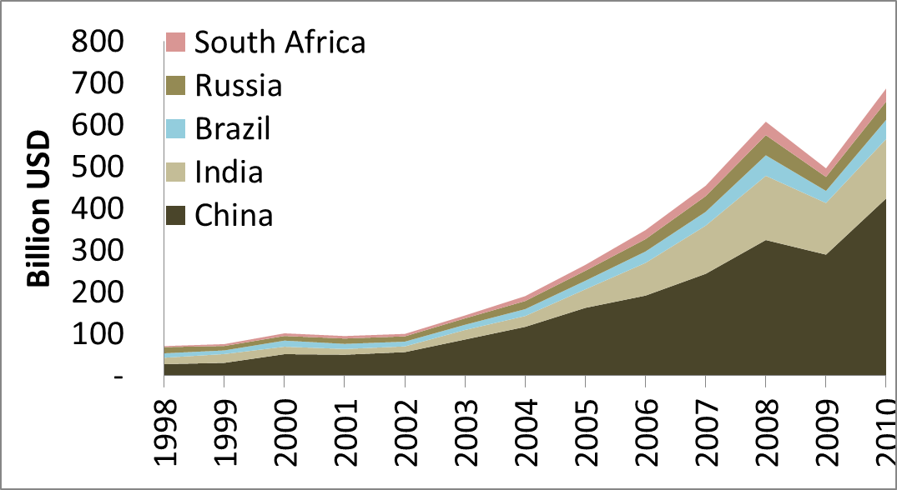
Source: Felix Preston lecture

But just how sustainable are current trends in resource consumption? Figure 4 shows trends in imports for five large emerging economies. China, shown at the bottom, is by far the largest both in terms of its resource consumption and its overall absolute growth. India is playing a prominent role too.

One important point to note is that emerging economies are consuming these resources partly in order to build cities and industries the purpose of which is to produce goods which are then consumed in other places like the EU and USA. Clearly, the growth trends shown will continue to have an upward trajectory!

The result of rising demand has been a decade of high prices and price volatility, meaning natural resources are firmly back on the political agenda again (Figure 5). Most resource prices climbed dramatically high a few years ago and have since stayed there. This dramatic increase in prices across the range of natural resources is an extremely sensitive issue for governments (Table 4). When prices increase, it hurts the poorest, including the fragile middle, most.

Figure 5 International commodity prices 1980-2013

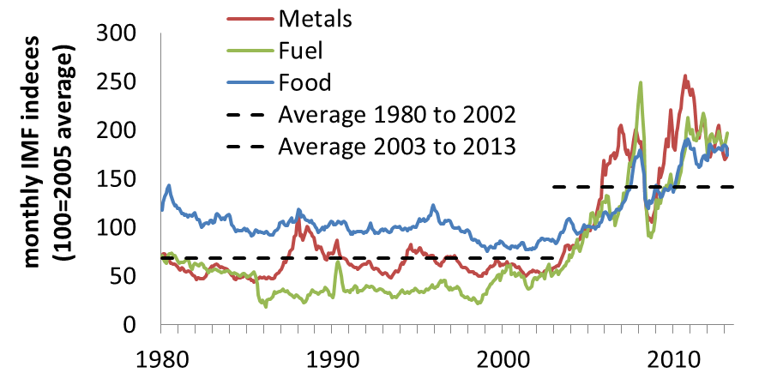
Source: Felix Preston lecture

Figure 6 (also available as a separate hand-out for students) provides another analytical focus. It is reproduced (with permission) from the ‘Resources Futures’ report from Chatham House.

- The grey lines (the inner lines drawn for each flow) show the state of play in 2000, while the coloured lines show the increase by 2010.
- This illustration of the expansion in exports from different parts of the world provides a snapshot of the dramatic state of growth across all kinds of resources markets.
- Emerging economies such as China are responsible for almost all growth in resource consumption during the last ten years across nearly every category.
Edexcel AS-level teaching tip
This graphic provides a very valuable resource to support teaching of Unit 1 (global networks).

Ask students to:

identify the fastest-growing flows of trade
identify important global hubs for trade
suggest reasons for the changes shown

Figure 6 Growth in global trade flows 2000-2010

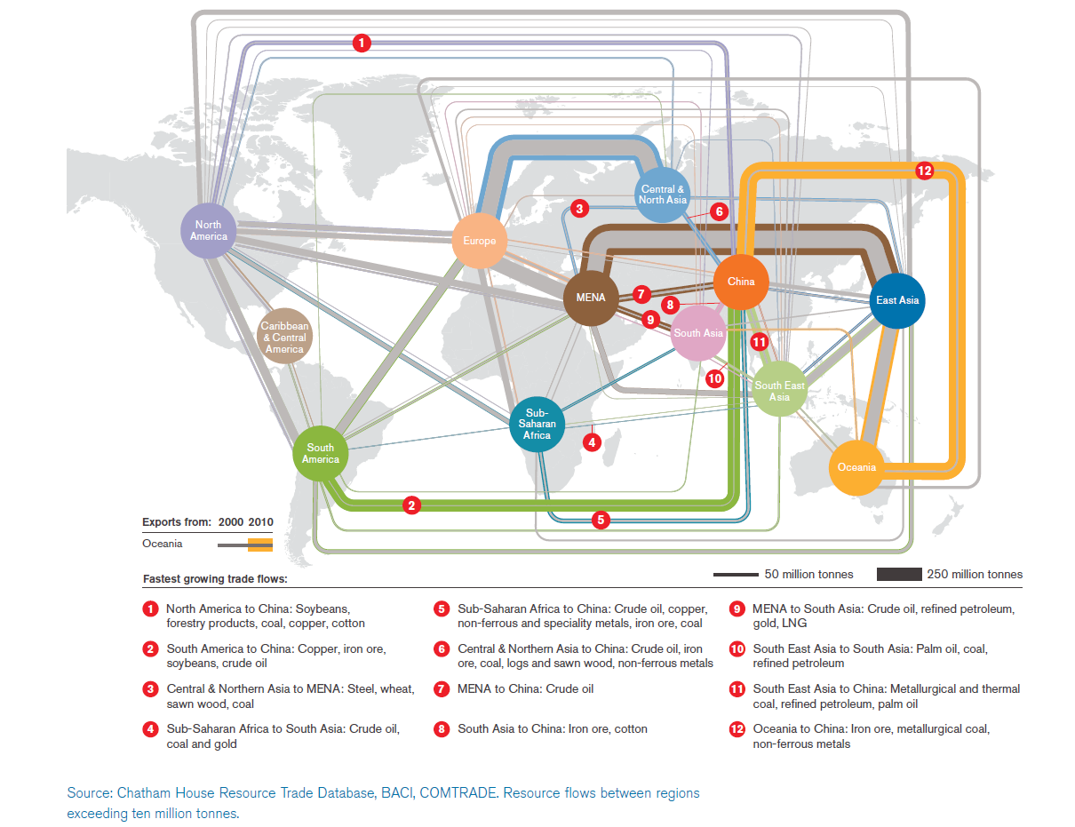
Source: Felix Preston lecture / Chatham House [http://www.chathamhouse.org/sites/default/files/public/Research/Energy,%20Environment%20and%20Development/1212r_resourcesfutures_es.pdf]
Table 4 Growing middle-class pressure on natural resources

Food | By 2050, food demand is expected to increase by 70%-100% worldwide. A step-change in productivity is needed, particularly in sub-Saharan Africa. Middle-class diets are characterised by their greater consumption of meat and dairy (higher protein). But due to the inefficient way food chains operate, animals use up a lot of converted biomass energy roaming around, defecating and respiring. Beef cattle eat about 8kg of grain for every kilogram of flesh they produce; a kilogram of battery-reared chicken needs just 2kg of feed. With meat consumption escalating in the BRIC and MINT nations, less grains and cereals are left to be sold cheaply as food on global markets to people in the poorest nations.
Energy | We can expect an increase in demand of 18% by 2020, and a 50% increase by 2035. Over half a trillion dollars of investment is needed every year until 2035 to meet projected demand for oil and gas alone.
Water | Growing demand for water comes from a mixture of urban consumers, agricultural producers, industry and dams (for hydroelectric energy supply). Food and drink producers place enormous demands on water supplies. Crop cultivation, crop processing, food distribution (and even the final recycling phase for food and drink packaging) all require water. Agriculturally-driven water stress is especially evident in the Indus river basin (which is home to the world’s largest irrigation system).
Metals and rare earths | We may expect an overall growth in demand for metals of 30-50% between 2010 and 2020, Rare earth demand will double from 2010 levels.
Manufactured goods | More clothes are being purchased which, in the case of cotton, also brings a big rise in water footprint. Plastic household items, from plates to toys, use oil. More expensive manufactured items, especially televisions and ‘white goods’ such as fridges and electric cookers, use metals and plastics in their manufacture. They consume electricity throughout their working life. All of this drives energy consumption, potentially increasing the world’s carbon footprint further. At the end of their useful life, manufactured items must be disposed of, perhaps in landfill, which increases the ecological footprint of consumer populations even further.
Hi-tech goods | Both smartphones and less sophisticated mobiles are increasingly priced within the grasp of the poorer end of the global middle class, as Figure 7 shows. 60% of people living in Africa have a mobile phone; in India, there are over one billion subscriptions. The manufacture of these items require inputs of rare earths.
Figure 7 Growing global use of mobile phones

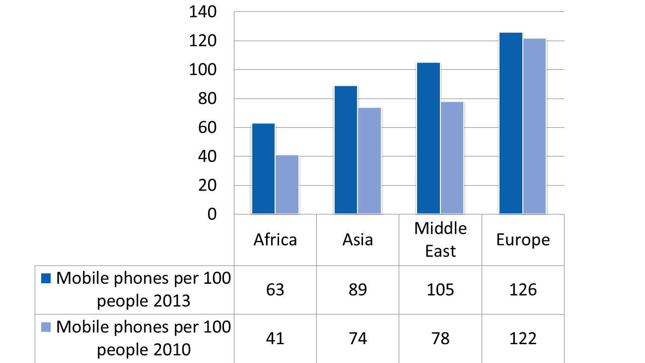

Main activity
(2) Exploring global food and water consumption

Example 1: Global pressure on food supplies

Wherever we look, the story is that people are eating more. Mostly that would be considered a good thing but it does put more pressure on the production of global resources. In many cases, emerging economies are still consuming a lot less than the EU and USA in terms of their calorie intake per capita. However, they are increasingly switching to meat consumption, which is extremely water-intensive agriculture. It is also closely related to forest clearance and a whole range of other environmental issues which often link with climate change.

According to UK government scientific adviser Professor John Beddington, increasing wealth is causing a food crisis globally: ‘Once you move to [an income of] between £1 a day and £5 a day you get an increase in demand for meat and dairy products ... and that generates a demand for additional grain.’ Consider the following facts:

- Average per capita consumption of meat in high-income economies increased from 56 kg per annum in 1990 to 94 kg in 2002.

- Whereas, China’s annual meat consumption per capita went from 4 to 52 kg and Brazil’s from 28 to 82 kg in the same time period.

- In India, calorie intake could rise by 20% by 2030, while China’s meat consumption could rise to 75kg – still below western levels.

- One-third of the world's land is already experiencing desertification attributed to overgrazing, with livestock producing about 80 million metric tonnes of methane per year. Producing 1kg of potatoes requires 500 litres of water; 1kg of beef requires 15,000 litres.
Example 2: Global pressure on water
Key terms

water footprint is a measure of the amount of water than was used in the production and transport to market of food and commodities.

water stress is the term used when the annual supply of water directly available per person (not including ‘virtual water’) falls below 1,700 cumecs.

water scarcity is the term used when the annual supply of water directly available per person falls below 1,000 cumecs.

Some of the world’s key agricultural centres are threatened by water scarcity. Based on their population density, vulnerable regions include: eastern parts of North America, central parts of Europe, Northern Asia, India, Southeast Asia, Japan and the Middle East.

- 35% of water use globally in the industrial sector is used in the mining, transport, processing or energy-related industries. Growth is expected in all of these.

- There is also growing water demand from populations in urban areas. The growth in water resource consumption is closely tied to urbanisation and urban middle class growth in emerging economies (though their consumption is still below western levels).

Figure 8 Global production of key resources in water stress areas

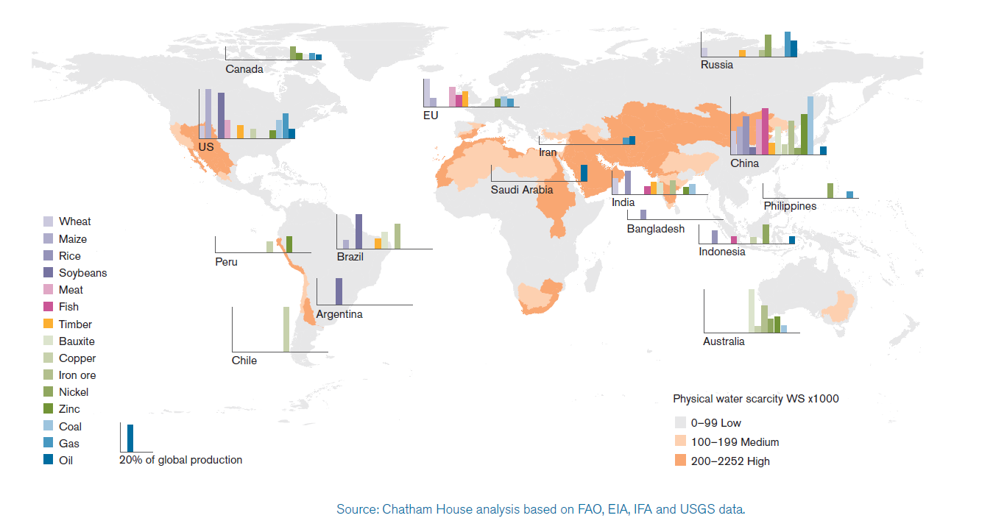
Teaching tip
Use Figure 8 as the basis for a class discussion, homework assignment or the stimulus for independent research. Each student could choose a different resource from the key and research (a) where the main production areas are located (b) how much demand the industry places on local water supplies.

Figure 9 Cities of 100,000+ people in areas of water shortage

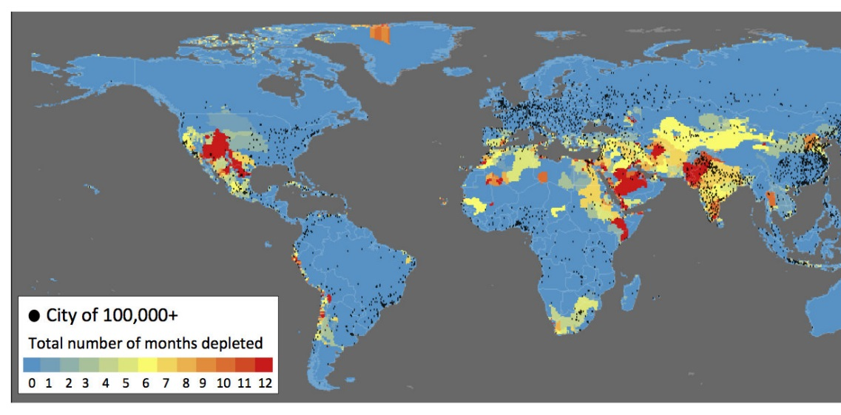

The world’s emerging economies are increasingly urbanised too. Sometimes, the cities that people migrate to are located in areas of water stress, unlike the places they have left behind! Many of the world’s growing cities are badly in need of new, low-cost, and reliable sources of water, as the picture above shows.
Teaching tip
Ask students to study Figure 9 alongside an atlas. They should try to identify any major urban concentrations in regions showing a water shortage for more than 6 months of the year. Next, they should establish how many of these urban regions are located in emerging economies where water demands are rising sharply (with special attention paid to the BRIC and MINT groups).

Plenary
Could emerging economies be the solution, not the problem?

When speaking at the Royal Geographical Society recently, Felix Preston noted that discussion about emerging economies and natural resources frequently presents countries like China as a ‘dangerous threat’ to the planet. Which is a pity given that the rise of the global middle class is an incredible human success story. Billions of people have escaped poverty.

The viewpoint that sees China as no more than a threat to global sustainable development is, in fact, poorly informed. The truth is more complex and nuanced. This is because emerging economies are also pioneering some of the global solutions needed to resource depletion and shortages everywhere, including the developed countries. However, emerging economies may suffer disproportionately in the event of resource shortages and rising prices due to the relatively lower incomes of their citizens. The fragile middle in particular would lack resilience. Thus it comes as no surprise that China is, in fact, investing large amounts of money in renewable energy and measures to reduce carbon emissions.

This is reminiscent of the famous maxim ‘necessity is the mother of invention’ used in the past by Ester Boserup. She took an optimistic view on the relationship between population and resources, arguing that innovation will raise the carrying capacity of the land once necessity demands it.

We can look at the world today and find similar grounds for optimism:

- The BRIC-MINT urban middle classes are driving up resource use, but they are politically engaged with being part of the solution.
- Emerging economies are now among the leaders in resource efficient technology and renewable energy.
- China’s middle classes citizens have become highly active, both on the streets and online, in raising awareness about poor water and air quality (Photograph 1). In response, China’s government is highly engaged with trying to clean up its act.
- Chinese leaders met with the US administration in 2014 to discuss ways of reducing their carbon emission intensity even further.
- China’s government launched the ‘1000 industries’ programme recently, instructing the chief executives of China’s top 1000 businesses to make greater steps towards energy conservation.
- By 2020, many experts predict that a lot of Chinese industry will be world class when it comes to energy intensity improvement.
- China’s manufacturing revolution is actually driving down the costs of low carbon, resource-efficient technologies like LEDs. Mass production can bring these technologies to the masses.

Find out more at: http://www.eurobiz.com.cn/sustainable-development-urbanisation-drives-innovation/

