MODULE 4: how do we PREDICT THE FUTURE?

Answer Sheet
Aims: To understand that although it is difficult to forecast the weather, climate change is determined by large scale features which it is easier to make predictions about.
To understand it is not possible to make a perfect prediction.
To understand how past climates are measured
To investigate the instruments used to measure the elements of the weather.
To understand the stages of making climate predictions

Activity one
This activity builds on the activities in the Introductory Module. It illustrates how difficult it is to predict the weather with any accuracy. It illustrates how the daily weather can be very different from the climate at a particular time of year. The final part of this activity shows how prediction models can be biased to give certain results and this has to be considered in computer modelling.

Activity two
Projecting changes in climate due to changes in atmospheric composition or other factors is a much more manageable task than predicting the weather. As an analogy, while it is impossible to predict the age at which any particular person will die, we can say with high confidence what the average age of death for the population is.

Activity three
The article should include mention of ice cores and tree rings prior to 1850 and the development of more accurate measurements since then. The addition of data from Antarctica completed the knowledge of global circulation models.

Activity four
Temperature – thermometer
Precipitation – rain gauge
Humidity – hygrometer
Cloud cover – observation
Wind direction – wind vane
Wind speed – anemometer
Pressure – barometer

Activity five
There are many stages involved in making climate forecasts. These include:
- Making estimates of the gases and particles that will be released into the atmosphere in the future. These are created by making assumptions about population growth, energy use, economic and technological developments;
- Using carbon cycle models to convert emissions to concentrations of greenhouse gases in the atmosphere. More assumptions have to be made, based on our knowledge of things like how ecosystems respond to changing carbon dioxide availability etc;
- Using full climate models to calculate the effects of increasing greenhouse gas concentrations on global climate. There are uncertainties in the models themselves, mainly due to the fact that very small scale processes have to represented in a fairly coarse sort of way, as well as uncertainties in our knowledge of the climate system – are there feedback mechanisms that will come into operation that we don’t know about?
- Translating global change into local impacts, a whole range of more uncertainties come into play, like how local land use change will impact on the chances of a particular river flooding.

Activity six
Statements which can be made with certainty are in bold.
- The climate is changing and will change in the future due to people-made green house gas emissions.
- Global temperatures will increase over the next 30 years between 0.5 – 1°C.
- We can say exactly what will happen to the climate in the future.
- An increase in global temperatures will affect every part of the world in the same way.
- We can all change our lifestyles and be a part of the solution.
- We are getting better at saying what the climate is most likely to do and what it probably won’t do.
- We cannot say exactly what will happen to the climate in the future.
- Global temperatures will increase over the next 30 years between 2 – 4°C.
- An increase in global temperatures will affect different parts of the world in different ways.
- We haven’t got a clue what the climate is going to do.

Activity seven
An animation showing the break up of ice sheets can be found at http://www.passporttothepoles.org/about.php?content=polar_futures

- Loss of ice in the Arctic will
  - Open up the north west passage for shipping
  - Affect the lifestyles of the indigenous people living in the Arctic
  - Allow greater access to mineral deposits
  - Affect the migration patterns of birds and animals

More information on the effects of climate change can be found at www.discoveringthearctic.org.uk

Aims: To categorise a range of climate predictions into themes
To investigate how the climate is expected to change in a range of continents
To investigate the impact of climate change on the Arctic
To investigate the impact of climate change on small islands

Activity EIGHT – this is not activity 8 as currently listed in the student part, it is the next one (currently 1)
The statements could be made into cards and the students could work in pairs to categorise the statements. A whole class categorisation could be done following class discussion with at least ten links identified. Climate change scientists often specialise in one category of climate change. The class could discuss the reasons for this.

Activities NINE to FIFTEEN
The class could work in groups, each group working on a different region. Different regions are more likely to be affected by some of the projected climate change impacts than others. For example:
- Sub-Saharan Africa is more likely to be affected by water stress and a reduction in crops
- Asian mega-deltas are more likely to be affected by flooding
- The Arctic is more likely to be affected by ice sheet loss and changes to the ecosystems
- Small islands are more likely to be affected by coastal erosion and inundation.
After a feedback discussion overlaps should be identified and the need for a new theme discussed. Some climate change scientists specialise in one region, the merits of this could be discussed.

Activity SIXTEEN
- These maps show what the Arctic Circle looks like now and how it is expected to look in 2080.
- Polar Regions - reductions in thickness and extent of glaciers and ice sheets will have detrimental effects on migratory birds and mammals as their current routes will change with less ice.
- Arctic permafrost will reduce with consequent effects on buildings
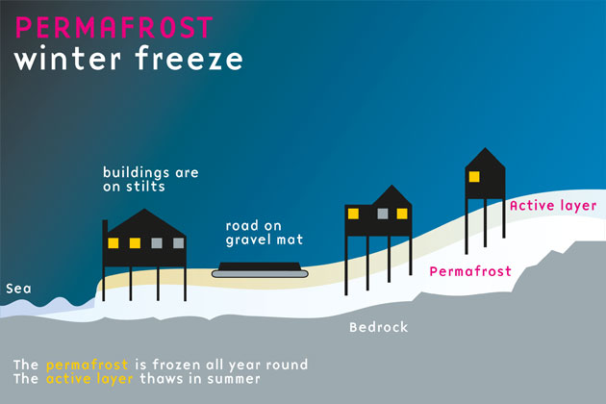
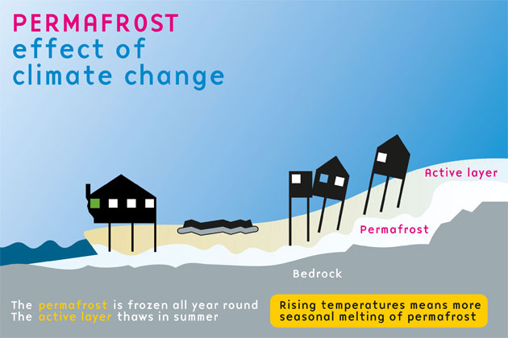
- Arctic - traditional ways of life and infrastructure will suffer as hunting routes change and the migration patterns of the birds and animals alter.
- Heating costs will be reduced
- Northern sea routes will be easier to navigate.
- The treeline will move northward to higher latitudes, with the coniferous boreal forests of the taiga replacing the tundra vegetation.
- The tundra vegetation will move into the polar deserts.
More information about climate change and the Arctic can be found at http://www.discoveringthearctic.org.uk/6_what_happens_next.html
More interactives and information about climate feedbacks can be found at http://www.discoveringthearctic.org.uk/6_sensitive_arctic.html
The ‘Ask an expert’ video ‘At what speed would we see climate change increase if the permafrost completely melted?’ could be shown at this point.

Activity SEVENTEEN
- This map shows why small islands are extremely vulnerable to the effects of climate change.
- Rising sea levels and extreme events like storm surges and cyclones are likely to damage buildings, roads and other infrastructure.
- The erosion of beaches and coral reefs will affect the fishing industry and reduce money earned from tourism.
- By 2050, many small islands in the Caribbean and Pacific could suffer from water shortages during low-rainfall periods.
- Higher temperatures will lead to increases of non-native plant and animal species, especially on mid and high latitude islands.
Aims: To investigate the difference between adaptation and mitigation.
To investigate the effectiveness of different measure in terms of:
positive and negative aspects
cost
easy to do
To explore how groups of people at a variety of scales are adapting

