Whales and whaling

There are 8 main species of whales that spend time in the southern ocean. Many feed in the nutrient rich cold waters in the summer and then migrate further north in the winter to breed and give birth. Today most whales live safely with their only possible disturbance being from whale watching trips but his wasn’t always the case.

History
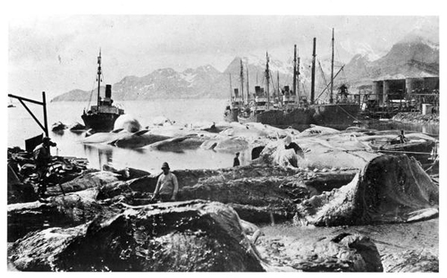
The first Antarctic whaling station was established in 1904 by a Norwegian, CA Larsen, at Grytviken, South Georgia. From this date until its closure in 1965 it processed over 54,000 whales. It was a highly profitable business making a total of around £25 million from oil, meat and bone meal products.

The Grytviken whaling station was an industrial community. As well as buildings and equipment to extract all useable materials from the whales it had everything that the population would need to support living there including a church, cinema and football ground.

Initially the whalers caught humpback whales that lived closer to the coast but as technology improved they moved offshore and targeted the largest whale, the Blue whale. As stocks declined they moved onto fin whales, sei and minke whales. Grytviken closed in 1965 when whaling stocks were so depleted that it became unprofitable to continue.

Regulations
The International Whaling Commission (IWC) was set up in 1946 to ‘regulate the orderly development of the whaling industry.’ By 1982 whale numbers were so low that they implemented a ban on all commercial whaling. Pressure from environmental groups from the 1970’s was influential in lobbying for this ban. Greenpeace took the most public and dramatic action which involved direct pursuit of whaling boats. Only Japan and Norway have continued to kill whales for scientific purposes, Japan take 300 whales each year from Antarctic waters and continue to campaign to lift the ban.

Whale watching
For many tourists the highlight of a cruise to Antarctica is to whale watch. The IWC has guidelines for whale watching which ensure that it is ecologically sustainable and they have monitored it since. The guidelines include tips to:

- Regulate the number of boats, the size and amount of noise emitted
- Offer training programmes for operators
- Provide conservation information to whale watchers

Further information

www.iwcoffice.org International Whaling Commission
www.wdcs.org Whale and Dolphin Conservation Society
www.greenpeace.org/international Greenpeace

Compiled by Kim Stephenson

