Background:
Fed up with shopping surveys and urban transects? This is the fieldwork activity for you – an alternative take on the urban study. It can be applied to any town or city and features a number of activities that you can select and adapt to suit your requirements.

This fieldwork activity was developed for a Year 9 group at Guildford High School – a selective independent school. As a result, the students achieved a lot during the time allocated and the fieldwork booklet aimed to stretch them. Teachers may therefore need to adapt the booklet to suit the abilities of their own students – it is divided in to sections to make this process easier. The activity could also be undertaken with students in Years 10 and 11.

Students were divided into groups of 5 or 6 to complete the fieldwork. As they were visiting different areas, the groups were organised so that a group from each Geography set visited each site, allowing them to share data back in the classroom. Please see the accompanying fieldwork schedule for an idea of how the day was organised. Each group was given one booklet between them, to ensure that no data was lost and to save paper and photocopying costs.

Aims:
To determine how the city of Guildford compares to other towns and cities in the country in terms of:

- The shops that it provides on the High Street.
- Its 2001 census data, including housing type / price and levels of crime.

Format of the activity:
Starter
The starter activity for this fieldwork can be found in the accompanying booklet. It involves students making predictions about what they think they will find when they go out into the field. Students read an article about clone towns from The Guardian newspaper to develop an understanding of the definition of a clone town, and decide whether they think that Guildford fits to this description. They also study national average census data for housing type and price, crime and satisfaction with the local area, and think about how Guildford will compare with this. The work is completed in groups. This activity proved very successful, preconceptions about the students’ local area were discussed and analysed within the group.

Main activity
The main activity was divided into two parts: one focusing on central Guildford, an area which all students visited at some point during the day, and the second looking at a housing area within walking distance of the centre. In this case students visited two contrasting housing areas, but as the data is shared between groups one would be sufficient.

Part One: Central Guildford – Students complete three tasks within central Guildford:
- A survey of house prices in a range of Estate Agents’ windows.
- A clone town survey using a survey form from the New Economics Foundation (NEF) (see link) to record 50 shops on the high street.
- A questionnaire of shoppers to determine which shops they prefer to shop in, and additional questions which the students have decided on within their groups.

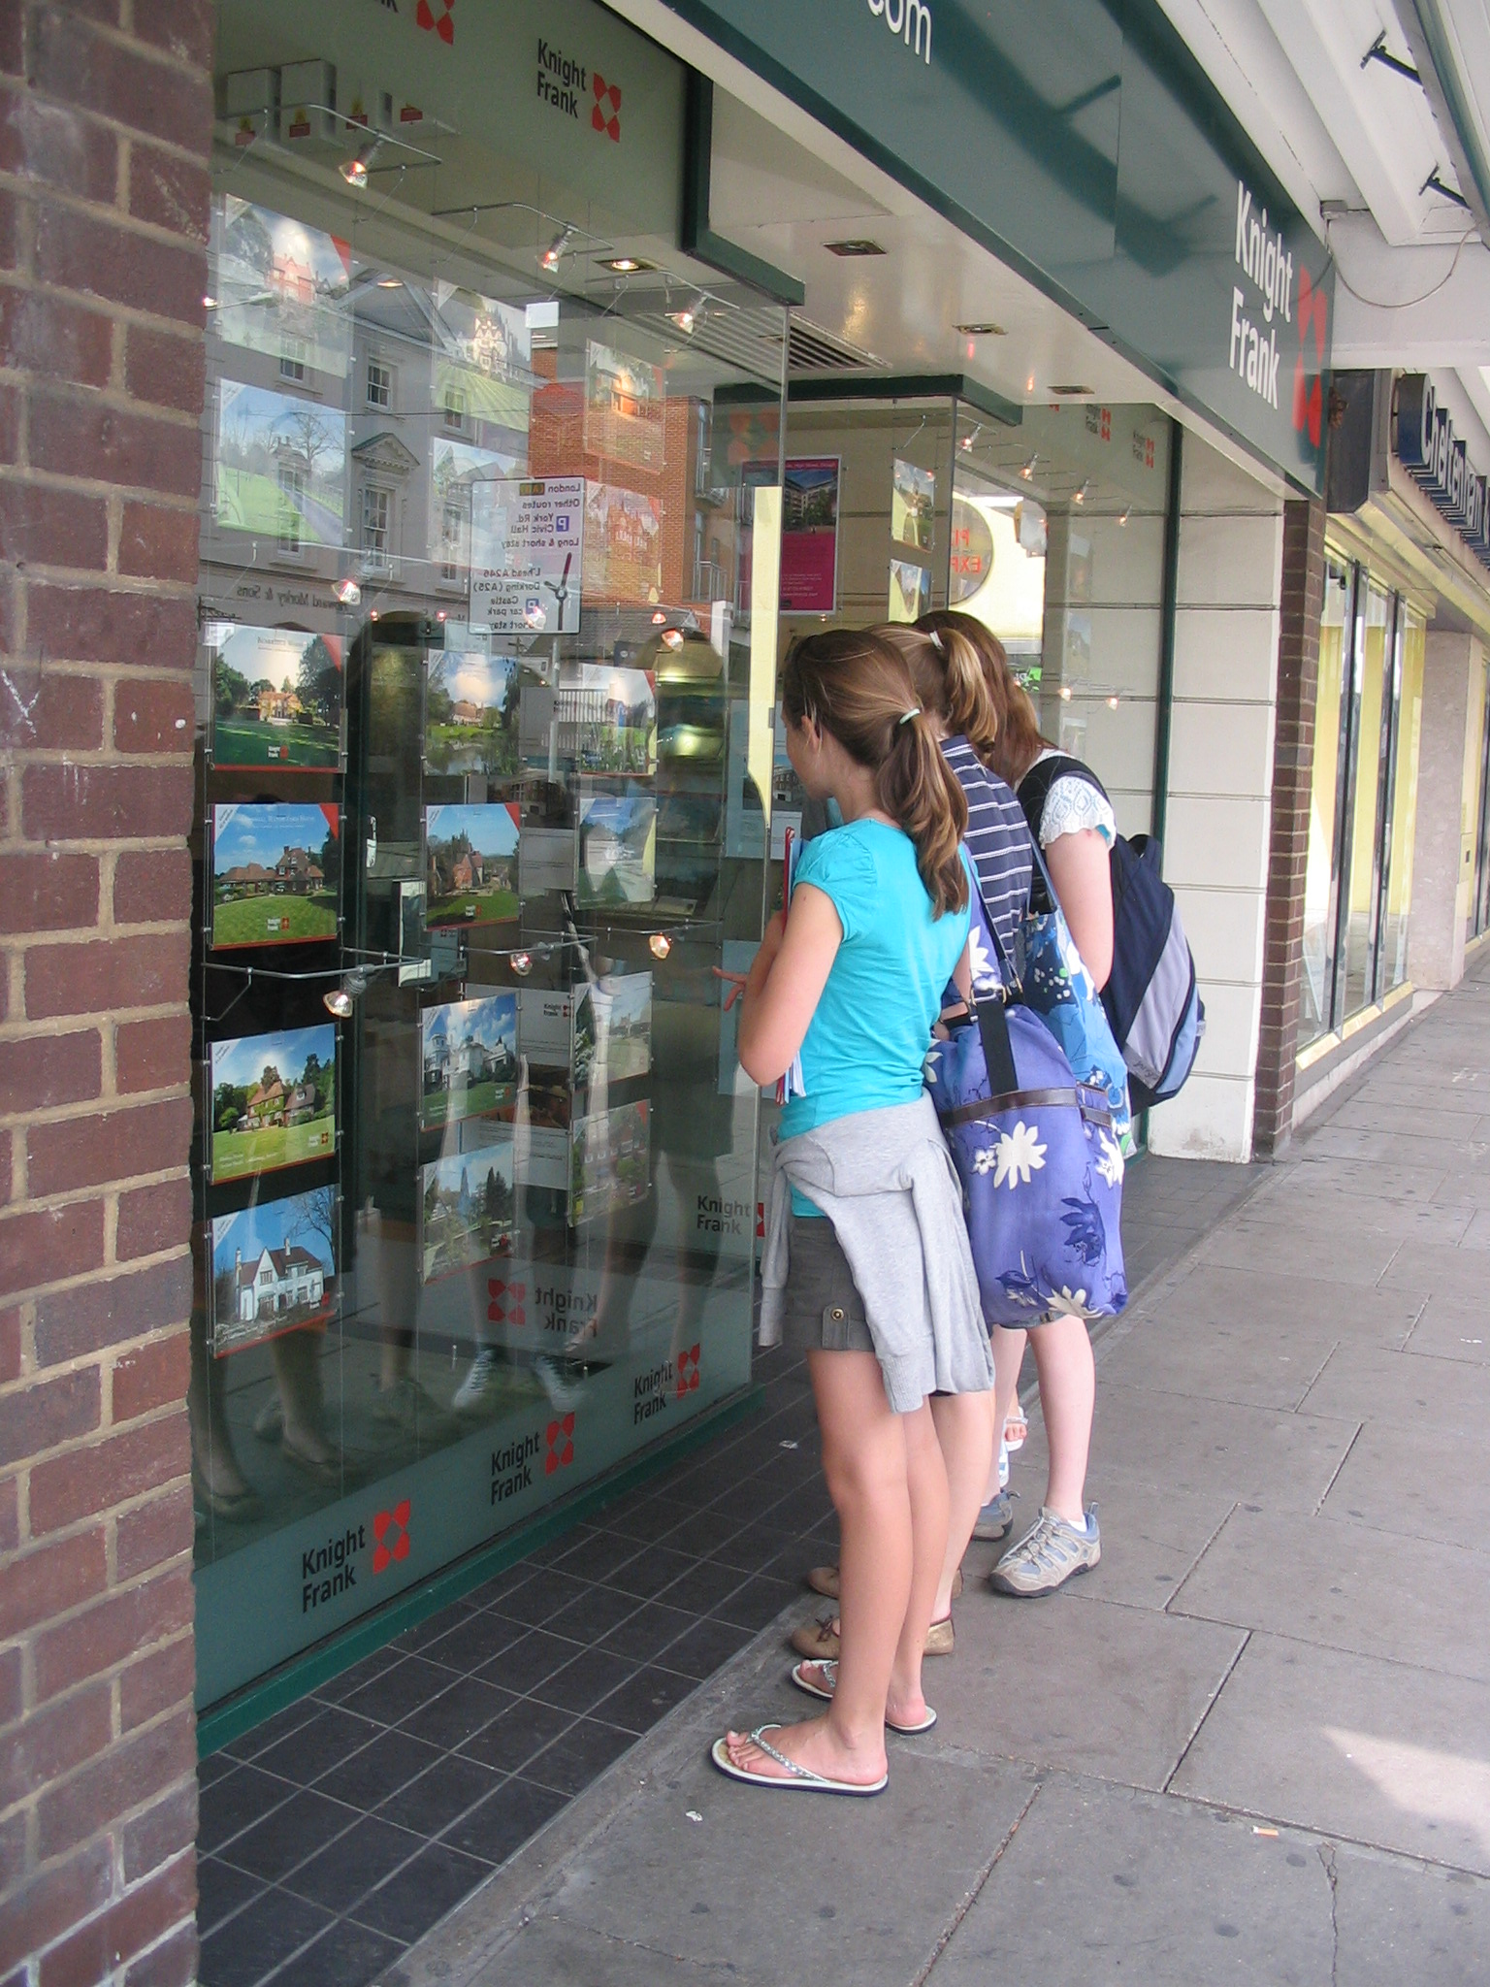
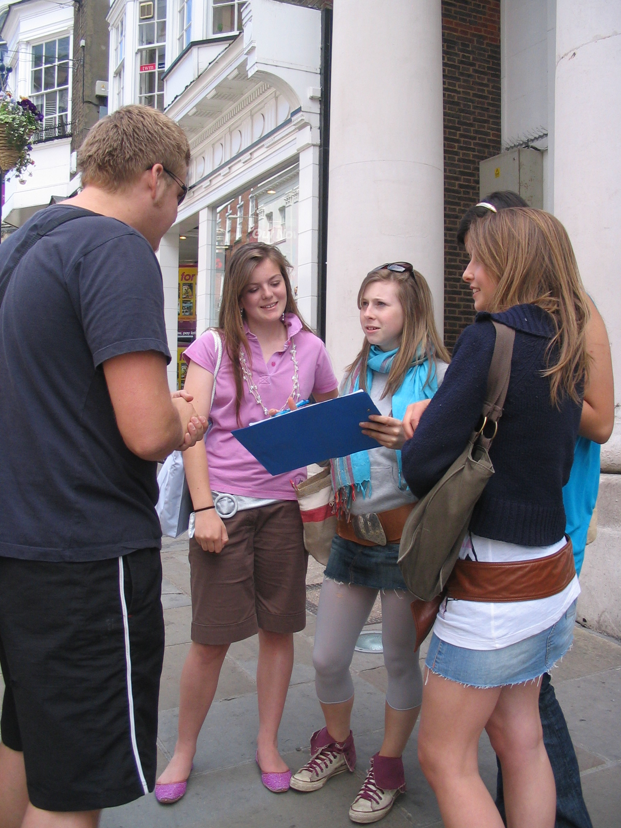

Part Two: Guildford’s housing areas – Students complete four tasks within their allocated area(s):
- A tally of the different housing types (the first 50 houses in the area).
- A photo environmental quality survey – an alternative take on the traditional EQA (with thanks to the FSC), whereby students use digital cameras to record evidence of the best and worst examples of various categories, for example street furniture and traffic congestion, and make a decision as to what the majority of the area is like. To remind them of the photos they have taken, they can either keep a written record, or draw labelled field sketches in the grid provided in the booklet.
- A survey of any evidence of crime in the area.
- A questionnaire for local residents about their satisfaction with the local area – again with the opportunity for students to write their own questions.

Follow-up
Back in the classroom, students were provided with a “to do list” of tasks to complete:
- Complete the photo environmental quality assessment using a provided template, and save it to the class folder.
- Input data findings into either a shared Excel spreadsheet (with embedded formulae to complete calculations of mean figures) or a shared electronic survey – both allowing data to be distributed between groups who had visited different housing areas.
- Analyse findings, comparing them to earlier predictions, to actual census data for Guildford and to national statistics.
- Create a group presentation: “Is Guildford a Clone Town?” using PowerPoint, MovieMaker, Google Earth or Google Maps (students were given a fairly free rein), including evidence to support any conclusions drawn.
Students were provided with a list of websites they should access for census data and statistics. See booklet or weblinks for further details.

Extension tasks
The booklet includes some ideas for additional research that students can undertake. Guidelines are given for comparing results for Guildford to other towns/cities of a comparable size, as well as to the national average, and for locating other census statistics that might be of relevance to the study, for example life expectancy, ethnic diversity and indices of deprivation.

Embedding this fieldwork activity:
With the starter and follow-up activities provided, this activity works well as part of a study of the local area with students from KS3, introducing key skills such as census data interpretation and the use of presentation software. If used with GCSE students, many syllabuses introduce the theme of shopping and also that of quality of life / standard of living, for which this activity would be relevant.

Adapting this activity for alternative sites:
This activity is extremely adaptable. Census data for other locations can be found on the websites listed (down to ward level), and also on local council websites. The NEF survey can be applied to other locations and the NEF website (www.neweconomics.org) has further details on the subject, including a summary of NEF’s own clone town survey. In addition, the activity can be adapted to focus on a more specific theme, for example a study of crime in the local area or standard of living/perceived quality of life as compared to other similar sized settlements elsewhere in the country. To take things even further, follow-up work could investigate whether a north-south divide still exists in this country, and whether there are exceptions to this. There are many articles about the north-south divide available on newspaper websites, see for example The Guardian 23/07/07 “North-south divide will narrow but not rich-poor gap, says report”.

Resources:
- NEF’s “Clone Town Britain Survey” pdf (see link provided)
- Newspaper articles (see links provided for examples of relevant articles)
- Survey route maps (created using Google Maps)
- One fieldwork booklet per group
- Risk assessment
- Equipment: digital cameras

