Starter resource

- What am I?

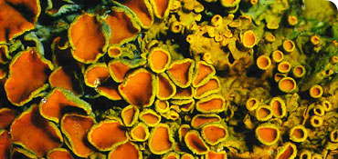
My name is…

Three facts about me are…
1.
2.
3.

- L______________ are an example of two o_______________ living together in a s________________________ relationship. This means… ______________________________________________________________________________________________________________________________

- There are three main types. These are…

1.
2.
3.

- Why are they useful?

  - In the environment?

  - As a resource for human beings?

  - To help us understand the health of the environment?

- Write down the aims of the fieldwork activity in the space below.

