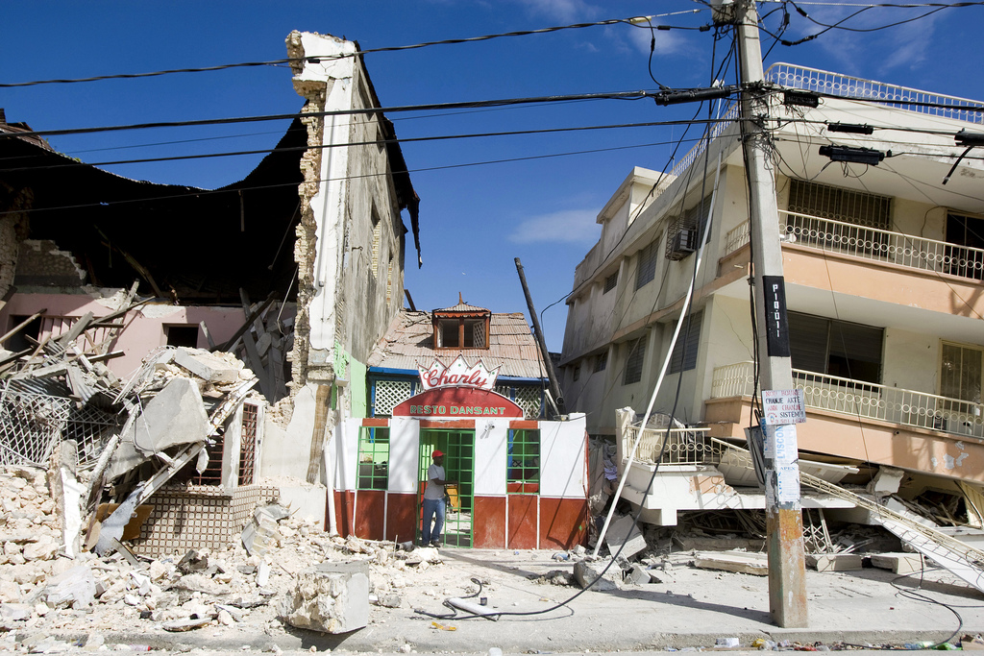
Disaster management:

working in partnership

Disaster management strategies may aim to do more than treat people’s injuries. Many disaster relief agencies and the non-governmental organisations (NGOs) that work with them have a broader set of goals in mind: total community reconstruction and the resumption of normal economic and social development for people living in the disaster zone How can such ambitious strategies be successfully implemented on the ground?

rchitecture for Humanity is an
NGO that operates in almost 40 countries with nearly 300 projects. 40% of its efforts are currently focused (in 2010) on Haiti, helping rebuild communities in the aftermath of the earthquake that hit Port-au-Prince in late 2009 (Photograph 1). This NGO’s speciality is providing disaster-hit communities with sustainable housing solutions that often harness solar or wind power and can also harvest rainwater resources. Its co-founder, Cameron Sinclair, recently spoke to a meeting at the Royal Geographical Society.

Delivering post-event reconstruction work

Sinclair outlined several criteria that he believes should be met if relief operations are to be judged as successful. They are as follows:

- Aid is best delivered in a spirit of collaboration and not competition. Sinclair especially advocates the ‘tugboat and tanker’ model where smaller NGOs (‘tugboats’) with specialist knowledge can help big well-funded charities like Oxfam (‘tankers’) identify priorities for action in partnership.
A
- Where societies suffering from systemic poverty have been affected, such as the slums of Port-au-Prince in Haiti, NGOs may need to commit themselves to as much as four or five years of engagement if they are achieve a lasting impact.
- A quick response is vital. Some NGOs have an effective network of regional offices rather than a strict hierarchy topped by a single decision-making centre (that can be slow to respond to disasters in distant corners of the globe).
- NGOs can try to empower and support local professionals after a disaster has struck, thereby helping money to re-circulate (by re-booting local multiplier effects). For instance, Architecture for Humanity recommends employing local building firms and buying local materials as part of any relief effort. The other side of the coin? NGOs can avoid out-sourcing work overseas – for instance, by creating pre-fabricated buildings in the USA and then shipping them to a disaster zone such as Haiti. Doing so brings little employment to people in the disaster zone. FDI flows are unlikely to grow again until infrastructure is restored, so boosting local incomes in any way possible becomes vital.
- Structures built as part of a relief effort need to be made durable. Local knowledge of the kinds of materials that can resist weathering in a particular physical environment can be important: NGOs and aid workers can make sure that they try and question local people about this before they start re-building.
- Community cohesion is important to maintain, especially if there are ethnic or religious differences that could become a focus for unrest as people become frustrated with their post-disaster situation. Following the 2004 tsunami in Sri Lanka, Tamils and Muslims were provided with a cricket ground where tensions between the two groups could be eased in a competitive, sporting context (Source: Cameron Sinclair)
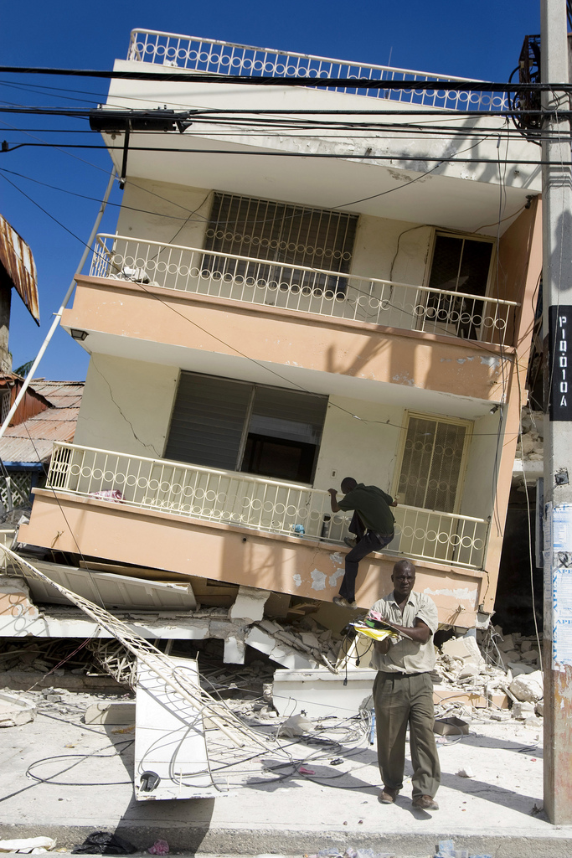

Photograph 1 A collapsed building in Port-au-Prince

Key terms

Disaster The realisation of a hazard that brings harm to human society. Also see Hazard.

Foreign direct investment (FDI) Investment (such as factory-building or store construction) provided by a transnational corporation (TNC) to a country.

Geophysical hazard A hazard formed by tectonic / geological processes (such as earthquakes, volcanoes, mass movements).

Hazard A physical event or process with the potential to harm human life, welfare or assets.

Human resources The abilities and potential of the human population in terms of their educational levels, their skills, the languages they speak and their capacity to innovate and invent.

Hydro-meteorological hazard A hazard formed by hydrological processes (floods) and / or atmospheric processes (such as storms, drought and bushfires).

Multiplier effect The knock-on effects that one economic activity (e.g. manufacturing employment) has for other sectors of a regional economy (e.g. services).

Resilience The capacity of an individual or community to cope with a disaster and its after-effects and to rebuild and resume their normal lives afterwards.

Vulnerability A high risk combined with an inability of people to cope with a natural hazard event.

Vulnerable group A sub-section of the population who are highly likely to suffer the worst effects of a natural disaster e.g. the elderly, or in some societies women and children.

What makes good governance?

Taking a global perspective, it is clear that disaster responses take place at many different geographical scales - and as a result they need to be carefully co-orientated. A lack of co-ordination can actually hamper relief efforts. For instance, in Haiti in 2010, 170 agencies attended a water security strategy meeting after the earthquake (under the auspices of the international ‘water and sanitation cluster’ group).
According to a report by Barbara Stocking, the Chief Executive Officer of Oxfam, with so many people attending it was difficult to reach a consensus about what to do (because there were too many conflicting opinions and levels of experience and expertise around the table).
However, large groups of players working together can also yield successful results (Figure 1). The following outline suggests optimum ways in which different players, working at different scales, can take action in co-ordinated ways:
- Collaborative NGOs Non-government organisations can make a long-term positive economic impact when they form partnerships with local businesses and the private sector in disaster zones. For instance, Oxfam were offered a major financial contribution by a major UK clothing company after the 2004 Asian tsunami. Their approach was to suggest the firm placed more orders with its own clothing suppliers in Sri Lanka (an affected area) thereby providing clothes for survivors while also boosting local output and employment.

Photograph 2 Soldiers help rescue injured citizens in Port-au-prince

Figure 1 Collaboration between players involved in disaster management

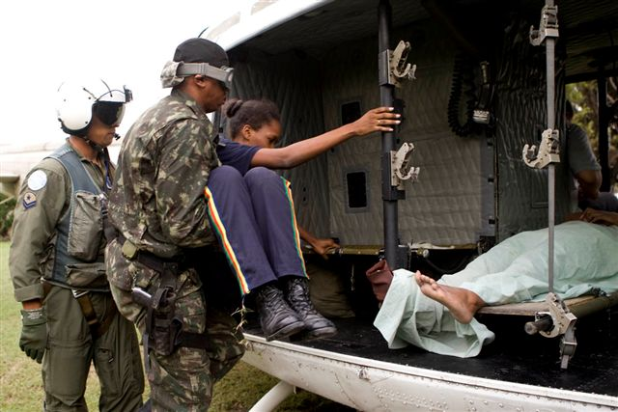
- Active citizens & businesses Individuals and local communities sometimes need to take greater responsibility for doing what they can to build up their own personal resilience to hazards in areas where there is a known hazard risk. In flood-prone Bangladesh, some schools are now being built on stilts to make sure they remain open during flooding.
- Responsible states A nation’s governments needs to work closely with international donors rather than obstruct efforts for political reasons. They can mobilise their army, quickly, to work alongside international aid agencies (Photograph 2). An example of what not to do? Cyclone Nargis made landfall in Burma (Myanmar) in 2008. A cyclone of the North Indian Ocean basin, it was one of the very deadliest meteorological hazards of all time. The final death toll was around 135,000. Aid agencies reported that much-needed food and equipment did not get to those who needed it in the immediate aftermath of the cyclone. This was because Burma’s military junta (army officials who seized control in 1962) failed to transport and distribute supplies. Worse, they refused to give access to experienced western aid workers who could have helped save lives.
- U.N. leadership The United Nations is the only player that can truly co-ordinate the response of national governments at a global scale. The UN now has a framework to help give the global community a united vision for achieving better disaster management: this is the Hyogo Framework for Action 2005-2015.
Increasingly, many agencies are also using new technologies in a range of ways that helps them co-ordinate their efforts and share expertise (Table 1).
Technology | Advantages
GIS and mobile phone applications | New technologies can help coordinate relief efforts. Aerial photographs allow superior mapping of an area after a disaster has struck. Google Earth was a major player in the Haiti 2010 relief effort. The company uploaded laptops with up-to-date post-event aerial photographs and flew them out to the disaster zone for NGOs to use. The GIS images contained on the laptops were a vital aid helping workers on the ground analysing what had been destroyed (Haiti’s own GIS team were all killed by the earthquake). Mobile-phone cameras can also be used to help agencies map and document a disaster zone – this can often be a citizen-led response.
Video-conferencing | Many of Architecture for Humanity’s donations come from school-age students and school charities. The NGO has helped interconnect schools all over the world using video-conferencing. For instance, UK and US schoolchildren were able to talk directly to young disaster victims from schools in New Orleans after Hurricane Katrina struck in 2006. This personal interconnectivity has resulted in much greater numbers of donations being made by young people who want to contribute to the  ‘students rebuild’ programme.
‘Open-source’ technology for reconstruction work | All of Architecture for Humanity’s work (their architectural designs) is ‘open-source’. This means that the designs are freely available to be shared and used by anyone who wants to. They are registered with a ‘creative commons’ license. The NGO is not seeking to profit from intellectual copyright in the long term. You may already be familiar with this kind of approach to ‘open-source’ sharing from using on-line resources such as Wikipedia or Flickr.

Table 1 Employing new ‘technological fixes’ for disaster management

Key Points

- Many agencies – or players – collaborate as part of post-event disaster management and reconstruction work.
- Good results are achieved when local employment and multiplier effects can quickly be boosted as part of the reconstruction.
- Working together in a coordinated, these players can contribute to long-term community reconstruction and growth.
- A lack of coordination can hinder relief efforts; so too can an un-cooperative state government.

Written by Simon Oakes (2010). Content information based on lectures by Cameron Sinclair and Barbara Stocking. Images by UNDP, re-produced under Flickr Creative Commons license.

