Life in a Maasai Village
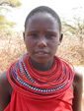
This child lives in a Maasai village in Northern Kenya. Most Maasai people live in an enkang, which is a small village made of huts.
- A thick thorny hedge is usually built around the enkang to keep out dangerous animals such as lions and leopards.
- The Maasai bring their animals into the centre of their villages at night, through narrow alleyways. These alleyways are blocked up at night to protect the people and cattle from dangerous animals.
- The huts are built by the women from materials found in the local area, such as mud from the river and cow dung.
- Inside a Maasai home it is dark and smoky from the fire. There are usually animal skins on the floor to sleep on.
- The women of the village collect sticks for the fire and water for drinking and cooking. They also make beautiful jewellery to sell.
- The men look after and guard the animals.

A Maasai child
(© K Winser)

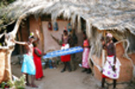

Maasai people outside their home
(© A & D Boys)

But Maasai villages are changing because so many people are moving to the cities.

Why are the Maasai leaving their villages?
What happens to a village when all the young people leave?

The climate is changing. The land is getting drier and there is no grass for the animals to eat
If there are no familes in the village, no new Maasai will be born. This means the village
will slowly die.

Life in the city is easier! There are hospitals, shops and cinemas there.

The traditions of the Maasai are slowly lost because there is nobody to remember them
Schools close down because there are no children to go to them and no teachers.

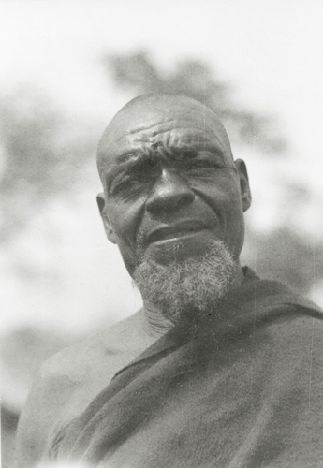
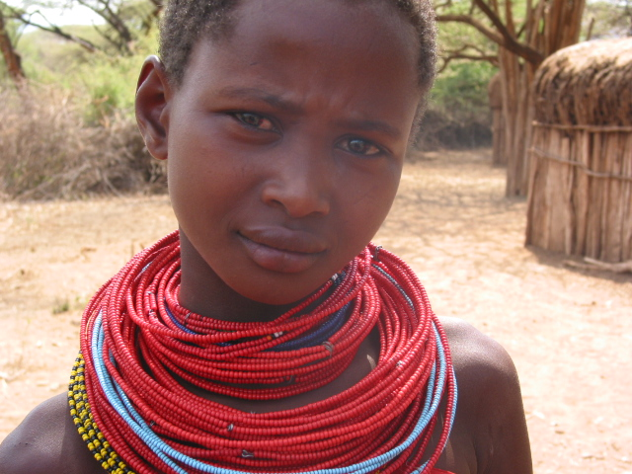
You can buy everything you want in the city!

We don’t own the land we live on. If the land is taken away to make national parks or build houses we can’t feed our animals.

When all the young people leave, only the old and very young are left. These people can’t work, so no money comes into the villages.
We have to find jobs to make money, but there are no jobs in the villages.
When the young people move to the cities there is nobody left to look after the cattle.

© K Winser
© RGS-IBG

