Adapting to an urban future

Photos of urban dwellers Sheet

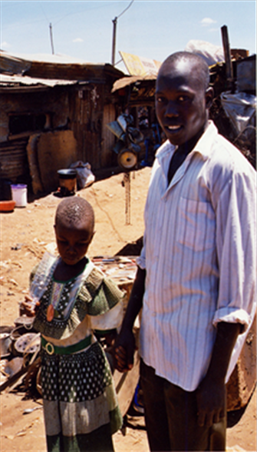
Image 1

Image: Robert Neuwirth

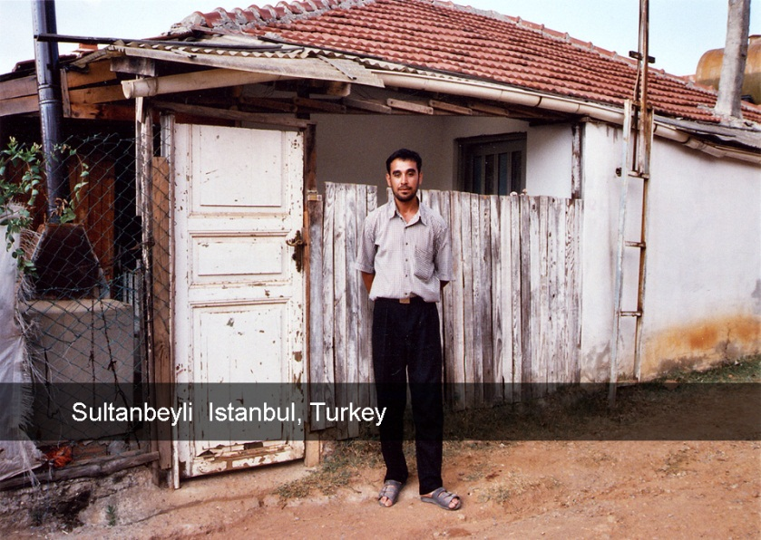
Image 2

Image: Robert Neuwirth

