Dear Jeremy,  I’m in the best city in the world, a city that never sleeps. I think that the climate plays a huge roll in this, especially in summer.  Today it stayed 29 degrees celsius so we could stay out without jumpers and we didn’t even get cold! The only problem with it being so hot in a concrete jungle is that there is no escape from the heat, unless you get lost in central park.  I advise that when you come to New York, you also come in August so that you don’t get as much rain as they experienced this year in July. Apparently it nearly flooded!  Send all my love to the family,  Georgia. |   Royal Geographical Society  1 Kensington Gore  London  SW7 2AR
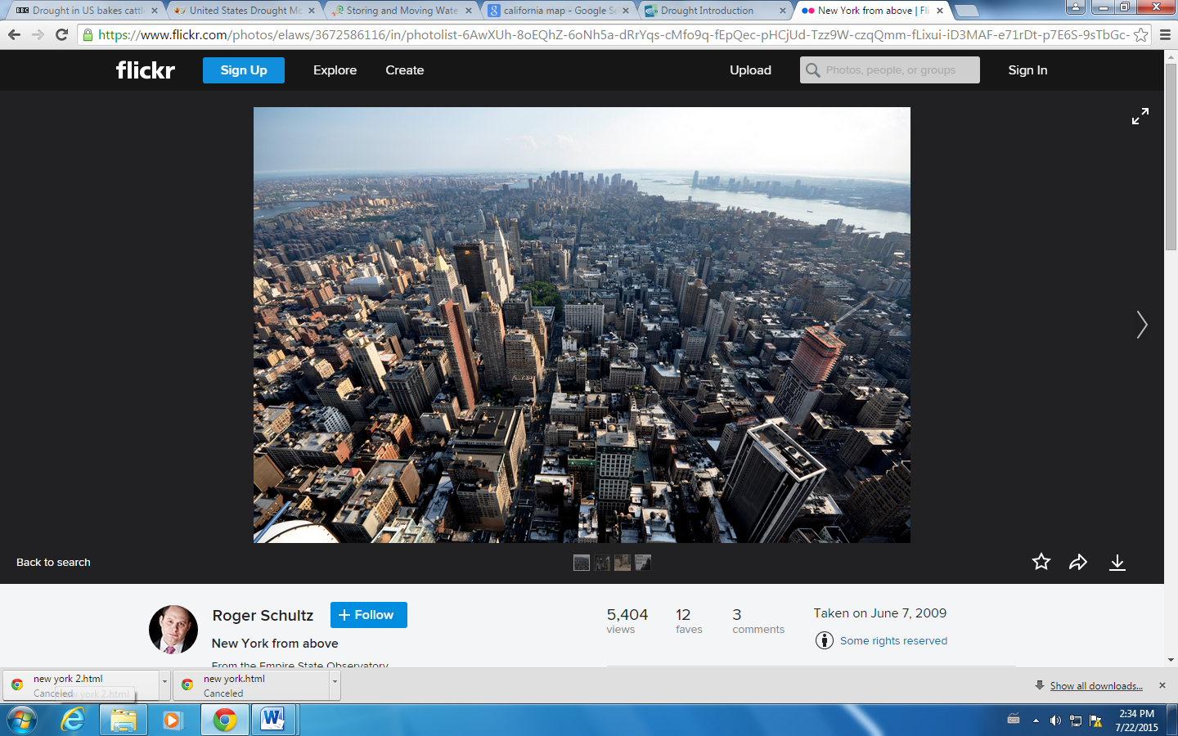
New York, New York

