
Are you flood ready?
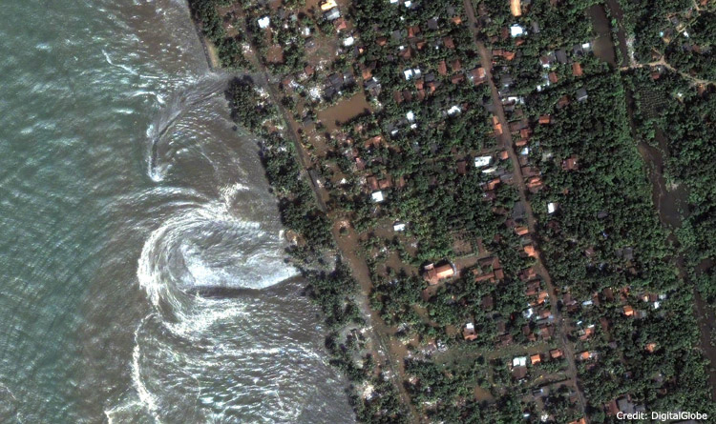

Massive flood waters flow back into the ocean after the tsunami has hit

Just the day after Christmas in 2004, an earthquake in the Indian ocean created a massive ocean wave known as a tsunami which resulted in the tragic death of over 150,000 people.

One trillion tonnes of sea water was pushed upwards when the ocean floor moved.

The wave was so large that it hit Indonesia and Thailand within an hour of its creation. Later in the day, waters reached Sri Lanka and India, eventually travelling as far as parts of eastern Africa.

Thousands of people died as the tsunami struck each country. It showed how vulnerable the coastal populations are in Asia and Africa.

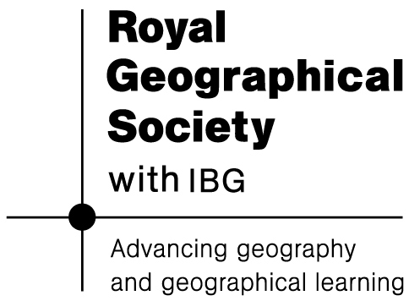
This very unpredictable event made people everywhere question just how effective human societies really are in dealing with such extreme natural disasters – in terms of levels of preparation, the quality of warning systems and getting help to the countries that are worst affected.
What Caused the Tsunami?

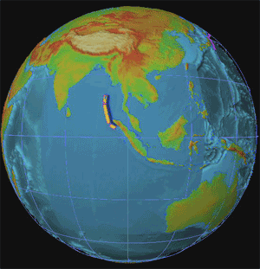
Where the tsunami struck

Earth’s surface is made up of plates (properly called tectonic plates) that move about, and have done so for billions of years. The tsunami was caused by a giant earthquake triggered in a place where two of the plates meet.

These plates had been pressing together for hundreds of years, moving at an average rate of about 6cm a year. The long build up of tension eventually caused the sudden release of one of the plates, making it spring upwards.

This earthquake movement caused a sudden change in ocean depth – this is what led in turn to the tsunami. One trillion tonnes of sea water pushed upwards when the ocean floor moved.

The resulting wave travelled at about 900 kilometres per hour in all directions from the earthquake’s centre. As it slowed it then gathered into surges that came crashing down on populated coastal areas.

What was the human Cost of the asian tsunami?

The cost was huge, both in terms of human life and the money that it cost to help the survivors and mend some of the damage. It was the fourth worst natural hazard since the start of the

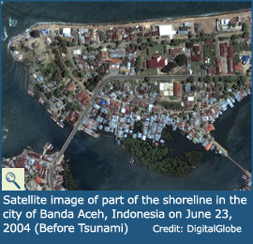
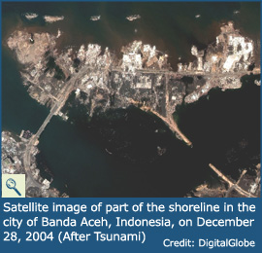
A devastated coastline – could anyone have prepared for this?
20th Century. As well as the physical causes of such a large wave, there were also human factors that determined the scale of the impact on the region’s societies.

(1) Population density and distribution Lots of people live in the region. Indonesia and India have large populations. Work opportunities have encouraged many people to come and work in the areas that were effected. The population in this part of Asia is also spread out across many islands. They were difficult for the rescue teams to get to at first.

(2) Poor Warning Systems and Preparations Letting people know that a disaster is about to happen, even if it is only a matter of hours or minutes, can really help people get to safety and save their lives. There was a lack of warning systems in this area - so people were not aware of what was about to occur. There was insufficient preparation, which sadly led to so many people dying.

(3) Time of year The tsunami struck on Boxing Day, when numbers of tourists were higher than at many other times of the year. This may well have raised the final death toll.

Adapted from “Geography in the News” (by Dr Simon Oakes) View more images of the tsunami at http://www.geographyinthenews.rgs.org/news/article/?id=326

Longer-term consequences were as follows:

(1) Secondary hazards The spread of disease was sometimes unavoidable.

(2) Aid efforts Although large amounts of money by countries all over the world were given to help the region, it was extremely difficult to organise a relief operation on this scale.

(3) Tourism Tourism is extremely important to the region. However, now a disaster has occurred, less people visit (though numbers are recovering)

(4) Hazard Management One good consequence was that people are now aware of the problems caused by the tsunami – and are working to create systems that will predict, warn and evacuate people who will be effected by any future repeat event in the region.

