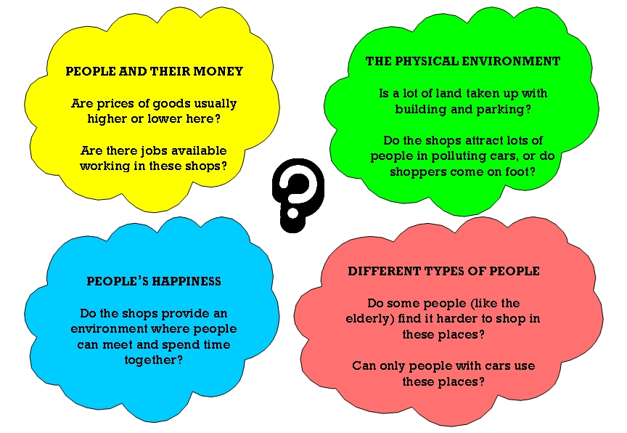
Instructions

- Fill in the table below to show as many possible advantages and disadvantages as you can think of for the different shopping environments described.

- To help you get started, two boxes have already been filled in.

- There are four sets of questions you can ask - to help you start thinking about the positives and negatives associated with each type of shopping environment.
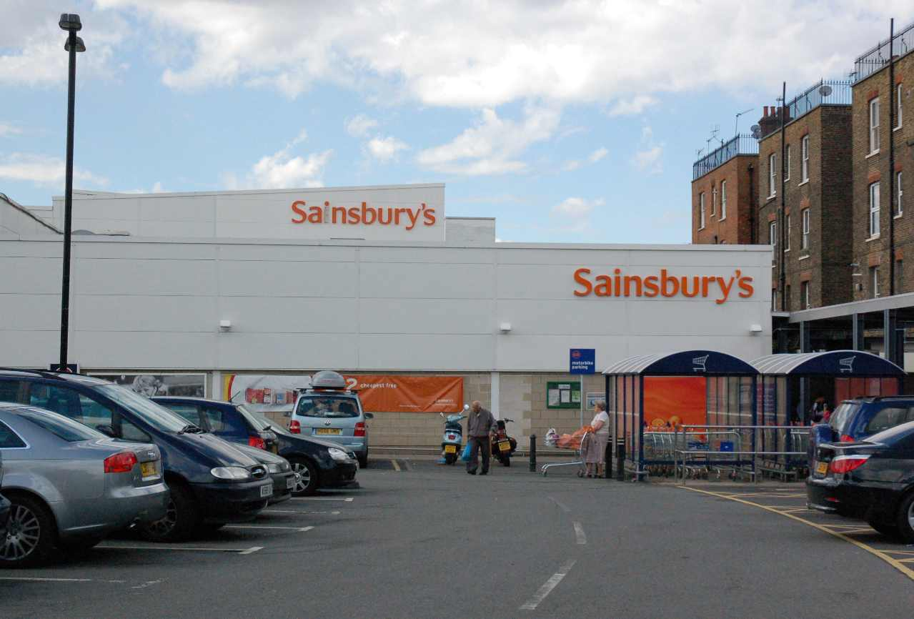

Type of shopping experience | Advantages | Disadvantages
Convenience store Local stores such as newsagents and small grocery stores. |  | Products are often expensive and there is not much variety because they do not have the room to keep a lot of things in stock.
CBD Comparison store Stores found in the Central Business District (CBD) of a town selling more expensive goods, like shoes and electrical equipment.

Street market Vegetables and other foods can be bought from street markets on certain days of the week in some towns. | Food from local farms will not be heavily packaged, which is good news for the environment. Local people can meet there and swap news (like in TV’s Eastenders)
Out-of-town superstore Very large branches of a retail chain, usually found at the edge of a city in retail parks.

