Local Economies and Global impacts

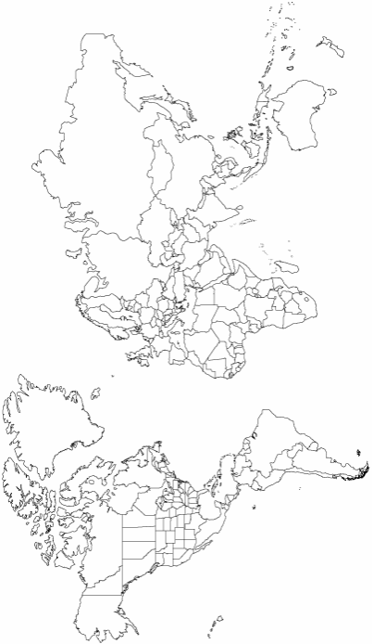
Choose one product that is imported into the UK from a source that might be readily changed. For example you might choose a specific agricultural product that could come from any number of different locations. Using the map draw and annotate factors that might affect that flow of goods. This might include the climatic variation, competition from other locations etc. You might choose oranges sourced from South Africa for example. Should circumstances change, the purchasing company could switch its purchasing to the USA, Spain or elsewhere.
This exercise is for you to think about what might make places vulnerable when they are involved in international trade. On the map mark down the origin of goods that might be flexibly sourced showing the alternative origins of the same product.

