Lesson one
United States of America: An Exploration
Factsheet for teachers
Purpose of this lesson
In order to develop an in-depth knowledge of the USA pupils need to understand the key geographical features of the country. In this lesson pupils will work with an atlas (and/or online maps) in order to create their own map of the USA.
Vocabulary
Geology the study of the origin, history, and structure of the earth.
Lake a body of water surrounded by land.
Latitude the distance of a place north or south of the earth's equator.
Longitude the distance of a place east or west of the Greenwich meridian.
Mountain a large landform that stretches above the surrounding land in a limited area, usually in the form of a peak.
Mountain Range a series or chain of mountains that are close together.
Prairie a large grassland.
River a large stream of flowing fresh water.
Topography the study of the shape of the surface features of an area.
Key Features of the United States of America
Political and Administrative Boundaries
The USA shares borders with Canada, Mexico and maritime borders with Russia, Cuba and the Bahamas (as well as Canada and Mexico).
The United States of America is a federal republic made up of 50 states.
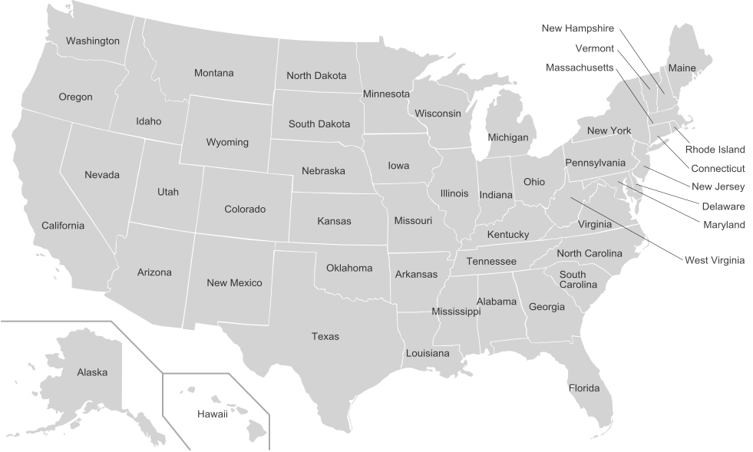
Map of USA © Wikimedia
The population distribution across the USA will be explored in more detail later in this module. However the exercises in this lesson introduce pupils to some of the key settlements in the USA.
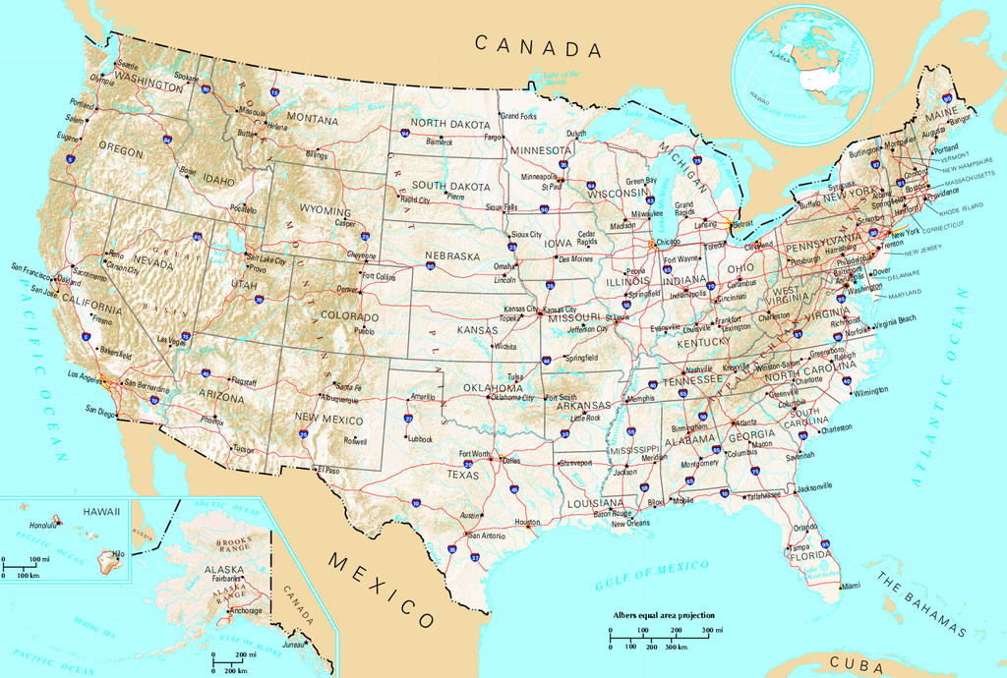
Map of USA © Wikimedia
The National Geographic website entry for ‘Human Geography’ provides a good introduction to the different features of the country. Go to the National Geographic website http://education.nationalgeographic.co.uk/education/encyclopedia/north-america-human-geography/?ar_a=1
Physical Features
This video provides a good overview of the physical features of the USA which you may wish to use with your pupils at the end of the mapping activity.
United States Physical Geography. Go to YouTube website https://www.youtube.com/watch?v=sLs3KJQdLxg
For more information about the National Parks Go to the National Parks Service website http://www.nps.gov/index.htm
For more information on a wide range of issues related to the geography and geology of the USA and is useful for background information, real time data on a number of phenomena as well as maps and images go to the United States Geological Survey website http://www.usgs.gov/

Key Features
Appalachian Mountains: Located in the North East. They are a line of low mountains separating the eastern seaboard from the Great Lakes and the Mississippi basin. | 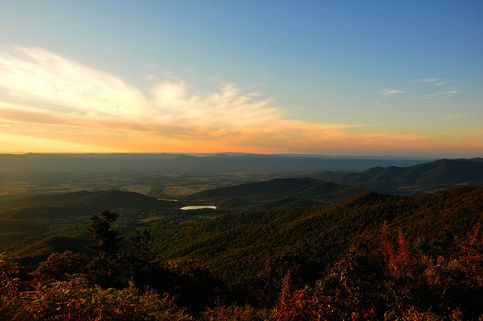  Appalachian Mountains © Ashley Harrigan, Flickr
Cascade mountains: Located in the North West this includes large intermittent volcanic mountains. | 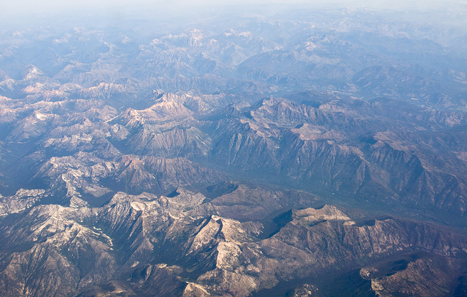  Cascade Mountains © Moss, Flickr
Rocky Mountains: A major mountain range located in the West. The range stretches from Canada nearly to Mexico. Its highest peaks are in Colorado, the tallest is Mount Elbert (4,400m). | 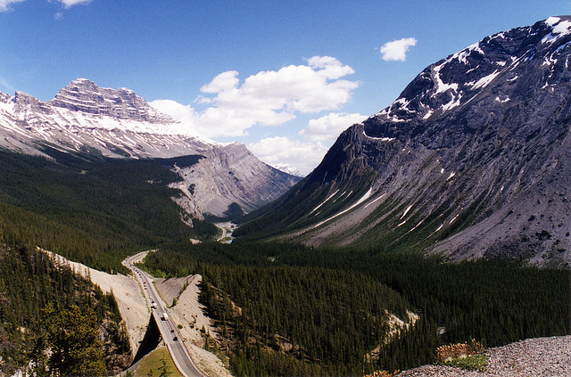  Rocky Mountains © Mattman4698, Flickr
Sierra Nevada: Mountain range in the west running 64km north to south and approximately 110km across. It includes Lake Tahoe which is the largest alpine lake in North America. | 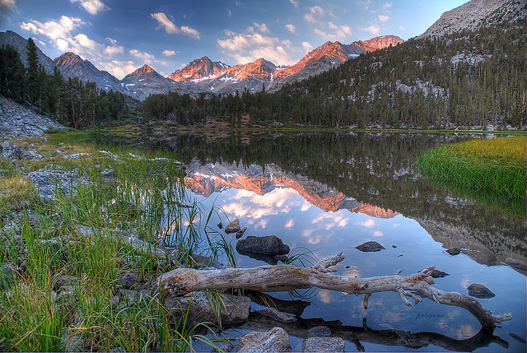  Sierra Nevada © Jono Hey, Flickr
Five Great Lakes: Series of interconnected freshwater lakes in the north eastern The form part of the border between the USA and Canada.  - Lake Eerie  - Lake Huron  - Lake Michigan  - Lake Ontario  - Lake Superior | 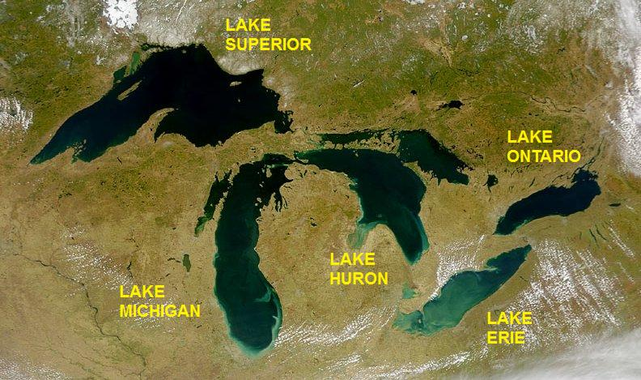  Five Great Lakes © Wikipedia
Great Plains: Grassland region of North America between the Rocky mountains and the Mississippi river. | 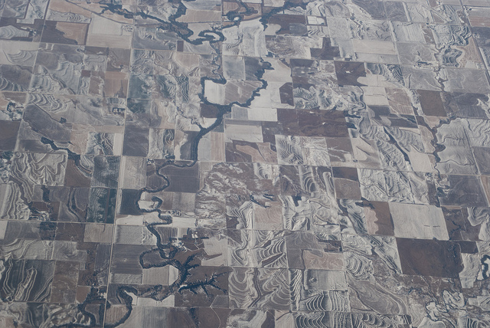  Great Plains © Eldan Goldenberg, Flickr

For an overview of how mountains are formed, go to the RGS-IBG subject knowledge animation ‘Mountains, Volcanoes, Earthquakes’: http://www.rgs.org/OurWork/Schools/Teaching+resources/Key+Stage+1-2+resources/Subject+knowledge+animation+Mountains+volcanoes+and+earthquakes.htm

Rivers
Top 10 Longest Rivers in the USA
Rank | Name | Mouth | Length | US States
1 | Missouri River | Mississippi River | 3,768 km | Montana, North Dakota, South Dakota, Nebraska, Iowa, Kansas, Missouri
2 | Mississippi River | Gulf of Mexico | 3,544km | Minnesota, Wisconsin, Iowa, Illinois, Missouri, Kentucky, Tennessee, Arkansas, Mississippi, Louisiana
3 | Yukon River | Bering Sea | 1,979km | Alaska
4 | Rio Grand | Gulf of Mexico | 2,830km | Colorado, New Mexico, Texas
5 | Colorado River | Gulf of California | 2,330km | Colorado, Utah, Arizona, Nevada, California
6 | Arkansas River | Mississippi River | 2,322km | Colorado, Kansas, Oklahoma, Arkansas
7 | Columbia River | Pacific Ocean | 2,000km | Washington, Oregon
8 | Red River | Atchafalaya and Mississippi River | 1,811km | Oklahoma, Texas, Oregon Washington
9 | Snake River | Columbia River | 1,674km | Wyoming, Idaho, Oregon, Washington
10 | Ohio River | Mississippi River | 1,575km | Pennsylvania, Ohio, West Virginia, Indiana, Illinois, Kentucky

These are just a few of the physical features you may wish to discuss with your pupils as an introduction. You may wish to set a homework activity to investigate some of these further.
You may also wish to mention the National Parks. There are 59 protected areas in the USA known as National Parks. The most famous:
Yosemite National Park, California.  Includes North America’s largest waterfall (Yosemite Falls) and the world’s tallest uninterrupted granite monolith (El Capitan). | 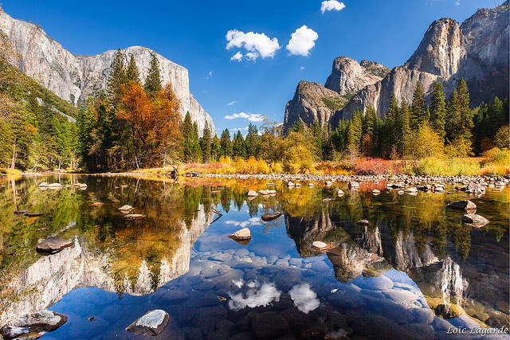  Yosemite National Park © Loic Lagarde, Flickr
Rocky Mountain National Park, north west America: Shaped by glaciers and remained covered in ice until about 11,000 years ago. | 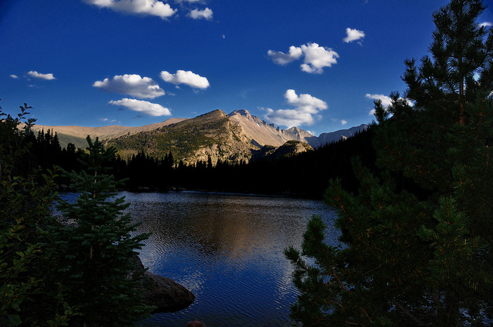  Rocky Mountain National Park © Amit Rawat, Flickr
Redwood National Park, California: Named for its famous sequoias. | 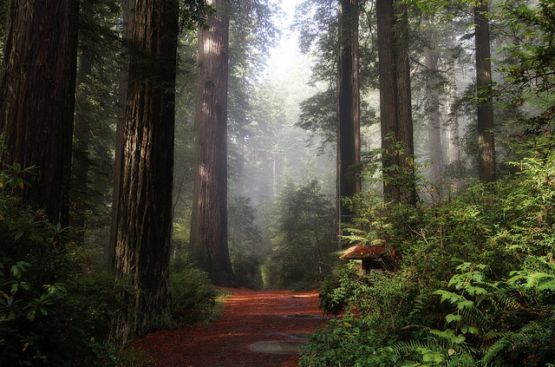  Redwood National Park © John (little time), Flickr
Grand Canyon, Arizona: After the Great Smoky Mountains, Grand Canyon is the second most visited national park, at least 5 million people visit every year. Stretches 277 miles along Colorado River. In places up to a mile deep and 18 miles wide. | 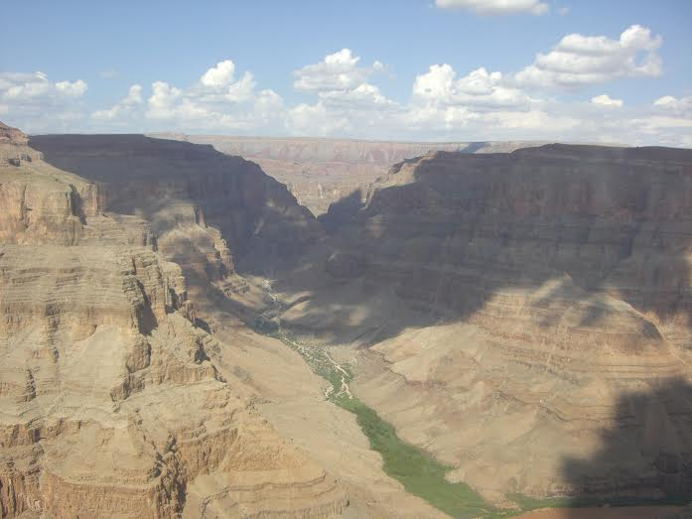  Grand Canyon © Natasha Smith, Flickr
Hawaii volcanoes, Hawaii: One of the world’s most volcanically active spots located on the Hawaiian Island in the Pacific Ocean. Two active volcanoes Kilauea and Mauna Loa. | 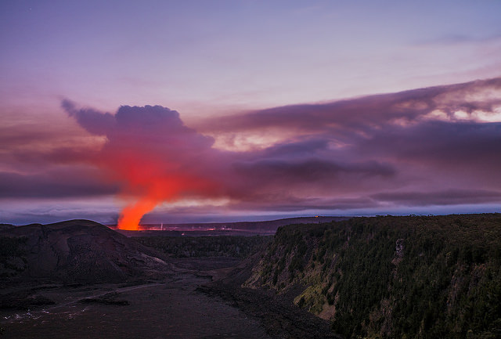  Hawaii © Tom Bricker, Flickr
Everglades, National Park, Florida: The only subtropical wilderness in the USA. Intricate network of rivers and wetland. | 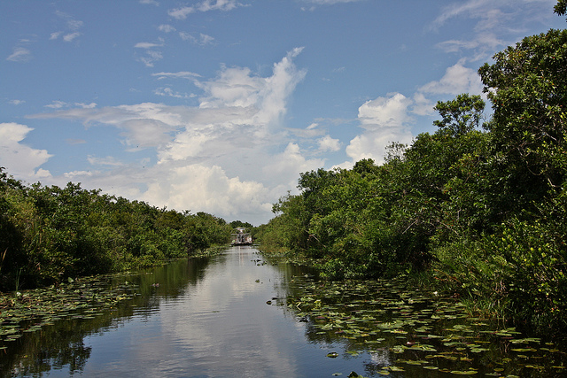  Everglades © dicau58, Flickr
Mesa Verde, Colorado: One of the first National Parks established to ‘preserve the works of man’. The park includes more than 4,000 archaeological sites. | 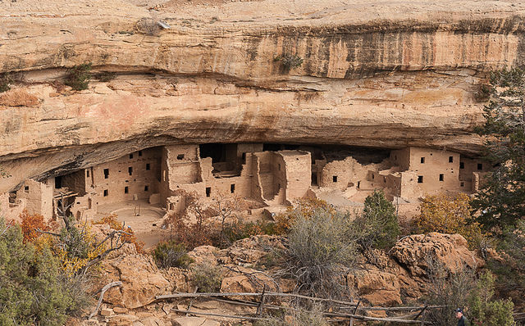  Mesa Verde © Jacqueline Poggi, Flickr
Yellowstone National Park, Wyoming. More than 10,000 hot springs, fumaroles, and geysers – Old Faithful is the most famous landmark. In 1872 Yellowstone became the first national park. Yellowstone Lake is North America’s highest altitude lake. | 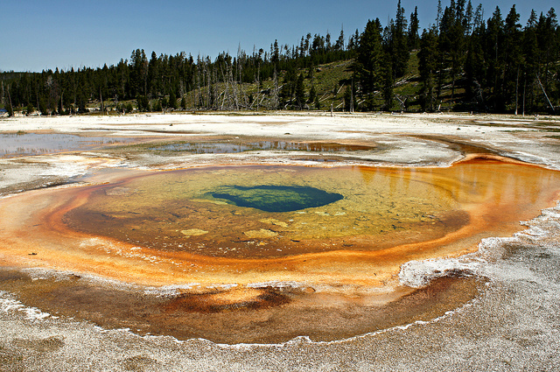  Yellowstone National Park © tjflex2, Flickr
Main Activity
Possible answers for task one includes:

Cities; Monuments; Landmarks; Tourist attractions; Stereotypes; Famous names; Rivers; Lakes; Mountains; Settlements; States; Deserts; Geographical features; National parks.
Possible answers to task three on sound clips:
Any major towns or cities (Las Vegas, Los Angeles, New York City); Any smaller towns and cities (Oklahoma, Dallas, Seattle); Waterfall (Niagara Falls); Train (San Francisco, Washington DC); Desert (Death Valley); Nature Reserve (The Grand Canyon, Rocky Mountains, Red Wood National Park).

