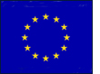

Key terms Snap!

Cut out the following key terms, definitions and pictures and play a game of three-way Snap! with two other people in your class to test your knowledge of sustainability and energy…

Key terms:
Sustainable energy
Renewable energy
Wind energy

Solar energy
Non-renewable energy
Tidal energy

HEP

Off-shore wind farm
Biomass

On-shore wind farm

Wave energy
Geothermal energy
Wind farm

Definitions:

The movement of water caused by the wind can be used to drive turbines.

Living things and organic matter can be harvested sustainably, e.g. wood for fuel.

Wind farms built on land, within a country.
The pull of the moon creates a flow of water which can turn turbines.
The movement of the air can turn turbines.
Hydro Electric Power – trapped water can be released to generate electricity.
Energy generated from heat deep within the earth.
Energy sources which, if used sustainably, will not run out and can be used again and again.
Generated by capturing the sun’s energy.
Wind farms built out to sea.
A collection of wind turbines built together.
Energy which can be generated without causing harm, and leaving resources available for future generations.

Finite energy resources which will run out.
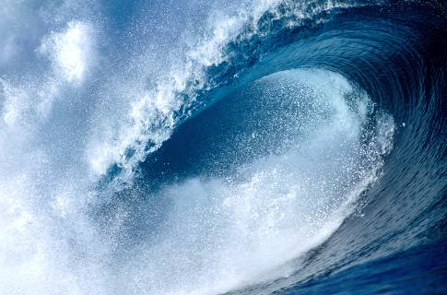
Pictures:

