My ‘Winter’ in Antarctica, March to June 2004

By Tim Burton
Reproduced with permission from Tim Burton. All photographs, copyright Tim Burton

We have not seen the sun for well over a month, the sea has frozen all around us, many of the animals have migrated north, the temperatures have dropped and we had the shortest day of the year last week. It’s a beautiful time of year as the light is so amazing – because the sun is only just below the horizon for four hours of the day, there is what looks like a sunrise for four hours!! The frozen sea creaks and groans with the gentle waves and tides beneath, and the icebergs that are locked into it glow pink in the sun.

Winter Training Trips

In my last report I was about to leave with Fin the Doctor on a winter training trip into the mountains of Adelaide Island (where Rothera Station is located). Since then I have been on three others and they have all been amazing, doing different things in different areas of the island. The weather controls everything down here, especially when we are travelling on glaciers. Glaciers have dangerous crevasses and if the light is poor because of mist or cloud then I can’t see them (no contrast) so we can’t drive around on skidoos and are limited to local travel on foot and ski. On the four trips I have managed to visit the three main areas of the Island.

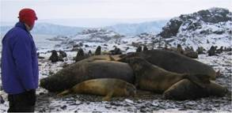
On the southern tip of the island Cyril the chef and I stayed at Carvajal - an old British base 90 miles away that is now owned by the Chilean Antarctic Survey and is deserted. Our 6 day trip ended up being 16 days long though as we had long spells of bad weather and very strong winds. We spent a lot of time being entertained by the Fur Seals (there are hundreds!), Elephant Seals (these are HUGE!!!) and drinking tea!

On the Northern end of the Island I travelled with Andy - he’s a marine biologist and diver here. The weather was excellent with blue skies most of the time as we camped above the low cloud. We were able to drive up to a ridge at 1800m on the 2200m Mount Reeves and look north across the sea over hundreds of miles of mountains and islands. It was the most beautiful spot for a picnic I have ever seen and we even had amazing powder snow to go skiing in afterwards.

The other two trips – with Fin the Doctor and Hamish, another marine biologist and diver – stayed on and around this side of the island. Between the two trips we managed to climb several mountains, ski up and down some of them and take them ice climbing too. You don’t have to go far here for exciting things to do as some of the local mountains offer some excellent skiing and climbing.

Visitors!!!

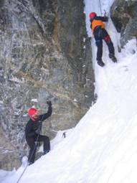
Normally after the ship has left in March we wouldn’t expect to see anyone else until the middle of October. This year, however, was different as we had 3 visits from ships. The RRS Ernest Shackleton, which had left in March, came back again to drop off the remains of a BAS single otter plane they had recovered whilst cleaning up old British bases on the peninsular. It is in many pieces and crashed tens of years ago so we don’t have a new toy for the winter!!
We also had a late notice visit from the Argentinian ship the Almirante Irizar whilst on a resupply cruise. It is a massive ice breaking ship with two helicopters on board too. Ten of us were flown out onto the ship for a tour and drinks in the captain’s lounge – very nice! Lastly we had a visit from the US research ship the L.M.Gould. They brought us some fresh food, which was lovely, but the ship was moored in strong winds and was battered against the wharf for several hours!
Ice Climbing

Midwinter’s Week

The 21st June is the longest day of the year in Britain, but down here it is the shortest day – there is no sun and only 4 hours of twilight. As we are so busy over Christmas and New Year midwinter’s day is our big celebration. We even get the week as a holiday (although we can’t go anywhere hot and sunny!!) People organise lots of events over the week – we had our own Rothera 2004 football competition, a casino night, a photo competition, ski lessons and a moonlight bar-b-q at -15ºC where your drink froze in minutes and the burgers were cold in seconds!

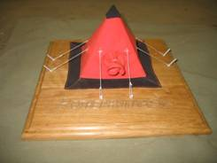
For midwinter’s day itself we all make a present and pick a name out of a hat to decide who gets it. Everyone makes very different things – I made a scale model of a pyramid tent and received 3 frames with beautiful photos in them. Others varied from a CD rack made from sledge parts to a homemade hammock. After giving these out we sat down and listened to the BBC World Service Midwinter Broadcast. This is a special programme for people wintering in Antarctica with messages from our friends and family. Cyril fed us afterwards with a massive 7 course meal that he had spent days preparing – we could hardly move afterwards!!

Base Life

When the Field Assistants (that’s my job) are not on winter training trips we check and repair all the equipment that goes into the field in the summer. We fix sledges, clean and sew tents, check boxes and lots of others jobs. At the moment one of our other jobs is to drill the sea ice to see how thick it is – if it is thick enough we can walk and ski and even drive on it. At the moment the ice is about 25cm thick and enough for you to walk around on. Tomorrow we will use a chainsaw to cut two holes in the ice for the divers to use to carry on their research. Seals usually adopt one hole as a breathing hole so we have to make two just in case! It must be amazing diving in the crystal clear waters under a ceiling of ice with seals for company.

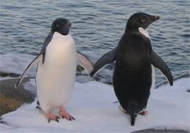
The science work still goes on in the winter - there are seven scientists here now. Three of them are marine biologists – diving under the ice to study the underwater wildlife and the water itself. Three others study the atmosphere using weather balloons, special aerials and hi tech lasers. The seventh looks at land based wildlife around the area. We have seen lots of wildlife – a few weeks ago we had a pod of about 12 Killer whales swimming 50m from the beach, we often have Minkie whales swimming in the bay and normally have lots of Elephant, Weddell and Fur seals and penguins around too. One day in April we had more than 700 fur seals around base – and they really pong!!! Now they have nearly all migrated north as need to fish in the open water and it has frozen here now.
Adelie Penguins

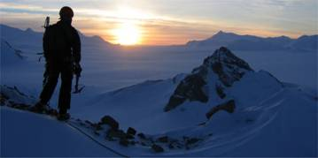
In our time off we go skiing and climbing in the local area or wander round the “point” to enjoy the spectacular views and watch the wildlife. We can also play badminton, volleyball and football in the aircraft hangar (although it’s -10ºC in there at the moment!!), do circuits in the gym and pool and table tennis too. You can develop your own photos in the lab, watch films and lots more. There’s no excuse to be bored anyway!!
Last of the Sun after Ice Climbing on Stork Peaks

What Next?

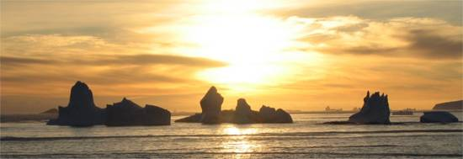
Now the midwinter’s celebrations and holidays are over we are all back at work. The winter training trips start again in 3 weeks time and I will get to take 4 people either out into the mountains or hopefully across the frozen sea to other mountains and islands in the region. Travelling on sea ice is something that you can only do in a few lucky places in the world, so we all have our fingers crossed – driving across the ice between the locked icebergs should be an awesome experience. The trips run until the end of September and then we all spend a couple of weeks getting the base and ourselves ready for the arrival of some new people for the “summer” season and our first post for 7 months!!!
Sunset at Carvajal

