Country Fact Sheet

Kenya is found on the equator on Africa’s East coast. It is most famous for its wildlife, Maasai culture and the Rift Valley which cuts through the middle of the country from north to south.

This map shows you where Kenya is:
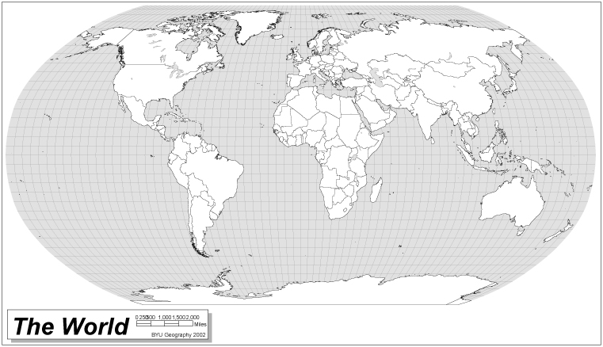
Kenya is on the East coast of Africa. It has an Indian Ocean Coast measuring 480 kilometres.

This map shows Kenya in more detail, can you pick out the important cities?
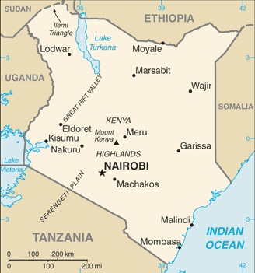

Nairobi is the capital city of Kenya.

Mombasa is Kenya’s biggest coastal city, traders have been sailing here in ships for 800 years!

©CIA

The Kenyan flag
This flag was launched in 1963 when Kenya became an independent country. The symbol in the centre is the Maasai warrior’s shield and represents the defence of freedom. The colours of the flag (black, red, green and white) also mean something.
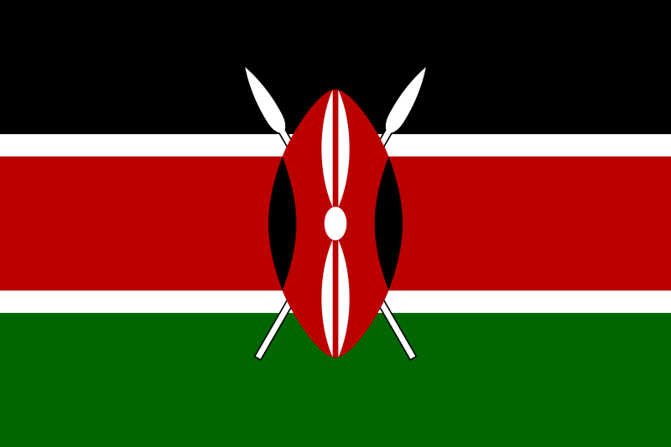

Black: Is for the people of Kenya
Red: Is for the people killed during the fight for independence
Green: Is for the health of the land
White: Is for peace

Currency:
Kenyan Shilling (100 cents = 1 Kenyan shilling)

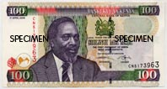
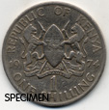
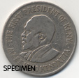

This coin and bank note show Mzee Jomo Kenyatta, who was the first president of Kenya in 1963.

Fast facts:

Country Name: The Republic of Kenya

Land area: 580,370 Square kilometres

Population: 36.9 million (2007 estimate)

Capital City: Nairobi (this is also the country’s largest city and has a population of 2.5 million people).

Other important cities: Mombasa, Kisumu, Eldoret, Nakuru.

Borders with: Sudan, Ethiopia, Somalia, Tanzania, Uganda, Lake Victoria and the Indian Ocean.

Major Religion: Christianity

Main Languages: Swahili and English.

Government: The President of Kenya is Emilio Mwai Kibaki, he was elected in 2002.

Life Expectancy: 55 years for men and women (2007 estimate)

Adult Literacy Rate: 85.1% of the total population are able to read and write.

Access to clean water: 61% of the population are able to get clean water to drink.

Main industries: Farming and Tourism

Main Crop: Maize. This is made into ‘Ugali’.

Many different groups of people live in Kenya. The most famous are the Maasai who are known as fierce and proud warriors. The Maasai depend on their animals for food. The animals are even more important than money to the Maasai!
Did you know?

Information was obtained from the following websites: Foreign & Commonwealth Office, Central Intelligence Agency, Unesco and Unicef.

