Changing Functions of Dubai
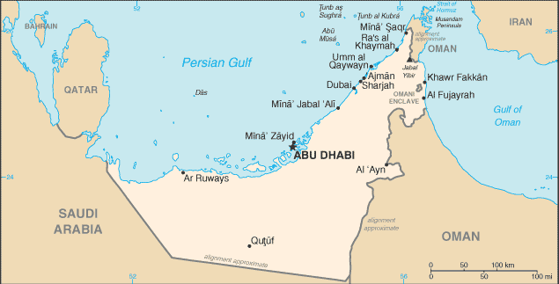
Dubai at a glance

Dubai is one of seven states that make up the United Arab Emirates.

The population of Dubai is 1 million (90% are expatriates)

Ruled by a Sheikh.

Hot and dry. Outside the city it is desert

Timeline:
- 18th century Fishing / pearl village
- 19th / 20th century Trading partner with Iran and India
Centre for gold smuggling until 1990s
- 1960 population reached 20,000
- 1966 Oil discovered.
Huge increase in wealth used to develop Dubai with modern roads schools and hospitals, and superb communications and transport facilities. No taxes!
- 2006 population reached 1.1 million.
Oil only accounts for 3% of total income. Economy has been diversified towards tourism and service industries

Diversification of economy away from oil:
Tourism
Hi-tech industry
Business and finance

Largest artificial waterfront in the world (Dubai Waterfront)
Man-made islands e.g. The Palm and The World

Own airline (Emirates)

Tallest building (Burj Dubai)
Luxury hotels (Burj al-Arab)
World’s largest shopping mall
Dubai Internet City
(Microsoft)

Dubai Media City
(CNN)
Dubiotech
(Biotechnology research and development)
Dubai International Financial Centre
(Finance)
Jebel Ali Free Trade Zone
No tax
Pro-business laws and regulations
Foreign companies keep 100% of profit

